GSN: Science Relevant to Society

Overview
In testimony before the U.S. Senate, February 2, 2005, on the Indian Ocean Tsunami of 2004:
"This disaster has raised awareness of and attention to the phenomena of earthquakes and tsunamis, and their predictability. NSF has long funded scientific and engineering research infrastructure aimed at detecting and understanding the impacts of these phenomena. Prominent examples include the real-time Global Seismographic Network (GSN), the data from which forged the critical core of the early warning of the December 26, 2004, earthquake. This Network, operated by the Incorporated Research Institutions for Seismology, is funded in partnership by NSF and the United States Geological Survey, and is the primary international source of data for earthquake location and tsunami warning."

Arden L. Bement, Jr., Director of NSF
The Global Seismographic Network is a cooperative partnership of U.S. universities and government agencies, coordinated with the international community, to install and operate a global multi-use scientific facility as a societal resource for Earth observations, monitoring, research, and education. The GSN is also a state-of-the-art, digital network of scientific instrumentation and inheritor of a century-long tradition in seismology of global cooperation in the study of the Earth. GSN instrumentation is capable of measuring and recording with high fidelity all of seismic vibrations from high-frequency, strong ground motions near an earthquake to the slowest free oscillations of the Earth excited by giant earthquakes. Sensors are accurately calibrated, and timing is based on satellite clocks. The primary focus in creating the GSN has been seismology, but the infrastructure is inherently multi-use, and can be extended to other disciplines of geoscience.
The concept of the GSN is founded upon global, uniform, unbiased Earth coverage by a permanent network of over 130 stations with real-time data access. The equipment is modular, enabling it to evolve with technology and the science needs. Equipment standardization and data formats create efficiencies for use and maintenance. GSN telecommunications are heterogeneous, utilizing both public and private Internet links, as well as dedicated satellite circuits.
A cornerstone of the GSN is free data exchange with the international community. All real-time GSN data are available to anyone in real-time, without restriction, via GSN Data Collection Centers or the IRIS Data Management System (DMS). All GSN data are archived and openly accessible through the DMS by anyone with an Internet connection.
The GSN is both benefactor and beneficiary of government-university cooperation involving the National Science Foundation, U.S. Geological Survey, Department of Defense, NASA, National Weather Service and NOAA. The GSN is a foundation for the Advanced National Seismic System (ANSS) in the United States, and serves as the critical core data for the Pacific Tsunami Warning Center. Data from GSN stations are being used by the International Monitoring System for the Comprehensive Test Ban Treaty. The GSN is an official U.S. observing system component of the Global Earth Observation System of Systems (GEOSS). With IRIS a founding member of the international Federation of Digital Broadband Seismographic Networks (FDSN), the GSN serves as key component of the FDSN Backbone. Primarily operated and maintained through the USGS Albuquerque Seismological Laboratory and the University of California at San Diego, the GSN is joined by independent national and international Affiliate stations and arrays.
The GSN is an educational tool for the study of Earth. With the ease of access to data and blossoming computer technology, GSN data are now routinely used in

introductory college courses and high school use is rising. The GSN stations themselves are focal points for international training in seismology. Real-time access to GSN data has led to rapid analysis of earthquake locations and their mechanisms, bringing public awareness of earthquakes as scientific events, not just news events.
GSN management includes a far-reaching international component of direct relationships with:
- Russian National Network
- Chinese Earthquake Administration
- Geoscience Australia
- Geological Survey of Canada
- University of Brazil
- Germany’s GeoForschungsZentrum, Bundesanstalt fur Geowissenschaften und Rohstaffe (Geological Survey), and Alfred Wegner Institute for Polar Research
- Italy’s Instituto Nazionale di Geofisica
- Mexican National Seismic Network
- British Geological and Antarctic Surveys
- Japan’s National Research Institute for Earth Science and Disaster Prevention, University of Tokyo Earthquake Research Institute, Japan Marine Science and Technology Center (JAMSTEC)
- France’s Institut de Physique du Globe de Paris and Dipartement Analyse et Surveillance de l’Environnement (DASE)
- New Zealand Geological and Nuclear Sciences
- Chile’s Fundacion Andes
- Singapore’s Meteorological Service
- Comprehensive Nuclear Test Ban Treaty Organization (International Monitoring System and Global Communications Infrastructure)
- International Ocean Network
- Federation of Broadband Digital Seismic Networks
- Global Earth Observation System of Systems (GEOSS)
National partnerships include:
- National Science Foundation (Earth, Oceans, Atmospheres and Polar Programs)
- USGS (Albuquerque, Reston, Golden and Menlo Park)
- National Weather Service
- Pacific Tsunami Warning Center
- NASA/JPL
- Air Force Technical Applications Center (AFTAC)
- US State Department Verification Monitoring Task Force
- UNAVCO
- University of California at San Diego
- Harvard University
- Caltech/University of Southern California
- Saint Louis University
- Oregon State University
- University of Arizona
- University of California at Berkeley
- Penn State University
- University of Texas at Austin
- Carnegie Institution of Washington
- University of Hawaii at Manoa

The GSN is a fundamental global resource for society. Like a vigilant sentinel, the GSN listensto the earth's vibrations. Its real-time, open data enables rapid reaction to earthquakes worldwide, whether for disaster response, tsunami warning, or hazard mitigation. On this tectonically active planet, GSN data are critically useful in mankind's proximity to earthquakes, volcanoes, and tsunamis.

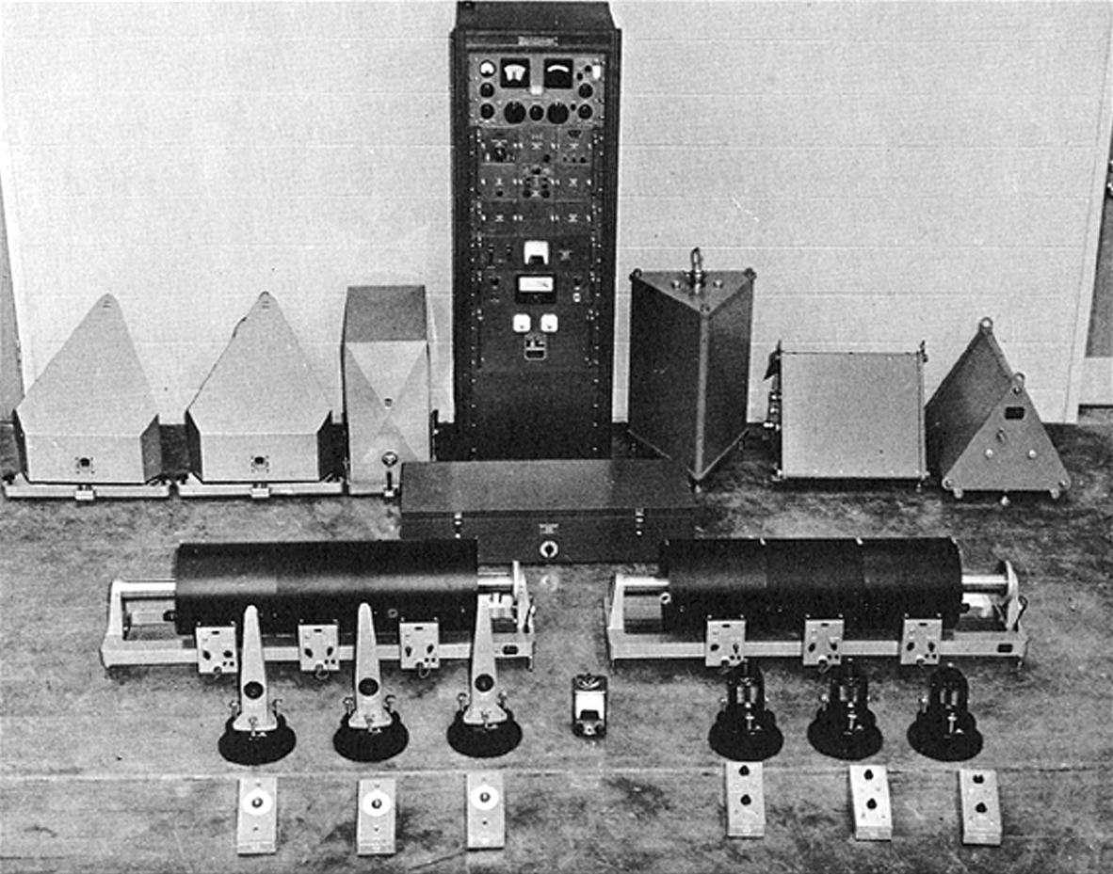

History
International, global seismographic coverage was born at the beginning of the 20th century when a network of more than 30 Milne seismographs first spanned the globe-in essence the first global seismographic network. In 1960 analog World Wide Standard Seismograph Network of 100+ seismic stations was initiated to provide basic global coverage for seismological research and monitoring nuclear tests. The WWSSN formed the core data for modern seismology and the discoveries in plate tectonics. Entering the digital age in the 1970s, legions of graduate students spent countless hours digitizing WWSSN photographic records for observations to be compared with newly computer-generated models of earthquake source dynamics and Earth structure. Global digital seismology initiated with the USGS/ARPA Seismic Research Observatories of both underground and borehole seismometers and the NSF-sponsored UCSD ultra-long-period International Deployment of Accelerometers (IDA).
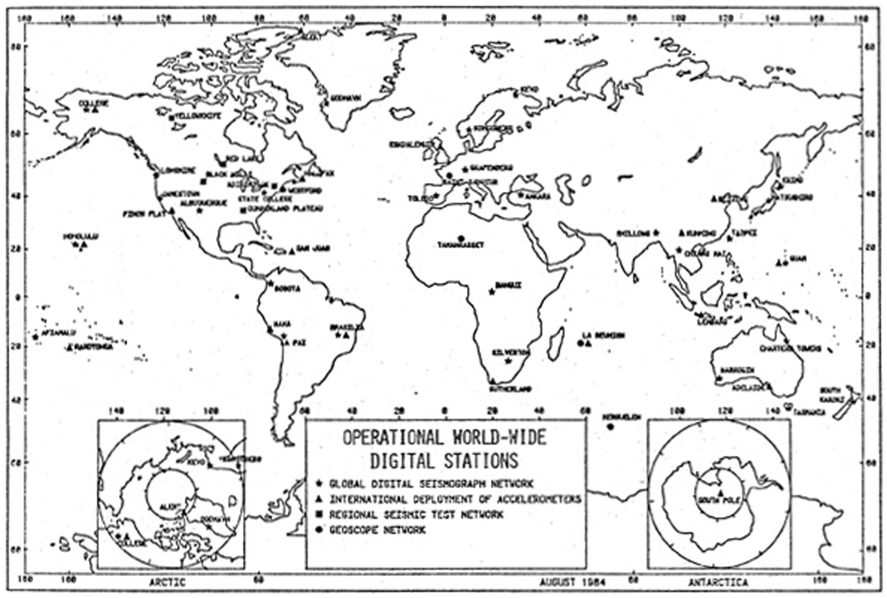
The seeds of the GSN were planted around 1980 when seismometers with feedback electronics became
available with very-broad bandwidth (from ~12-hour tidal periods to frequencies of tens of Hz), high-dynamic range and linearity for recording the largest earthquake signals, and instrumental noise below the lowest natural seismic background noise. Digitizers were developed with more than 140 dB dynamic range to encode the analog signals from these new broadband sensors. Computer costs declined whereas processing speeds and recording capacities increased exponentially. Global telecommunications were advancing.
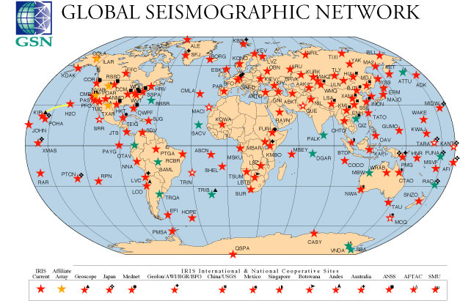
This strong technological foundation came at a time when the science of seismology had advanced theoretically beyond its observational capacity. The questions being posed by the science could not be answered with the limited data available. Furthermore, existing seismic stations were unevenly distributed about the planet and strongly biased in coverage-enormous areas of the oceans and large sections of continents were not instrumented at all. The southern hemisphere was particularly poorly monitored. At the same time, the view of the Earth as a system was coming into focus. Seismology with its unique vantage into the planet was called to image the Earth's interior and provide fundamental physical data for other branches of the geosciences. Finally, the deaths of several hundred thousand people in a single earthquake in Tang Shan, China, in 1976 and the billions of dollars lost worldwide in earthquake damage accentuated the need to understand better the dynamics of earthquakes in order to mitigate their hazards.
Guided by the seismology community's scientific requirements, with the concurrent technological developments as its framework, the IRIS Consortium initiated the GSN in 1986 with funding from the National Science Foundation, and in cooperation with the U.S. Geological Survey. The GSN built upon the foundation infrastructure of WWSSN, SRO, and IDA stations, which it extended to create new and more uniform coverage of Earth, complementing the GEOSCOPE (France) network, a network of now ~25 similar stations started in 1982.USGS/ASL and UCSD IRIS/IDA were established as the prime Network Operators. Growing slowly at first, then accelerating with funding from the nuclear verification community in anticipation of the Comprehensive Test Ban Treaty, the GSN is now the state-of-the-art digital network with terabytes of multi-use data from its 137 stations on all parts of the planet-from the real-time Hawaii-2 Observatory (H2O) on the sea floor between Hawaii and California to the South Pole Remote Earth Science and Seismological Observatory (SPRESSO).
The basic GSN instrumentation design goal is to record with full fidelity all seismic signals above Earth's background noise. This has been accomplished using a combination of high-quality seismometers and data acquisition systems deployed in ways to minimize background noise. The bandwidth of the GSN system meets the diverse requirements of the scientific community, national/regional/local earthquake monitoring, tsunami warning networks, strong-ground-motion engineering community, and nuclear verification programs. To achieve this full coverage, several state-of-the-art seismometers are used in combination with data acquisition systems, which time-stamp the data from a GPS reference standard, provide an interface for operator
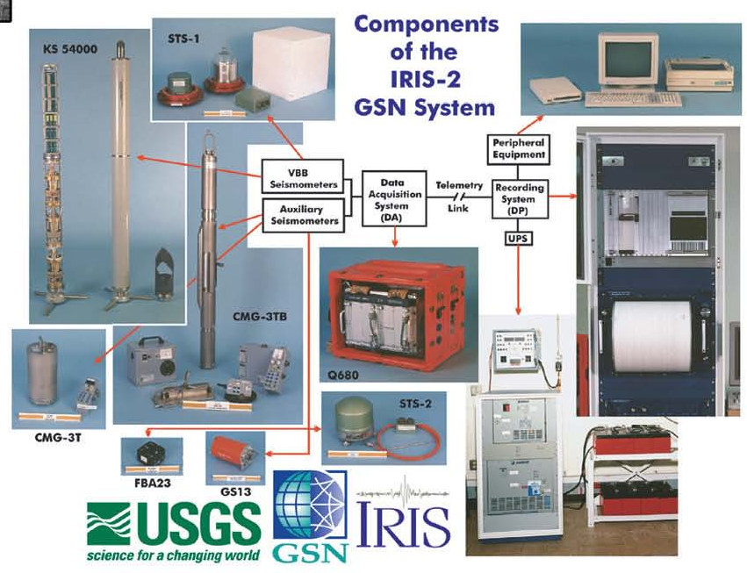
functions, format data, manage the communications interface, and store all data to a local recording medium. All GSN data are locally recorded for trans-shipment to a Data Collection Center, serving as back up when a real-time telemetry link exists. Established for seismology, the GSN infrastructure now serves as host for the world's largest microbarograph infrasound network, one of the major global GPS networks, as well as for geomagnetic and weather sensors.
GSN stations are deployed to provide uniform Earth coverage. Local noise conditions vary dramatically. Sites have been selected to achieve the best possible quiet noise conditions, while balancing cost and logistical considerations. In general, underground siting is best-getting away from wind-generated and diurnal temperature influence-if one can avoid groundwater and noisy pumps. Hard rock provides for the best coupling of the sensor to the Earth. Sediment sites tend to trap high noise into the layer, and also have spurious local resonances. Boreholes work effectively to reduce long-period (>20 sec) horizontal noise on both the continents and larger islands, and also reduce high-frequency noise (>3 Hz) though not as dramatically. However, ocean loading effects on very small islands and atolls produces additional long-period noise that is not mitigated by a borehole deployment. Noise level in the "microseism" band from about 2 Hz to 20 sec is generated by the oceans and is not mitigated by installation depth. Here the distance from the sea is the determining factor, with the best sites being within the continental interiors. Many GSN stations are deployed in a split configuration where a local radio link exists between a remote seismometer/digitizer, deployed for low noise conditions, and the computer system located at a local host organization where local personnel are directly involved in the operation and maintenance of the system.
GSN and Monitoring

As the GSN has become a real-time network, its data are routinely now used by operational monitoring groups, both in the U.S. and internationally. Nineteen GSN stations in the U.S. form a core for the USGS Advanced National Seismic System. The National Earthquake Information Center receives data from all real-time GSN stations globally. Twenty-one GSN stations now participate in the Comprehensive Test Ban Treaty International Monitoring system, nearly 50 will when communications arrangements are completed. The GSN is used by AFTAC to augment data from its U.S. Atomic Energy Detection System (AEDS). The Pacific Tsunami Warning Center uses data from over 75 real-time GSN stations, distributed globally. The Japan Meteorological Agency augments their own stations with selected GSN stations for their tsunami warnings. The twelve GSN stations in Russia and the Ten in China form a core for their respective national seismic networks. Canada, Australia, and Kazakhstan link to real-time GSN stations in their respective countries to augment their national networks. In 2004 the GSN became an official contribution of the U.S. as an observing system component of the Global Earth Observation System of Systems.
Global telemetry, which was a dream when the GSN began, has become a reality today through steady development, with more than 80% of the stations now available through real-time connections. The GSN was a pioneer with open, dial-up data from its first stations. When the Internet became available, the GSN immediately began linking its stations, and helped to bring the Internet into remote regions of the world, from Siberia and Mongolia to Gabon and the Galapagos. The first GSN satellite link started in 1990 between the Soviet data collection center in Obninsk near Moscow and the IRIS/IDA facility in La Jolla using a large INTELSAT C-band system. With the advent of the very-small-aperture terminal (VSATs) and growth in available satellite circuits, GSN moved rapidly to utilize this new infrastructure, both through direct application of GSN funds and through a wide range of national and international collaborations. There are now VSAT links to GSN stations on all continental and oceanic regions.
As the eponymous global network for seismology, the GSN's history is internationally written. Through IRIS, the GSN is a founding member of the Federation of Broadband Digital Seismic Networks (FDSN), which has served to help coordinate siting of global stations among member networks and to establish an international data exchange format for seismic data (SEED). The GSN cooperates internationally through its individual relationships in cooperation with over 100 host organizations and seismic networks in 59 countries worldwide. Many GSN stations are cooperatively operated as part of joint international collaboration with other FDSN member networks, or as a part of the national or regional networks within the host nation. The GSN has established Affiliate stations-initially BFO Germany, BTDF Singapore, and LBTB Botswana-with organizations that provide all of the necessary equipment to meet GSN design goals, and fund their own operations and maintenance to GSN standards. Cooperative efforts result in the contribution of seismic equipment, telemetry, and other support in kind that has enhanced GSN stations above and beyond the funding from the United States. International partners include Network operators in Australia, Botswana, Canada, China, France, Germany, Great Britain, Italy, Japan, Kazakhstan, Kyrgyzstan, Korea, Mexico, New Zealand, Norway, Peru, Russia, Singapore, Spain, and others.
On the broadest level, each GSN station represents a formal international partnership. In establishing the GSN, the IRIS has entered into a wide range of agreements, from formal government-to-government documents to "a handshake", which illustrate the flexibility with which IRIS can act in serving and furthering its scientific programs. With the first signs of glasnost and with the eventual breakup of the Soviet Union, IRIS and its university members were able to move quickly and effectively to establish the first new GSN stations in this vast territory. With private funding from the Green Foundation through UCSD, the IRIS/IDA component of the GSN was been able to establish a seismic station in Pakistan, even when formal government channels were blocked. With two Network Operators, IRIS has been able to finesse regional conflicts such as the Argentine-Falkland dispute by operating its Argentine station through USGS and the Falkland station via UCSD.
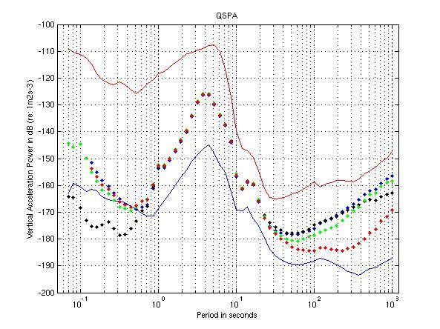
The GSN has been and continues to be a major participant in the nuclear treaty monitoring. Prior to the Comprehensive Test Ban Treaty (CTBT), 44 GSN stations participated in United Nations Conference on Disarmament GSETT-3 verification monitoring experiment. Over 50 GSN stations have been designated in the CTBT as sites for participation in the seismic component of the International Monitoring System (IMS), and the GSN is working actively with IMS to link its stations to the International Data Centre.
The GSN has collaborated, with financial resources from IRIS member universities, to establish higher-density of the coverage of the GSN within the United States, which serve as core infrastructure for the U.S. Advanced National Seismic System Backbone, and a framework for the USArray Project of EarthScope.

Current Status

Stations
The GSN now consists of 137 stations. During the past 5 years, 19 sites have been added to the Network. Three of these stations are collaborations with FDSN partners who contributed equipment, including Raoul Island and Funatfuti in the Pacific (with NEID Japan) and Tristan da Cunha (with GEOSCOPE France). Site preparations on Raoul Island and Tristan da Cunha were coordinated and co-funded through CTBTO IMS. Three arrays in Alaska, Texas, and Wyoming, and two stations in the Aleutians and Antarctica joined the GSN as Affiliates, which are independently operated and maintained by the U.S. Air Force Technical Applications Center. An array in Nevada operated by IMS and Southern Methodist University joined as GSN Affiliate. These Affiliate sites meet GSN design goals, and data are distributed via the IRIS DMS as a part of the GSN. An additional site at Scott Base, Antarctica-which serves as a backup to the AFTAC Vanda site- has joined the GSN via the USGS.
In addition to the new sites near McMurdo, Antarctica, a new site at the South Pole, QSPA, was installed 8 km from the Pole as part of the South Pole Remote Earth Science and Seismological Observatory (SPRESSO). Because of seismic noise levels had increased dramatically with human activity at Amundsen-Scott Base-where the seismic station has been the longest continuous scientific project since IGY in 1957-working with NSF Polar Programs the GSN established a new "Quiet-sector" to insure minimal noise conditions. Deploying seismometers in boreholes over 250m deep in the ice minimizes noise due to wind and other sources, which gets trapped in the low-velocity, soft ice/snow at the surface. The site, linked by electro-optical cable to the Pole, achieved the world's record for quiet seismic background noise above 1 Hz, where it is over 10 dB quieter than any other place on the planet.
More complete legend needed:
QSPA noise, from; copied on April 13, 2005 from http://ida.ucsd.edu/Noise_Study/results/QSP

PA.html
More
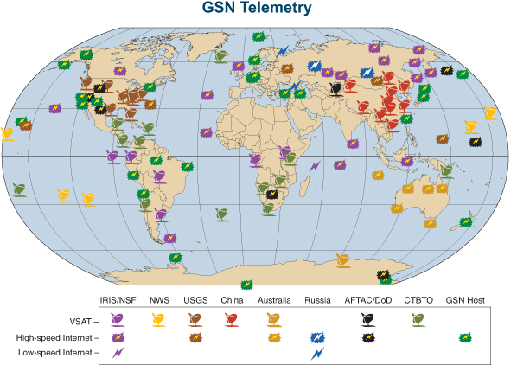
Two GSN stations have closed. The South Pole site SPA has been replaced by QSPA. GSN is working with IGN Spain to relocate the Canary Islands station, which was closed due to environmental difficulties in operation.

Telemetry
GSN real-time communications have experienced extraordinary, revolutionary improvements in the past 5 years. The network has evolved from one primarily based on telephone dial-up and tape-based media with less than 25% real-time coverage, to a dominantly real-time network with over 80% of the stations real-time-capable. These tremendous strides have come without concomitant cost increases, primarily through resourceful partnerships both national and international. GSN has benefited from the overall growth of the Internet, which has brought local Internet Service Providers (ISP) into closer proximity to some GSN stations, and has improved backbone transfer speeds. The two figures show both the extent of GSN communication improvements as well as the diversity of the communications providers that the GSN utilizes.
Establishing Internet links requires active efforts by GSN field teams canvassing local possibilities during site visits and arranging for the "last km"-setting up the radio, leased-line, or other access connection between the ISP and the site. In Australia, these have been aided by the direct efforts of our partner, Geoscience Australia, which also helped set up a satellite link to their Antarctic base at Casey. In Russia, where IRIS helped establish the basic infrastructure to our stations in Siberia, GSN has seen improvements in connectivity and lower costs as more people and commercial traffic joins the shared Internet. Additionally, the Russian National Network provides leased-lines from GSN sites to their Network Operations near Moscow, which forwards the GSN data to the Internet.
The GSN has expanded its VSAT coverage in South America, started in the late 1990's. Multiple inbound routes share a common outbound route via the GSN hub in Houston, packaging and lowering satellite link charges to the group of stations. This also provides for easy data sharing for Ecuadorian partners between sites in Galapagos and Ecuador.
Working with VSATs and a satellite hub provided in our cooperative partnership with Japan's National Research Institute for Earth Science and Disaster Prevention (NIED), the GSN has arranged with the National Weather Service (NWS) to provide GSN data from 5 sites in the Pacific directly to the Pacific Tsunami Warning Center (PTWC) on Oahu, Hawaii. NWS pays for the satellite link charges, and PTWC hosts the GSN Hub earth station. Data are then relayed onto the Internet from PTWC. This link serves PTWC as a direct data source for tsunami warning in the event that Internet connectivity to the mainland US (and other GSN data sources) is temporarily lost. One of these VSATs was deployed on Pitcairn Island, where GSN has also arranged for access to Internet service for the local school and Pitcairn Islanders (a service which GSN has provided elsewhere in the Network for our host friends).
The USGS Advanced National Seismic System provides both the VSATs and satellite connectivity to 8 GSN sites in the United States. GSN and NASA/JPL/UNAVCO share connectivity and maintenance from our joint VSAT installation site in Uganda. U.S. Department of Defense circuits bring their GSN Affiliate stations and arrays to IRIS DMS, as well as funding the link to our GSN station in Pakistan through Norway. NSF Polar Programs provides communications links to GSN sites in Antarctica at McMurdo, Palmer, and South Pole.
The GSN first proposed real-time links to our 10 joint stations with the New China Digital Seismic Network and then collaborated with our Chinese partners in connecting their VSATs to their National Network System. For ten months, the benefits of real-time data were enjoyed by all. However, China then revoked access to 4 sites and delayed transmissions for 100 minutes at the 6 others (all data still flow unfettered to the Chinese National Seismic Network). GSN has been working with the international community to re-open access, but the challenges remain in convincing the "relevant authorities.
Starting in 2000, the GSN initiated discussions with CTBTO on joint uses of their Global Communications Infrastructure (GCI) being established to bring data to their International Data Centre in Vienna. Over 50 GSN stations were to become participants in the IMS as Auxiliary Stations with VSAT equipment. Under the Treaty, however, IMS could provide no operations and maintenance support for its Auxiliary Network, even though high data availability was required. GSN noted that to provide for reliable data, access to the data streams were a necessity for the Network Operations. At the same time, GSN noted that it made no sense for CTBTO and GSN to be installing VSATs side-by-side in remote locations. This concept of "GCI sharing" was carefully nurtured to fruition over several years through a series of phased implementation tests to establish the practicality and security, as well as through the Working Group B and Preparatory Commission political structure of the CTBTO. The concept was formulated not only for GSN, but also for FDSN and other potential users.
The arrangement is very helpful to the GSN. CTBTO provides the purchase, installation, maintenance, and satellite circuits for the GCI. GSN works with IMS to install their computer connected to the GSN stations (which formats and authenticates data to their CD.1 protocol), which forward data to Vienna. In a parallel flow over the same circuit, all GSN data channels are forwarded over GCI to a virtual-private-network (VPN) link to the GSN Network Operators in Albuquerque and San Diego. The GSN data utilizes "spare" extra capacity that is built into GCI system. While this lower priority does sometimes create bandwidth limitations, which are being addressed now and under this proposal, the free access to this global communications system is a remarkable achievement. Currently 18 GSN sites that are IMS Auxiliary Stations use the GCI sharing. In addition, through a close cooperative, working relationship with CTBTO, GSN also has access to GCI sharing at the GSN sites in Kenya and Tristan da Cunha, which are co-located with other IMS stations. Finally, at our Seychelles Island GSN station, which is not co-located with any IMS facility, GSN has been permitted to use the shared GCI, after purchasing and installing our own VSAT, working with Hughes Network Systems (the GCI contractor). GCI sharing is in part recognition of the extraordinary resource that the GSN brings-its data, equipment, stations, and Network operations-to CTBTO, which is complemented by their extraordinary communications infrastructure.
The diversity of GSN communications is both a positive attribute as well as a challenge. By having redundant communications infrastructure in large parts of the world, if a particular component-whether the Internet, or a satellite circuit, communications provider-goes down, the GSN still has other nearby sites utilizing alternate communications providing the real-time data. This avoids being "blinded" suddenly in all of Africa or the Pacific, for instance. However, this benefit requires the dedication of Network personnel and resources to work with and manage the diversity of the communications resources that the GSN uses.

Review
The Global Seismographic Network underwent two significant reviews during the last five years. The first was an internationally constituted, external review in 2003 mandated by NSF as part of its five-year Cooperative Agreement with IRIS, to "Carry out and report by July 1, 2003 an in-depth study of the operation, personnel and instrument costs, and support of the Global Seismographic Network, in collaboration with NSF, USGS, representatives of the Federation of Digital Seismic Networks (FDSN) and GSN network operators." The second was the giant (Mw~9.0) Sumatra-Andaman earthquake of December 26, 2004. In both instances, the GSN's performance was viewed as exemplary.
The Review Committee of the Global Seismographic Network (RCGSN), Chaired by Henry Pollack of the University of Michigan, met in February 2003 in Albuquerque NM and La Jolla CA, with site visits to the GSN Network operators, USGS/ASL and UCSD IRIS/IDA, respectively. The charge to the committee included 1) to provide an assessment of the operational quality and state of health of the GSN, 2) to provide recommendations and advice to the IRIS Executive Committee and President and to the National Science Foundation on ways to maintain the quality and improve the operations, efficiency and scientific return of the network, and 3) take a long-term perspective and consider how to ensure the continued viability of the network and quality of operations over the next decade. Key questions that the RCGSN addressed included 1) GSN Goals, 2) Technology, 3) Management, Coordination and Oversight, 4) Costs, 5) Partnerships, 6) GSN expansion, 7) Data Management. On April 15, 2003, the RCGSN issued its report (full text and IRIS' responses to questions be found on-line at www.iris.edu/webaddress__). In its introductory remarks, the RCGSN state, "At the outset the Review Committee is obliged and pleased to note that this community enterprise, the GSN, has been an extraordinary success. The establishment of a high-quality global digital network has been achieved, and it now serves as the primary source of data for seismologists worldwide. This data has revolutionized the solid Earth sciences. It is becoming ever clearer that understanding the way our planet works requires a whole-Earth perspective, and the highly successful GSN, along with the International Ocean Drilling Program, illustrate the immense value that international research facilities present to the entire Earth science community."
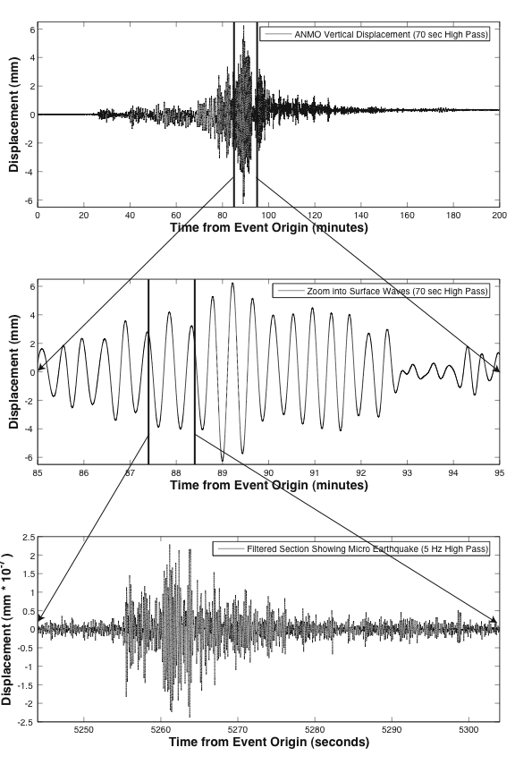
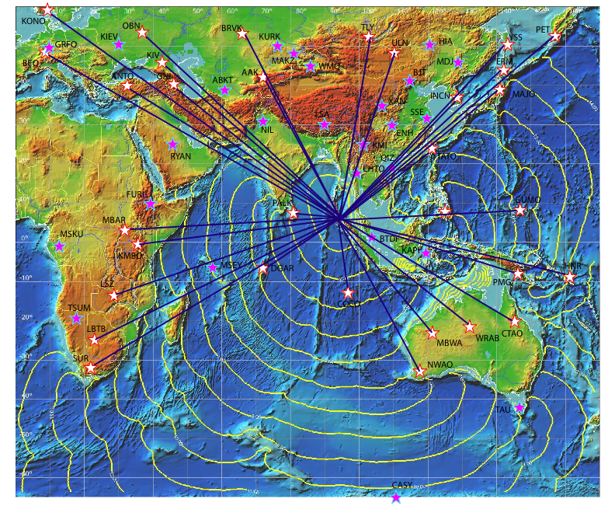
The GSN has taken specific steps toward implementing the recommendations of the RCGSN. Recognizing that the GSN is essentially completed, focus is shifted towards operations and maintenance, while coordinating internationally with efforts to improve coverage on land and within the oceans. Standardization of equipment and closer collaboration between GSN Network Operators has begun, starting with a review of GSN design goals (www.iris.webaddress___) and selection of new proto-type data acquisition systems to be jointly installed and maintained. Along with the IRIS Instrumentation Committee, GSN continues to be a proponent of developing a new ultra-long-period sensor to replace the STS-1, a key GSN sensor which is no longer in manufactured. In the short term, the GSN has arranged for equipment swaps for STS-1s (China), and is developing a pressure/temperature/magnetic shielded deployment mode for the STS-2 to improve its ultra-long-period performance. The GSN continues, unabated, its growth toward 100% real-time telemetry, and already provides the core data to tsunami warning efforts. Five new collaborative GSN sites have been installed with FDSN partners. AFTAC arrays and stations are now affiliated with the GSN, and an AFTAC observer participates on the GSN Standing Committee. The recent closure of the GSN site SPA at the South Pole in favor of the site QSPA in the Quiet-sector 8 km from the Pole reflects the GSN continued commitment to improved station quality. An EOS reference article on the GSN (Butler et al, 2004), and press coverage on the GSN subsequent to Indian Ocean tsunami have favorable placed the GSN in the media. A GSN Operation Manager has been hired to oversee network operations and maintenance, to establish standard equipment, practices, and costs, and to examine new efficiencies and approaches for GSN reliability.
GSN map of stations used by the PTWC centered on Sumatra, with tsunami one-hour isochrons (yellow contours). Stations marked with white stars were available in real time while pink stars indicate GSN stations with no (or delayed) telemetry. Seismic travel times to the GSN stations (paths marked with blue lines) were on the order of 3 to 15 min for the stations shown. Therefore the seismic energy greatly outpaced the tsunami wavefront.
Local microearthquake recorded on same record as Mw~9 Sumatra-Andaman earthquake. a) The first three hours of seismic waves from the Sumatra event recorded at ANMO Albuquerque, New Mexico at 136°Δ from the epicenter with a peak-to-peak maximum ground displacement of ~1.25 cm. b) Time expanded view of the surface energy arriving ~85 minutes after the event origin. c) High-pass filtered version of the data with clear P and S microearthquake arrivals from a local event with a peak-to-peak ground displacement of ~440 picometers (~30 million times smaller than surface wave displacement). This small event occurred ~25 km from ANMO with a duration magnitude of ~0.5. This clearly shows that local and regional data recorded during the Sumatra event are not lost due to dynamic range limitations. The GSN was able to record all aspects of the Sumatra wavefield while still providing valuable data from concurrent events.

The second and in some respects, more challenging, review of the GSN was the giant Sumatra-Andaman earthquake, which struck without forewarning on December 26 during the holiday season. As the largest earthquake since the 1964 Alaskan Earthquake, this event was the canonical earthquake for which the GSN was designed and engineered to record with full-fidelity. The disastrous tsunami generated by this megathrust earthquake focused the interest of the world on seismology and tsunami warning. During the January 14 press conference announcing the President's new Tsunami Warning System, the GSN had a sufficiently prominent role that John Marburger III, Science Advisor to the President, mentioned the "Network of the Incorporated Research Institutions for Seismology".
The performance of the GSN during the Sumatra earthquake was favorably reviewed by Park et al (2005), but the truest measure of the GSN's success rests in the extraordinary number of papers resulting from the data gathered by the GSN. The broad measure of GSN performance for the Sumatra-Andaman earthquake can be judged with respect to its Design Goals for which the network was engineered. At the time of the event, the GSN extended to 137 stations worldwide, providing truly global coverage, and supplemented with other FDSN stations, there were over 200 broadband sites available for global studies of the event. Equipment for the GSN stations was selected to create redundancy, and all sites have multiple sensor packages. The equipment operated under widely diverse environmental conditions from the polar to equatorial regions. The remarkable fidelity of GSN stations is displayed in the figure from Park et al, 2005. With this particularly large earthquake there were instances of clipping in sensor transducers before their expected full scale, but no data were lost due to this clipping as other on-site sensors recorded in full fidelity. Of the 125 stations under the operational control of UCSD and USGS, more than 88% (110) were functional at the time of the Sumatra-Andaman earthquake. "Nonfunctional" stations include cases where clipping or nonlinear waveform response marred a small portion of the record. Although the one seafloor station (H2O) was down for maintenance during the Sumatra-Andaman event, in previous instances H2O has recorded high fidelity seismic and hydrophone data, and possesses both the pressure gauge and current meter for detecting and measuring deep-water tsunamis.
Of the 137 GSN stations at the time of the Sumatra-Andaman event, 114 or 83% were equipped for real-time telemetry. Of these, 88 stations (64%) provided real-time data feeds. The remaining 26 telemetered stations were not available in real-time for this event due to delays in transmission for technical and political reasons, or simple failure. The only real-time capable stations that recorded the event, but did not contribute to the early alert were stations in China, which are subject to 100-minute telemetry delays imposed by the Chinese government. Using dial-up protocol following the initial NEIC alert, an additional 7 stations, or 95 total GSN stations were available within 89 minutes of the event origin time. These data were available in real-time not only to the USGS National Earthquake Information Center (NEIC) and NOAA Pacific Tsunami Warning Center (PTWC), but also, via the IRIS DMC, to anyone with access to the public Internet.
The availability of real-time data has emphasized an essential role for the GSN in global earthquake hazard and tsunami monitoring. Until the 2004 Sumatra-Andaman megathrust earthquake, however, the tsunami warning system had not responded to an earthquake that rivaled the massive, tsunamigenic 1960 Chile (Mw=9.5) and 1964 Alaska (Mw=9.2) events. The GSN data usage timeline (Park et al, 2005) for the Sumatra-Andaman earthquake underscores the GSN's essential role in the evolving understanding and response to the event as the seismic waves propagated outward from the source region. Using its real-time data, the Pacific Tsunami Warning Center (PTWC) and National Earthquake Information Center (NEIC) were able to respond immediately as seismic energy reached successive GSN stations. Indeed, 74 GSN stations were monitored in real-time by PTWC, and 86 by NEIC for the Sumatra-Andaman event. The PTWC geophysicist on duty observed the signals as they arrived at station COCO (Cocos Keeling Islands), the closest GSN station to the epicenter, three and a half minutes from origin time. The first PTWC automatic alert (Mw~8.0) was triggered by two GSN stations in western Australia, MBWA (Marble Bar) and NWAO (Narrogin), and was actually issued prior to the end of the rapid, tsunamigenic portion of the long fault rupture (< 600 sec, Lay et al, 2005). The initial NEIC alert was based on real-time GSN data recorded in Mongolia, Japan, Australia, Korea, Guam and Taiwan. NEIC was able to generate automatically the first hypocenter estimate 2.5 minutes prior to the seismic waves reaching stations in the continental US. These immediate alarms and solutions were performed solely on the basis of GSN data. As the waves continued to propagate around Earth, more GSN data were used to refine the initial estimates as more energy was recorded. With the size and complexity of this earthquake, standard automatic procedures were inadequate to estimate its true magnitude. This required the collection of more than one hour of data, as well as the intervention of a human analyst. A Harvard centroid moment tensor solution with a magnitude of 8.9 was calculated and distributed four hours after the earthquake (revised to 9.0 nineteen hours after rupture onset).

The Next Five Years
In the next five years, funding is requested to continue the extraordinary scientific mission of the Global Seismographic Network. From a vision twenty years ago, the GSN has grown into the essential, fiducial framework for global seismological and geoscientific studies of our planet. This state-of-the-art facility serves not only science, but also benefits mankind. With the advent and incorporation of real-time telemetry into the system, a concomitant and incipient monitoring mission for the GSN has naturally evolved. Designed to record with full-fidelity all seismic signals above the quietest Earth noise, the GSN is fully capable for nuclear treaty monitoring, tsunami warning, and global earthquake and volcano monitoring. GSN data have become fundamental for these operations. This recognition of the GSN's role as a societal benefit is evidenced in its designation as a U.S. observing system contribution to the Global Earth Observing System of Systems (GEOSS). Notwithstanding these monitoring responsibilities, the GSN remains at its core a scientific network, and this scientific vision in designing the network and its instrumentation has engendered its multi-use capabilities. To keep this core strong and vital, the GSN must look both inward and outward.
Operations and maintenance (O&M) of the GSN is the sine qua non of success. Improved productivity will be achieved through greater integration and collaboration between our IRIS/IDA and USGS/ASL network operators, initiated through the joint incorporation of low-power, standardized data acquisition equipment throughout the GSN. Enhanced O&M support for the GSN through USGS/ASL from Congressional action following the Indian Ocean tsunami is welcomed. Internationally, through collaboration, the GSN's maintenance burden may be shared with Nations (particularly those of the first world) which host GSN stations, operate comparable equipment in their respective national networks, and achieve the GSN's high standards for data availability and quality. However, the GSN cannot be sustained scientifically simply through maintenance. The development of new seismic instrumentation must be fostered to meet the needs of the science. This recognition focuses IRIS's NSF funding request for the GSN to engage in the development of the next generation GSN seismic sensors to replace aging equipment, which are no longer manufactured or increasingly difficult to maintain. Spectacular GSN telemetry growth was achieved in the past five years through modest investment of NSF funds. The GSN will focus the next five years toward continuing to leverage funding from other national and international interests in open GSN data to achieve growth toward 100% coverage with robust telemetry. Not only must the equipment of the GSN be maintained, but also the physical infrastructure. GSN data quality will be improved through upgrading infrastructure at sites, or through closing and relocating stations. Shared GSN telemetry and infrastructure continues to be the foundation for the GSN's geophysical observatory efforts. Innovation grants to Universities harness the breadth of talent of this community for GSN.
The GSN has lead efforts in establishing GSN stations and scientific observatories on the sea floor-the Hawaii-2 Observatory, H2O-and in the remote Antarctic ice-the South Pole Remote Earth Science and Seismological Observatory, SPRESSO-through successful collaboration with both NSF's Division of Ocean Sciences (OCE) and Office of Polar Programs (OPP), respectively. Seismological coverage within the oceans is essential for the truly uniform global coverage required to study Earth. The paucity of observations within the Antarctic interior limits resolution of axial processes such as inner-core anisotropy and differential rotation with respect to the mantle, as well as Antarctic continental seismicity. Both the oceanic and the polar regions represent the frontier for improving seismological coverage of the planet. Expanded GSN collaboration with OCE and OPP is proposed during the coming 5 years to bridge the disciplinary and environmental boundaries between the solid earth, oceans, and polar regions.

O&M and Sensor Development
The strength of the GSN is not only derived from the scientific findings achievable with the high quality instrumentation, but also from dependable operations. The emphasis for the next five years will be to ensure the core of the GSN remains strong and the dependability of the data flow to the user community is assured, while beginning the upgrade of the data acquisition systems to the next generation.
The responsibilities for the core operations and maintenance (O&M) of the GSN will continue to be shared through the very successful partnership between IRIS and the USGS. The USGS supports the field operations of 85 of the GSN stations through the Albuquerque Seismological Laboratory (90 after planned installations are completed) while IRIS supports the remaining field operations through a subaward to the UCSD. The IDA subaward will concentrate on the continued maintenance of the 40 stations (42 after planned installations are completed) of the GSN that falls under their responsibility. This includes adequate staff, facilities and funds for travel, host stipends, telemetry and equipment to maintain the stations with a performance goal of 85-90% data availability. IDA will also continue to assess the condition of the station infrastructure at each location and propose upgrades and enhancements to the civil works to assure the quality of the data from these stations is not adversely affected by ageing.
In addition to the maintenance of the existing systems, the next five years will begin the implementation of the next generation data acquisition system (DAS). The selection and procurement process is currently underway and the network operators have begun working together on how to integrate the new DAS into the GSN. Based on guidance from the GSN review panel, the new DAS are to be implemented not only to keep the GSN state-of-the-art, but to also allow for a transition to a standardized GSN station design. The original approach of the GSN had both operators taking separate paths on DAS design to take best advantage of the expertise in both groups to find independent solutions to the same problem. However, as the network stabilizes, it is clear that there can be efficiencies gained from bringing the two network operators back together and coalescing their experiences into a single standardized GSN station design.
IRIS will also continue to provide for the replenishment and recapitalization of the rest of the equipment for both network operators. This is to ensure the design goals of the GSN continue to be met and the network remains at a sustainable state-of-the-art. The current equipment refreshment plan has been proven successful at improving the performance of the GSN by having spare parts available to fix station problems as they arise. However, the rate of this refreshment has only been funded to a 5% level which has the equipment replaced over a 20 year life cycle. As critical station equipment (data acquisition systems and sensors) are coming to the end of their life cycle, it is clear that the low replacement rate is inadequate to design and implement the next generation of equipment. Although the next generation acquisition systems are commercial-of-the-shelf, replacing these on a 20-year plan will not be adequate to ensure the entire network is upgraded prior to reaching obsolescence. Additional funding is required to upgrade the systems in a more reasonable timeframe. The next generation sensors pose more of a problem, as there are currently no known replacements for the primary GSN surface sensor (Streckeisen, STS-1). A complete development program for the engineering design of a replacement to the STS-1 is most likely beyond the scope of funding available for the GSN, but funds will be programmed 1) to research and evaluate sensors and sensor emplacement techniques to find a suitable replacement and 2) to work with manufacturers to guide new sensor development. There are also many STS-1’s deployed in various other networks around the world and if those other groups determine they no longer require an instrument with the STS-1 response, we will be in a position to bargain, trade or outright purchase those instruments as they become available. As a result of all these equipment related requirements, we are looking to increase the funds for equipment to ~$1.56M which equates to a ~8% refreshment rate (or about a 13 year life cycle). Although not ideal considering the challenges faced with the GSN equipment, this will be an improvement over the current equipment funding scenario and fits within the other budgetary priorities of the GSN over the next 5 years.
In addition to sustaining equipment, we must also ensure our sites remain in good physical repair. Although civil works at a site do not deteriorate as rapidly as the electronics, there are still occasions when sites need to be upgraded, reconstructed, or outright moved to ensure high quality data and operations. We will program adequate funds to repair or move a site at the rate of ~1 per year, including both USGS and IDA components of the GSN.
Communication links to stations originally established to provide data segments, state-of-health monitoring, and remote access for maintenance have evolved into a telemetry system to provide GSN data to the scientific and monitoring communities in real or near real time. Not only has this reduced the response time to identify and respond to station problems, but it also has expanded the usefulness of the GSN data as a part of global seismic monitoring systems including those for earthquake and tsunami hazards as well as a part of the Comprehensive Nuclear-Test-Ban Treaty Organization’s International Monitoring System for the detection and identification of nuclear events. As the GSN data have become so useful to these communities, they have come to rely on the dependable nature of the GSN operations. In order to continue as a useful monitoring tool, these data need to be assured. Therefore, the most critical investment we can make in the GSN is the continued strong support of the operations and maintenance.

Telemetry
The goal of the GSN is robust real-time data from 100% of the network. Our current coverage exceeds 80%, orchestrating a diverse suite of national and international, satellite and Internet arrangements. Both the bandwidth and robustness of many links need improvement to carry all available channels reliably. Following the Indian Ocean tsunami, there is strong national (via the USGS) and international interest in expanding, upgrading, and enhancing GSN telecommunications. The availability and quality of global telemetry continues to progress rapidly, driven by commercial, national, and public interest in telecommunications. GSN will focus its telecommunications funds toward collaboration with these opportunities, and will continue making improvements to its infrastructure globally.

GSN Station Enhancements and Geophysical Observatories
The GSN is not a static collection of stations. While there is recognition that data from a site collected over a long time has greater value, poor performance cannot be accepted. The goal of the GSN is to provide real-time access to excellent, very-broadband seismic data with uniform coverage from a fiducial reference global network that is efficiently operated and maintained for science. No station should be deemed sacred. Nor should stations be moved or changed precipitously. The current collection of stations and their network operator affiliation grew out of logistic necessity and historical context in rolling out the new GSN. It is time now to reflect upon the network configuration and make appropriate adjustments that will enhance the GSN goals and O&M efficiency. Efforts are underway to assess site noise characteristics and overall station importance for scientific applications. This information will guide decisions regarding instrumentation flexibility, station upgrades or relocation, and new siting.
Just as equipment must be refreshed and upgraded to preserve the quality of the GSN, the physical infrastructure of GSN stations-vaults, boreholes, buildings, etc.-requires maintenance. For a network of 137 stations diversely located in all climates and environments, problems arise which affect both GSN data availability and quality. At an average cost of $100K per station spent in building the GSN infrastructure, requested funding at $100K/yr would permit refreshing infrastructure at a rate of less than 1% of the total investment annually.
From: jsvilla@space.mit.edu
Subject: HETE-2
Date: April 1, 2004 7:04:20 AM HST
To: dlambert@nsf.gov
Cc: rhett@iris.edu, grr@space.mit.edu, roland@space.mit.edu,
gbc@space.mit.edu
Dear David,
It's been a long time coming, but we here at the HETE-2 project would like to thank you and the IRIS GSN for making internet connections to our stations at Galapagos and Gabon possible. Giving us a portion of your space segment allows our computers at these remote locations to be connected to the net, and thus relay our satellite's messages in real time. The live coverage is essential to HETE's mission, which is to alert the astronomy community of the occurrence of enigmatic Gamma Ray Bursts, or GRBs.
Rapid follow up observations (including some of the world's largest telescopes) are key to solving the GRB mystery, since these transients fade away quickly. Prior to HETE, several hours to days passed before any kind of observations were conducted, and quite often no burst source identification was ever made.
Since its launch into low earth orbit in Oct. 2000, HETE has relied on a belt of equatorial VHF ground stations to relay GRB burst alerts within seconds of outburst. The Galapagos station covers a large segment of HETE's ground path in the Pacific, and the Gabon station covers portions of Africa. One burst, which occurred on Dec. 11, 2002, was detected and localized by HETE, and the coordinates relayed by the Galapagos station within seconds. Automated cameras reacting within seconds caught the optical transient associated with the GRB, and its subsequent fading was followed by other telescopes. This GRB was a singular event in proving that so called "dark bursts" (GRBs without traceable optical transients) may well be a result of our inability to look at the GRB fast enough, and that HETE and its system of VHF stations are on their way to solving this mystery.
The current successes of the HETE program is already acknowledged within the astronomy community, and is making inroads with the public as well; Science magazine for example, has rated the discoveries directly attributable to HETE as one of the top 10 science stories for 2003. We hope that your continued support of our activities will further allow us to rapidly disseminate burst alerts, and extend the contributions of HETE to resolving the mystery of GRBs.
Best Regards,
Joel Villasenor
37-414
MIT Center for Space Research
70 Vassar St.
Cambridge, MA 02139|
(617) 252-1667
jsvilla@space.mit.edu

The vast infrastructure of the GSN serves as a platform for other geophysical instrumentation. Simplifying the power and communications interfaces will ease and enable the installation of new, co-located sensors systems, and will improve integration of the GSN as an in situ framework for GEOSS. Funding is requested to develop this standard interface for GSN stations. Continuing the installation of microbarographs throughout the network fulfills the GSN scientific quest to measure simultaneously both sides of the seismo-acoustic interface for long-period, globally propagating signals, and complements higher-frequency, infrasound array measurements made by the International Monitoring System for regional distances.

Oceans
The oceans are vast, and no one approach will achieve a substantial improvement in seismological coverage in the near term. Progress may be slow, but necessary. Collaboration and coordination with international partners are essential. To obtain the necessary logistical resources in the oceans for global seismic coverage, the GSN approach focuses toward providing seismic instrumentation for existing and planned oceanic programs, coordinating with oceanic telemetry opportunities, and collaborating with the marine mammal community. The GSN will coordinate with the International Ocean Network (ION) efforts to instrument 3-5 boreholes of the International Ocean Drilling Project (IODP) in conjunction with the ORION Ocean Observing Initiative (OOI) global network of buoys for telemetry. GSN will provide for borehole seismic instrumentation packages. The GSN will also provide and designate for global use several sets of broadband ocean bottom seismometers to be managed under the NSF/OCE Ocean Bottom Seismometers Instrumentation Pool (OBSIP). To minimize ship costs and yet provide for improved, new oceanic coverage, the sensors are planned for deployments in conjunction with routine ships which service NOAA DART buoys, ORION ocean buoys, and Antarctic bases. Through a nascent Arctic/Antarctic Cetacean and Earthquake Science (ACES) collaboration, GSN will work to achieve independent funding from NSF/OPP toward adding OBSs to existing acoustic recording packages currently being deployed by the marine mammal community. This collaboration between biology and seismology will make dual-use of ships already being used in the polar regions. All data from GSN's oceanic efforts will be freely and openly available, without any proprietary restriction. GSN will coordinate its oceanic efforts with international efforts underway in Japan, the European Union, Australia, and elsewhere, to achieve more open seismic data from the oceans for everyone.

Polar Regions
Seismological coverage of the polar region of the southern hemisphere is sparse and limited to Antarctic coastal bases, plus the South Pole (U.S.) and Dome C (Italy/France). Both the SPRESSO site cabled 8 km to South Pole station and remote VNDA station telemetered by AFTAC to McMurdo Base point to the value in siting stations away from human-generated noise. Cabling is impractical over large distances, and the VNDA thermo-electric power source is very costly and challenging to maintain (even for the Air Force). To expand GSN coverage into the Antarctic interior requires the development of an autonomous power and telemetry capability. Recent power reductions in GSN equipment engender a coordinated approach with PASSCAL and the UNAVCO/GPS community to develop a remote, autonomous power/telemetry capability. Funding for this capability, which will have substantial applicability beyond seismology, will be sought from the NSF Office of Polar Programs. GSN will provide funds for the sensors to be used for GSN deployments, coordinated with NSF/OPP logistics.
In Antarctica, a new remote GSN site is proposed in West Antarctica at either Siple or Byrd camp, where there is current logistical support during the austral summer. Additional coverage (2-5 sites) is sought between South Pole and the coast, which can be supported by fixed-wing aircraft deployed from the Pole. Over the five-years of this proposal, we anticipate phased improvements in both the power and telemetry capabilities, growing from initial summer operation with internal recording to eventual year-round operation with real-time telemetry. Initial testing can be conducted at SPRESSO. In order to shorten the development/test cycle, collaboration will be sought with the Arctic Program of OPP to utilize the existing base at Summit, Greenland, and summer camp at the North Pole.

University Innovation
Considerable talent and expertise reside in the University community, which operate state-of-the-art regional seismic networks, participate in international projects, and maintain cross-disciplinary contacts in the broader geophysical sciences. This community is an independent resource for the GSN to tap. Modest funding is requested to encourage collaborations with University partners, which will enhance the GSN program.

