San Francisco PSInSAR Study

Final Report
Dataset: RSAT S3 ASCENDING
To the attention of:
Prof Roland Burgmann
SEISMO Lab
University od Berkeley
California
Date: 28 August 2007
Ref: 06.073C

Prepared for:

SEISMO Lab
University of Berkeley
California

Reference:
Prof. Roland Burgmann

by:

Tele-Rilevamento Europa
Via Vittoria Colonna, 7
20149 Milano
tel: 02.4343.121
fax: 02.4343.1230
http://www.treuropa.com
tre@treuropa.com

Ref: 06.073C

Engineer entitled of this processing: Fabrizio Novali

Project Manager: Fabrizio Novali

Index

1 Data-Set used for PS analysis: RSAT F4 TRACK 106 4
1.1 Images discarded 5
2 PS report 5
2.1 Information on LOS velocity field and target motion 6
2.2 Velocity Field 7
2.3 Velocity Standard Deviation Field 8

Data-Set used for PS analysis: RSAT F4 TRACK 106

# | Acquisition date | Satellite | Dc * | Bn ^ | Bt [day]
1 | 20011105 | RSAT-S3 | -5,6694 | 0,283704 | -528
2 | 20011129 | RSAT-S3 | -5,5848 | -0,13525 | -504
3 | 20011223 | RSAT-S3 | -5,6347 | 0,160123 | -480
4 | 20020116 | RSAT-S3 | -5,629 | -0,10303 | -456
5 | 20020305 | RSAT-S3 | -5,6503 | 0,010943 | -408
6 | 20020329 | RSAT-S3 | -5,5899 | -0,38156 | -384
7 | 20020516 | RSAT-S3 | -5,6882 | -0,02913 | -336
8 | 20020609 | RSAT-S3 | -5,606 | 0,077344 | -312
9 | 20020703 | RSAT-S3 | -5,6449 | -0,43565 | -288
10 | 20020727 | RSAT-S3 | -5,6391 | 0,647962 | -264
11 | 20020820 | RSAT-S3 | -5,6779 | 0,412736 | -240
12 | 20020913 | RSAT-S3 | -5,6834 | 0,101131 | -216
13 | 20021007 | RSAT-S3 | -5,6267 | 0,186425 | -192
14 | 20021031 | RSAT-S3 | -5,6379 | 0,289824 | -168
15 | 20030111 | RSAT-S3 | -5,5797 | -0,10911 | -96
16 | 20030204 | RSAT-S3 | -5,6619 | -0,18404 | -72
17 | 20030228 | RSAT-S3 | -5,6053 | 0,00074 | -48
18 | 20030324 | RSAT-S3 | -5,7377 | -0,05008 | -24
19(M) | 20030417 | RSAT-S3 | -5,7093 | 0 | 0
20 | 20030511 | RSAT-S3 | -5,7097 | -0,18422 | 24
21 | 20030604 | RSAT-S3 | -5,8812 | 0,461696 | 48
22 | 20030815 | RSAT-S3 | -5,7392 | 0,184677 | 120
23 | 20030908 | RSAT-S3 | -5,6562 | 0,321644 | 144
24 | 20031002 | RSAT-S3 | -5,6039 | -0,0706 | 168
25 | 20031026 | RSAT-S3 | -5,6122 | -0,06419 | 192
26 | 20031119 | RSAT-S3 | -5,6639 | -0,301 | 216
27 | 20031213 | RSAT-S3 | -5,6811 | 0,133959 | 240
28 | 20040106 | RSAT-S3 | -5,6007 | 0,174206 | 264
29 | 20040130 | RSAT-S3 | -5,5918 | -0,31633 | 288
30 | 20040223 | RSAT-S3 | -5,5564 | 0,265594 | 312
31 | 20040318 | RSAT-S3 | -5,7144 | 0,301046 | 336
32 | 20040411 | RSAT-S3 | -5,7319 | -0,06515 | 360
33 | 20040622 | RSAT-S3 | -5,7407 | -0,02295 | 432
34 | 20040716 | RSAT-S3 | -5,6488 | 0,058116 | 456
35 | 20040809 | RSAT-S3 | -5,6357 | 0,098276 | 480
36 | 20040902 | RSAT-S3 | -5,6679 | 0,477049 | 504
37 | 20040926 | RSAT-S3 | -5,5844 | 0,120019 | 528
38 | 20041113 | RSAT-S3 | -5,5537 | 0,172156 | 576
39 | 20041207 | RSAT-S3 | -5,5272 | -0,10087 | 600
40 | 20041231 | RSAT-S3 | -5,4528 | -0,2213 | 624
41 | 20050124 | RSAT-S3 | -5,4174 | 0,284087 | 648
42 | 20050217 | RSAT-S3 | -5,6092 | -0,21846 | 672
43 | 20050313 | RSAT-S3 | -5,6039 | -0,00963 | 696
44 | 20050406 | RSAT-S3 | -5,5355 | 0,39456 | 720
45 | 20050430 | RSAT-S3 | -5,5523 | -0,2558 | 744
46 | 20050524 | RSAT-S3 | -5,7045 | 0,385623 | 768
47 | 20050617 | RSAT-S3 | -5,6474 | -0,29097 | 792
48 | 20050711 | RSAT-S3 | -5,5338 | 0,340236 | 816
49 | 20050804 | RSAT-S3 | -5,7037 | -0,27912 | 840
50 | 20050828 | RSAT-S3 | -5,6492 | -0,00972 | 864
51 | 20050921 | RSAT-S3 | -5,6664 | 0,140912 | 888
52 | 20051015 | RSAT-S3 | -5,6494 | -0,13367 | 912
53 | 20051202 | RSAT-S3 | -5,5939 | -0,10956 | 960
54 | 20051226 | RSAT-S3 | -5,503 | 0,044872 | 984
55 | 20060519 | RSAT-S3 | -5,5718 | 0,356373 | 1128
^ Fraction of critical baseline * Fraction of PRF (M) Master scene

Images discarded

Acquisition date | Satellite | Bn ^ | Dc * | Bt [day] | Motivation
19981004 | RSAT-S3 | 1.115 | -0.075 | -1656 | High Bn
20040505 | RSAT-S3 | -7.996 | 0.115 | 384 | High Bn
20040529 | RSAT-S3 | -4.117 | 0.085 | 408 | High Bn
^ Fraction of critical baseline * Fraction of PRF

PS report

Site Name | SAN_FRANCISCO_RSAT_S3_A_T38_0_BERKELEY
Customer | BERKELEY
Reference Documents
Engineer entitled of this processing | Fabrizio Novali
Project manager | Fabrizio Novali

Process Date (final result) | 28/08/2007
Software used | PSproc
Version | 3.0
Analysis type | Standard PS Analysis
Interpolation factor | 2
Satellite data used | RSAT-S3
Descending or Ascending Orbit | ASCENDING
Critical Baseline [m] | 1824.968
Pulse Repetition Frequency [Hz] | 1361.868
Number of scenes used | 55
Date range of analysis | 05 November 2001 – 19 May 2006
UTC Time / Local Time | 02:04:17

Reference data used for georeference | LandSat
Projection system used | UTM10 – WGS84
Reference Point location | NORTH: 4147315.99 EAST: 596286.76
Hypothesis on reference point motion | motionless
Extension of the Area of interest | 7500 Kmq
Number of PS identified | 191815
False Alarm Rate | 10⁻⁰⁵
Average PS density (PS/km²) | 25.58

Information on LOS velocity field and target motion

Line Of Sight Versor Coordinates | H: 0.8117 | E: -0.5730 | N: -0.1131
Tilt or phase trends have been removed during PS processing?
Files delivered | SAN_FRANCISCO_RSAT_S3_A_T38_REF.dbf SAN_FRANCISCO_RSAT_S3_A_T38_TS.dbf

Velocity Field
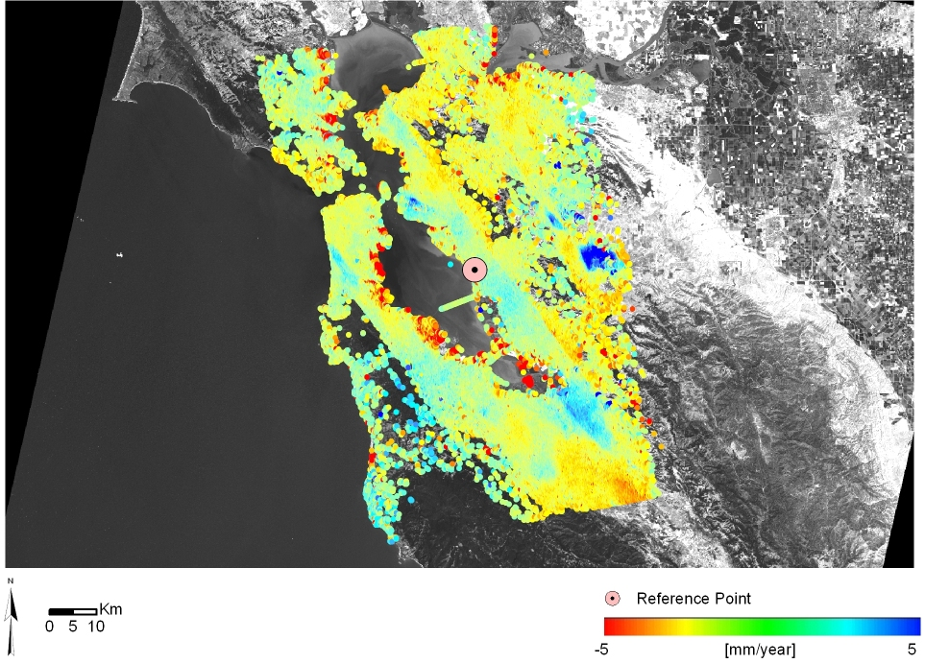

Velocity Standard Deviation Field
