

A Partnership of Earth Sciences and Emergency Management

INTRODUCTION
On the boundary between the Pacific and the North American plates, California is blessed with beautiful scenery, an excellent climate - and a long history of damaging earthquakes. In fact, California faces the highest seismic risk in the United States. The California Integrated Seismic Network (CISN) is a partnership of federal and state agencies and universities dedicated to provide information for public safety following major earthquakes and for long-term research in seismology and engineering practice.

Over the last decade, advances in technology have made it possible to improve monitoring capabilities and integrate existing, separate seismic networks into a single monitoring system. Modern seismic sensors with digital recording systems are capable of recording the full range of ground motions generated by earthquakes. Digital communications allows data to be transmitted to central processing hubs with minimal delay. New data analysis capabilities, made possible by sophisticated software, provide both faster and more accurate information for emergency response. Finally, regional networks have given way to a statewide system that emphasizes use of the same monitoring equipment and software throughout the system, as well as data sharing and redundancy.

In 2000, state funding was made available to develop the California Integrated Seismic Network (CISN), a project that incorporates the regional networks, continues the deployment of state-of-the-art equipment and provides significant benefits for emergency response. The CISN is a part of the Advanced National Seismic System (ANSS) of the USGS.

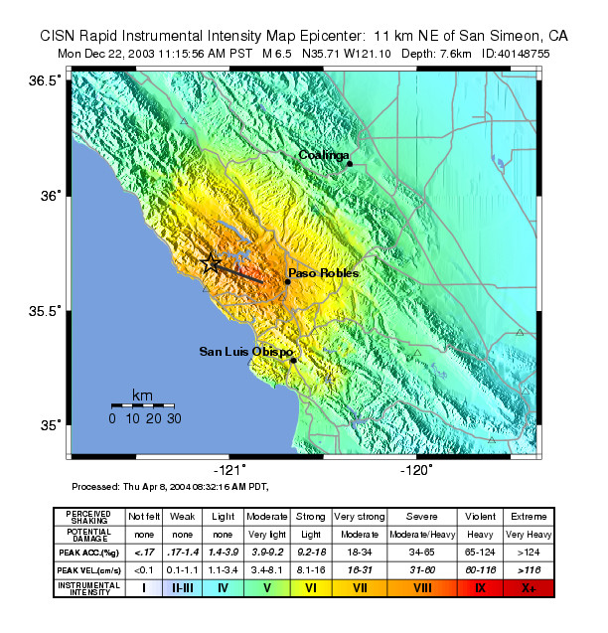

CISN ACCOMPISHMENTS

The CISN is working in several areas to improve capabilities and provide reliable earthquake information:

- Maintain the CISN dense network in southern California
- Expand and upgrade the CISN dense network in northern & central California
- Establish data processing centers in Pasadena (Caltech/USGS Pasadena), the Bay Area (UC Berkeley/USGS Menlo Park), and Sacramento (CGS/USGS NSMP)
- Operate a dedicated communications link between the processing centers and to OES Sacramento
- Standardize earthquake processing by participating networks and establish two parallel statewide processing centers

CISN PRODUCTS

The CISN is working to develop new earthquake products as well as to deliver these products reliably:

- Earthquake magnitude and location available within three minutes via pagers, email and the World Wide Web
- ShakeMap for any California earthquake over M3.5 within 10 minutes
- Rapid strong motion data for damage assessment.
- Special earthquake reports on seismological and engineering issues
- Tools for rapid alerting of earthquakes such as CISN Display and ShakeCast
- Rapid loss estimates for damaging earthquakes using HAZUS
- Exercise scenario development using ShakeMap and HAZUS

Earthquake parameters
The CISN routinely provides information about earthquakes in California within a few minutes after they occur. Information about location and magnitude is released via the Web and for larger events via pager and email. The CISN is producing ShakeMaps for earthquakes of M 3.5 and greater statewide and are posted on the Web Site within minutes of the quake. These maps use direct observation of ground motions combined with predicted values to provide estimates of the distribution of strong shaking. These maps are valuable products for the rapid identification of the areas of greatest impact.

CISN Display and ShakeCast
CISN Display provides statewide – and global - real-time earthquake information to emergency managers, other public safety agencies, and other client groups. CISN Display is a Web enabled earthquake notification system that “pushes” information to users. CISN Display provides automatic access to ShakeMap and other earthquake products as they become available. ShakeCast is a tool for the rapid distribution of ShakeMaps In addition to delivering ShakeMaps, the software allows users to define locations of interest and set shaking levels to trigger automatic notification, provide electronic notfication of events and projected intensity levels, and integrate with in-house GIS systems.

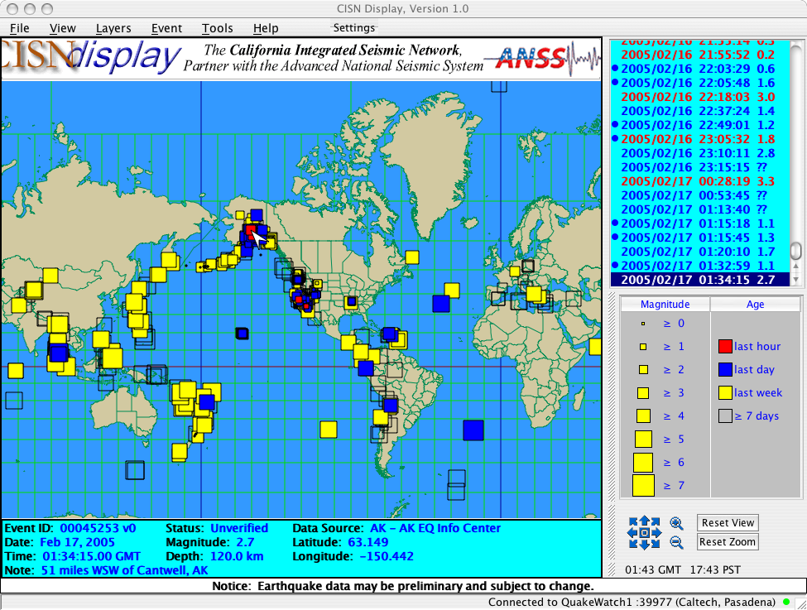

HAZUS and Shakemap
In cooperation with the CISN, OES is currently developing software and technology to provide ShakeMap information for automatic earthquake loss estimation using HAZUS. This innovation promises to provide state and federal emergency managers with early estimates of damage, casualties and the number of displaced persons needing care and shelter, and information about any special needs they may have.

RESOURCES
For more information on the CISN and CISN products, visting the Web sites below:

CISN: www.cisn.org
ANSS: www.anss.org

For earthquake information:

Recent earthquakes: earthquakes.usgs.gov
Shakemaps: www.cisn.org/shakemap
CISN Display: www.cisn.org/software
ShakeCast: www.shakecast.org
Earthquake Special Reports:
Seismology: www.cisn.org/special
Engineering: www.quake.ca.gov/cisn-edc/
Seismological archives:
Northern CA: quake.geo.berkeley.edu
Southern CA: scecdc.scec.org

HAZUS™ (Hazards US), developed for FEMA by the National Institute of Building Sciences

