

A Partnership of Earth Sciences and Emergency Management

INTRODUCTION
On the boundary between the Pacific and the North American plates, California is blessed with beautiful scenery, an excellent climate - and a long history of damaging earthquakes. In fact, California faces the highest seismic risk in the United States.

While the San Andreas fault is responsible for the majority of California’s earthquake hazard (source of the 1875 M7.9 Ft. Tejon and 1906 M7.9 San Francisco earthquakes), numerous other faults, capable of producing M6.7 and larger earthquakes, riddle the state. Both the Los Angeles basin and the San Francisco Bay area have a greater than 60% probability of experiencing a M6.7 or larger earthquake in the before 2029.

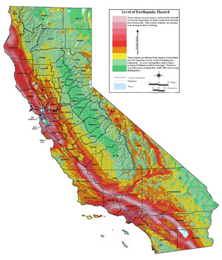

The CISN
The California Integrated Seismic Network (CISN) is a partnership of federal and state agencies and universities dedicated to earthquake monitoring and providing information for public safety following major earthquakes and for long-term research in seismology and engineering practice.

The CISN is cooperatively operated by the U.S. Geological Survey (USGS), the California Geological Survey, Caltech, and UC Berkeley. The CISN project incorporates the regional networks, continues the deployment of state-of-the-art equipment and provides significant benefits for emergency response and is sponsored by the USGS and the State of California. The CISN is a part of the Advanced National Seismic System (ANSS) of the USGS, a program for national earthquake monitoring.

CISN ACCOMPISHMENTS
The CISN is working in several areas to improve capabilities and provide reliable earthquake information:

- Integrate existing, separate seismic networks into a single monitoring system the CISN seismic dense network in southern California
- Improve the seismic monitoring infrastructure. Since 2000, over 200 seismic stations have been installed or upgraded
- Standardize earthquake processing by participating networks and develop reliable communications to improve the robustness of earthquake information distribution
- Produce earthquake products based on all available seismic data

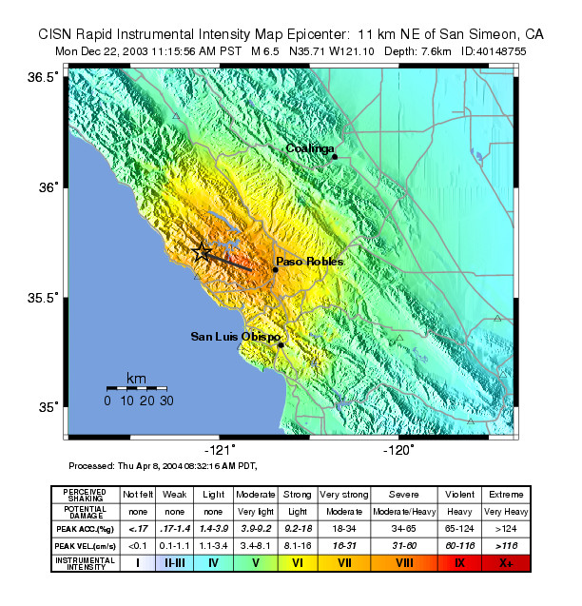 Park), and Sacramento (CGS/USGS NSMP)

CISN PRODUCTS
The CISN and ANSS are working provide rapid and reliable earthquake information and to develop new products to enhance the use of earthquake data:

- Earthquake magnitude and location available within three minutes via pagers, email and the World Wide Web
- ShakeMap for every California earthquake over M3.5 within 10 minutes

- Special earthquake reports on seismological and engineering issues
- Tools for rapid alerting of earthquakes such as CISN Display and ShakeCast
- Rapid loss estimates for damaging earthquakes and scenario development using HAZUS

Earthquake parameters
The CISN routinely provides information about earthquakes in California within a few minutes after they occur. Information about location and magnitude is released via the Web and, for larger events, via pager and email. The CISN produces ShakeMaps for earthquakes of M3.5 and greater statewide within minutes of the quake. These maps use direct observation of ground motions combined with predicted values to provide estimates of the distribution of strong shaking. ShakeMaps are valuable products for the rapid identification of the areas of greatest impact.

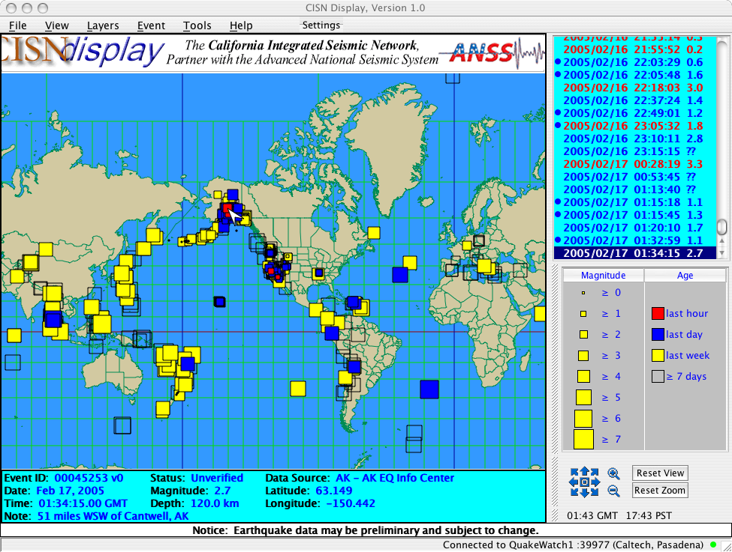

CISN Display and ShakeCast
CISN Display provides statewide – and global - real-time earthquake information to emergency managers, other public safety agencies, and other client groups. CISN Display is a Web-enabled earthquake notification system that “pushes” information to users, allows customized alerting and email, and provides automatic access to ShakeMap and other earthquake products as they become available.

ShakeCast is a tool for the rapid distribution of ShakeMaps. ShakeCast allows users to define locations of interest and set shaking levels to trigger automatic notification, provide electronic notification of events and projected intensity levels, and integrate with in-house GIS systems.

HAZUS and Shakemap
In cooperation with the CISN, OES is currently developing software and technology to provide ShakeMap information for automatic earthquake loss estimation using HAZUS. This innovation promises to provide state and federal emergency managers with early estimates of damage, casualties and the number of displaced persons needing care and shelter, and information about any special needs they may have.

RESOURCES
For more information, visit the Web sites below:
CISN: http://www.cisn.org
ANSS: http://www.anss.org

HAZUS™ (Hazards US), developed for FEMA by the National Institute of Building Sciences

