Draft Report of the
Network Architecture and Interconnection Subcommittee

5/28/2001

Table of Contents
Table of Contents 1
Executive Summary 2
Overview 3
Introduction 5
Interfaces and system hierarchy 16
Functional Design 17
Appendices 40

Executive Summary

Overview
As part of the process of developing the guidelines and standards for the establishment of the ANSS, the Technical Integration Committee formed five subcommittees to address particular aspects of the system. These included Instrumentation, Site Installation, Data Analysis and Products, Network Architecture and Interconnection, and Archiving and Distribution. Figure 1 illustrates the responsibilities of the various subcommittees in a functional diagram.
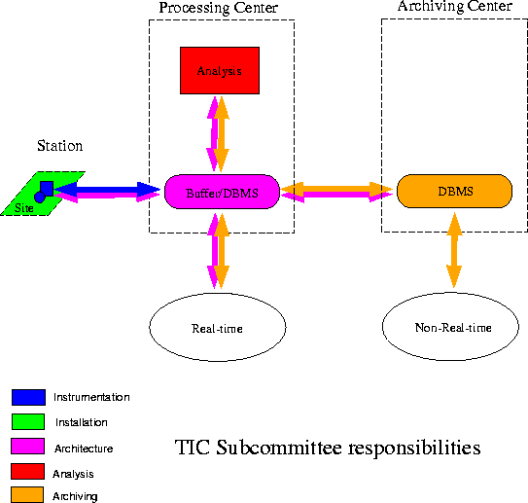
Figure 1: Functional diagram of ANSS components, color-coded by the responsibility of the TIC subcommittees. Primary elements include stations, processing centers, archiving centers, and the links among them. The white ovals indicate ANSS users.

The subcommittee on Network Architecture and Interconnection (NAI) was charged to
Develop consensus specifications for the integrated design of national, regional, and urban monitoring components and for communications among the components (sensors, data centers, and real-time recipients of data and products). This includes the technical design of communications protocols and data center design and functionality, but does not include specifications of data formats. The system should include consideration of appropriate levels of timeliness, completeness, robustness, and redundancy. The design must examine distributed data acquisition and processing, and must allow for distributed data archiving and distribution. The capability to incorporate data from sensors and networks owned and operated by other organizations should be included. Performance specifications for the data acquisition and exchange hardware/software system nationwide need to be identified.
The NAI subcommittee consists of core members from the seismological and engineering communities, representing both scientists and software developers. Membership of the committee includes:

Lind Gee, UC Berkeley, Chair
Doug Given, USGS Pasadena
Steve Goldstein, NSF
Kent Lindquist, University of Alaska
Phil Maechling, Caltech (now at Cysive Inc.)
Gary Pavlis, University of Indiana
Tony Shakal, California Division of Mines and Geology
Mitch Withers, University of Memphis

As an initial member of the committee, Phil Maechling made many important contributions to the outline and structure of the report. Although he was unable to continue participating, the committee is extremely grateful for his input. Gary Pavlis, Doug Given, and Steve Goldstein graciously agreed to join the NAI subcommittee mid-way through the process and provided valuable input during the writing process.
In addition to these participants, the NAI subcommittee was supplemented by liaison members from the Technical Integration Committee:

Tim Ahern, IRIS
Ray Buland, USGS Golden
Steve Malone, University of Washington

The NAI subcommittee released a draft report in March, 2001. Although the primary audience was the TIC, community input was invited in several ways. The NAI subcommittee presented a poster at the annual meeting of the SSA in April and advertised the report on several email lists. The NAI subcommittee began revising the report in late May.

Introduction

ANSS topology
Earthquake monitoring has a long history in the United States. From early seismographic stations in California to USGS-sponsored networks in the 1970s to the development of the TriNet project, the uneven evolution of seismic monitoring has left a complex legacy of spatially-variable infrastructure and capability. Stitching all the current pieces together into a coherent and operational system will require careful design and implementation.
In considering different ANSS topologies, the NAI subcommittee has realized the importance of establishing a well-defined nomenclature. Discussions were often complicated by differing interpretations of common terms. In particular, the ANSS is using the term regional in a different sense than has been traditional in the seismic network community. First, there are different levels of facilities:
National: Activities or operations pertaining to the Nation as a whole.
Regional: Activities or operations pertaining to one of the ANSS regions.
Local: Activities or operations in one of the participating networks in the ANSS.
Contributing: Activites or operations in networks that are not an integral part of the ANSS but that exchange data with or contribute to the ANSS in some way.
Second, there are different types of facilities:
Station: A site where seismological instrumentation (either weak-motion, strong-motion, or both) is deployed.
Data Concentrator: A facility where seismological data from multiple stations are consolidated onto high-bandwidth communications circuits.
Data Processing Center: A facility where seismological data are acquired and processed to produce summary parameters. Real-time data is pushed to critical users from the processing centers.
Data Archiving Center: A facility where seismological data are archived and where customer user requests are satisfied.
Data outlet: A facility where seismological data are interprested for emergency managers, the media, and the public.
Figure 2 presents elements of the system architecture as defined by the NAI subcommittee. Subsequent figures will draw upon the color scheme and symbology described here.
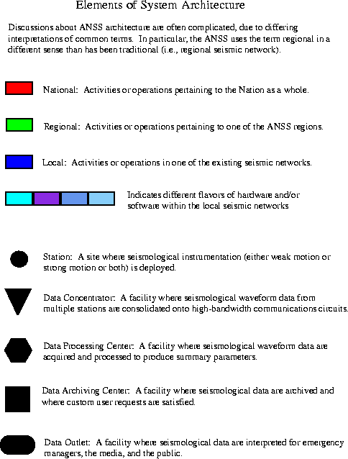
Figure 2: Elements of ANSS architecture. The colors and symbols shown in this figure will be used to illustrate different models.
Many models of ANSS architecture may be constructed from the building blocks in Figure 2. The status quo is illustrated in Figure 3, where there are activities at both the local and national level. At the local level are the existing seismic networks, some partially supported by the USGS and others not. The activities of the local networks (station operation, data processing, information distribution, and archiving) are generally characterized by a wide-range of hardware and software solutions and are not uniform across all networks. The NEIC represents the national level of activies at present, involving station operations, processing, and information distribution. All of the centers which receive some USGS funding have established data exchange with NEIC and, in some cases, with other local centers. Some local networks archive data at IRIS, while others have established local archives. The current system is a complex model, which is highly heterogeneous, with different hardware and software in the different elements or nodes, as well as highly asymetric, with different levels in the system performing different functions.
Further discussion of existing situation
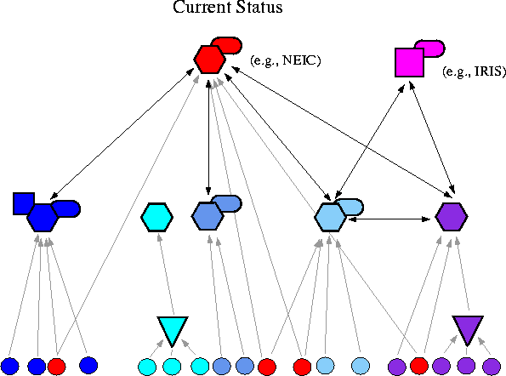
Figure 3: In the current status, the local processing centers are characterized by a wide range of hardware and software solutions. Functionality of the system elements is highly variable.
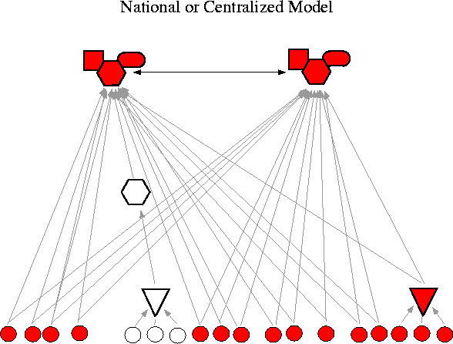
Figure 4: One end-member model for ANSS topology, illustrating a highly centralized system. All stations send data to both processing centers, which are 100% redundant.
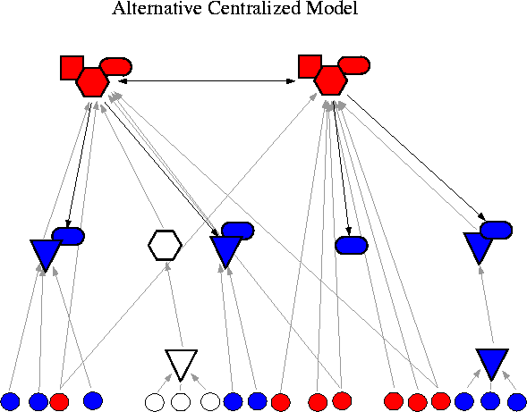
Figure 5: A variant on the centralized model, with local functions such as data concentration and data outlets.
Figures 4-6 illustrate a spectrum of possible models for the ANSS. One end member is a highly nationalized model as illustrated in Figure 4. All stations would be standardized. In some areas, local institutions would be used for data concentration in order to facilitate efficient communications. Many or all stations would have multiple communication links. There would be two (or more) national monitoring centers. Long-term archives would ideally be associated with each processing center. The model is simple, homogeneous (all ANSS nodes use the same software), and symmetric (all nodes perform the same level of processing).
Other variants on the centralized model may be constructed. For example, Figure 5 illustrates a model where local network participate in the ANSS by providing local communication points. Data are forwarded from the local networks to the national centers for processing, with or without minor local processing. Data outlets provide local intrepretation of results for emergency response operators as well as other users of ANSS data. This model is relatively simple and homogenous, but is asymmetric. Not all nodes in Figure 5 perform the same level of processing.
Figure 6 presents a more regional model for the ANSS. In this model, local networks would coordinate to create a "regional" processing center which would be the authoritative source for earthquake information within a region. While this model provides flexibility for regional variation, it introduces complexity by expanding the number of processing centers and the need for coordination among them - and with the national centers.
Within the seismological community, there are proponents for the highly centralized models of Figure 4 and Figure 5. This topology minimizes the number of tiers in the seismological hierarchy and therefore reduces the number of connections and interfaces. Processing would be highly centralized and standardized, and national earthquake products would be created uniformly and available with one-stop shopping. The issues associated with partial or incomplete views of events are reduced and the hierarchy of authority is easily defined. Because the number of facilities is limited, expensive resources such as technical people are minimized.

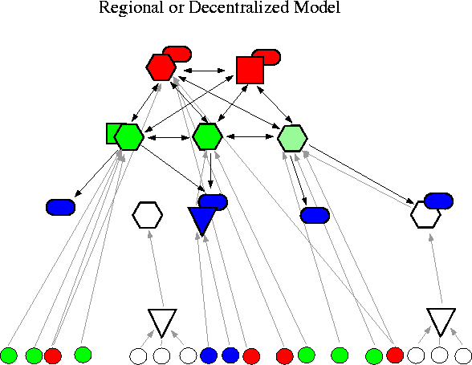
Figure 6: This figure illustrates a more regional model for the ANSS, with local networks coordinating to form a regional centers.
However, there is also strong support in the community for a model such as Figure 6, which illustrates a more regional architecture. The highly centralized model may create a large and potentially unwieldy operation, with limited responsiveness to local issues. For some, the centralized model is a deterrent to local buy-in (for example, at the state and local level). The highly centralized models do not necessarily build upon the existing infrastructure.
An important issue here is the need for evolution. The ANSS exists "now", with new stations deployed as part of the existing local networks. Whatever architecture is selected, it will be important to define a evolutionary path from the current situation to the final model, without interrupting operations. This is particularly important if ANSS funding grows slowly.
All models of the ANSS call for multiple processing centers. This is critical from the perspective of avoiding single points of failure. Therefore all models require rapid exchange of a variety of data and information products. The main difference between the national and regional models is the number of processing centers. The complexity of the system grows as the number of processing centers increases. This is particularly true if the processing centers are not clones of one another in terms of both software and input data.

NAI strawman
The final definition of the ANSS hierarchy is beyond the scope of the charge to the NAI subcomittee, particularly in terms of the number of regions. However, the NAI subcomittee has a strawman ...
The

USGS Circular 1188 recognizes a hierarchy in seismic monitoring, with multiple regional centers and national operations under the National Earthquake Information Center (NEIC).
Data processing is expected to be widely distributed, providing multiple sources of earthquake information and data. Legacy stations are an important consideration - bringing both the value of enhanced capability and the complication of added heterogeneity. Of particular concern will the issue of "authority" associated with the distribution of earthquake information.

Must the ANSS be so complex? Although some aspects of the complexity are motivated by politics and existing infrastructure, some may be justified on their own terms. In particular, the regional or decentralized model provides a natural scale for addressing issues of data quality control, scalability of processing systems, redundant reporting, data product quality control, and flexibility and responsiveness to local contacts. And it would be irresponsible to ignore the capabilities of existing infrastructure. However, the final structure of the ANSS is not within the scope of the NAI subcommittee. Instead, we use the hierarchy shown in Figure 4 to discuss the different elements - and associated assumptions - considered within the our purview.
The lowest level in any ANSS diagram is the seismographic station (red and black circles in Figure 2 and Figure 4). They may be any type of station: national, regional, or urban. Red indicates ANSS supported or funded stations, black indicates non-ANSS supported. The non-ANSS supported stations may be contributed to ANSS processing if the appropriate standards are met. The red lines indicate a communications link. The existence of ANSS and non-ANSS stations imply that the ANSS will need to address a highly heterogeneous environment.
Since seismic data are the cornerstone of the ANSS, it is likely that the consideration of system reliability will lead to the implementation of multiple communication links (indicated by dotted lines). These secondary links may be an alternate path to the primary recipient or a link to another processing center. Not all stations have multiple telemetry links but some number of critical stations do. This diagram does not differentiate between dedicated and "dial-up" communications. Certainly many sites will require continuous telemetry, but some, such as structural strong-motion arrays, may not.
The flow of data to multiple processing centers could create potential problems in terms of data loops and for determining "authoritative" copies for archiving, so the issue of tracking the path of waveform data will be important. It seems unlikely, however, that all waveform data will be processed by all centers. A more likely scenario is one where neighboring centers engage in complete - or nearly complete - waveform exchange in order to unify their view of events.
The seismographic stations will produce continuous and/or triggered time-series data. Triggered data present additional problems, particularly from the perspective of rapid earthquake processing, since they introduce a non-deterministic load on the system. In some cases, the dataloggers may output parametric data as well, such as state-of-health information, phase detections, or peak ground motions.
Between the seismographic stations and the regional processing centers, there may be one or two intermediate levels. It is likely that the need for these levels will vary from region to region. For example, in some instances data may be collected from several stations at a single point. These sites are denoted by yellow triangles and are called "data concentrators". In general, these will be unstaffed facilities, but there may be a local contact. There are two possible models for this tier. One is that these facilities just forward the data to the next level. In this case, there may or may not be local storage at this site (assuming that the dataloggers have local storage), but essentially, this level would be a telemetry collection point. A second model is that some low-level processing is done at the facility and only selected waveforms are forwarded to the next level. In this case, a system might perform subnet triggering or some type of event detection and then forward the triggered waveforms (and associated parametric data) out. This type of model might be useful in areas where it is difficult to obtain sufficient bandwidth to transmit all of the waveform data. These may or may not be ANSS-supported operations. For example, this might be a local utility that has deployed strong-motion instrumentation and is willing to contribute data to the ANSS. In another example, this might be data from a local array of stations, with a single, convenient point of outward communication.
Another intermediate level is that of a local center. This level is perhaps the least well constrained. The center may be responsible for the operations and maintenance of a number of stations, as well as for local acquisition, under the direction of a regional center. Waveform data collected by the local centers will be forwarded to its regional center and to additional regional or national centers as needed. By agreement with the regional processing center, the local center may run all or part of the earthquake processing software. The local center may perform review operations and local quality control (QC) on data from their stations. These facilities may provide local seismological expertise to the community and local technical support for operations at tiers 0 and 1. These are facilities staffed during normal hours of operation.
In terms of the scope of the NAI subcommittee, these two intermediate levels add some complexity, but do not significantly impact the system design goals. In particular, depending on the actual implementation, the local center may just be a scaled version of a regional processing center.
The regional processing center is a central hub of operations in an ANSS region and there may be more than one in a region. If there is more than one center within a region, it will be necessary to clearly define the scope of operations and authority. As envisioned, the regional center will have primary responsibility for rapid earthquake processing and notification. While the regional center will receive parametric data from other tiers in the system - and from adjoining regions - it will be the authoritative source of information on earthquakes in its region and will have responsibility for distribution of this information. It also has primary responsibility for quality control of waveform data and for maintaining the station infrastructure information. The regional processing center may or may not have a local archive, but will contribute data to the ANSS archiving facilities.
The national processing center (whose operations may be split among several facilities) is "the focal point for all seismic monitoring in the United States. . . . It should serve . . . as a backup for all regional networks and data centers. It must be able to replicate their services should a regional center fail due to a major earthquake, power loss, or other extreme event . . . ". In a truly decentralized system, one might not need a national processing center, as this “backup” role could be filled by neighboring regions. However, the United States has interests in earthquake activity outside of its borders and a national center is a logical place for this monitoring responsibility. Furthermore, many organizations with interests distributed among multiple regions may prefer to deal with a single entity and the national processing center will fill this role.
The archiving function of the ANSS may be handled in several different ways. Each regional processing center could have an accompanying archiving facility. This would lead to a distributed system, which complicates uniform and simplified access to ANSS data. In contrast, the archiving function could be centralized. At the very least, the design of the ANSS archiving facilities must address the issue of redundancy. In either case, the repercussions for the scope of the NAI subcommittee are the same: data need to be provided to the archiving facilities in a timely fashion.
An important component of Figure 4 and Figure 7 is the ANSS user community. The TIC has identified seven categories of users: global seismologist, regional seismologist, seismic hazard analyst, engineering seismologist, earthquake engineer, emergency management responder, and media/public officials/educators/general public. Another important user is the researcher or practitioner who serves as a local point of contact for the media, public, and others. Although not identified in Figure 4, the local "data outlet" is a concept that should be considered in the design of the ANSS. An example might be a seismology professor who provides advice to local emergency managers during an earthquake sequence. From the perspective of the NAI subcommittee, the paramount issue with respect to users is their need for time-critical information. As described later, the NAI subcommittee believes that it is important to differentiate between users with real-time needs (such as emergency managers) and "others". While "other" users may desire rapid access to data, we believe that there is value to identifying the core group who require real-time access. This differentiation is important from the perspective of putting predictable loads on the processing centers. This user group will drive some aspects of data delivery mechanisms because of the time-critical (and life-safety) nature of their application.
Finally, the linkages – or pipes – among the components of the ANSS are important elements of the system. Figure 4 and Figure 7 show considerable complexity in the connections among the elements - the ANSS will require both horizontal and vertical connectivity. The further up in the hierarchy, the more connectivity is required. Certainly a great deal of connectivity is anticipated among the regional centers and between the regional centers and the national centers.
The size of the connections has been the subject of some discussion. Estimates range from 50 Mbps in the worst case to 16 Mbps in the best, with differences due to assumptions about compression and continuous versus triggered data (for a discussion of this issue, please see Appendix D). In general, this problem will be largely solved by the rapidly evolving technology in networking. Where we still face limitations is in the links from the station to the processing center and at the archive. Although the communications field is evolving rapidly, the choices in remote areas, where many seismographic stations are located, are limited, often forcing choices between data latency and data completeness. In some sense, this is an expression of the digital divide, where rural seismic sites have limited communications options. Similarly, although storage technology is expanding quickly, some of the "worst case" numbers may stress current capabilities.

Assumptions
Figure 1 and Figure 4 were used to structure the thinking of the NAI subcommittee. Since Figure 1 emphasizes the role of the NAI subcommittee in forming the linkages among the many components of the ANSS, we viewed ourselves as the "pipe" committee and focused on several key questions:
Where do the pipes go?
What is in them?
What are they made of?
What is at either end?
In order to address these issues, we drew some lines and made some assumptions.
- We assume that the ANSS will be divided into a number of regions, somewhere between 1 and 10, with the potential for more than one processing center within a region. The regional centers are assumed to be responsible for processing - and reporting - on earthquakes in their geographical area. The regions are assumed to adjoin, that is, all states fall within a region. This differs from the current model of the Council of the National Seismic System (CNSS), where some areas of the United States do not fall within the boundaries of a network. This is a particularly critical assumption, as multi-source reporting adds complexity to the design.
- We assume that the ANSS will have some number of long-term archives, somewhere between 1 and the maximum number of regions. We assume that the long-term archive may be decoupled from the real-time processing center. The NAI subcommittee views archiving as a separable function that does not require collocation with the processing centers, although there may be other reasons to do so. In particular, while the processing centers will send real-time data (waveforms and parametric information) to the archives, the processing centers will not rely on storage capacities at the archives for access to these real-time data.
- One of the issues we struggled with is "What is the ANSS?" Is it a totally new system comprised of new hardware and software? The ANSS budget does not seem to allow for the development of an entirely “new” system. A likely path for the development of the ANSS is an evolution from existing systems, with new components developed to address specific problems and enhance capabilities. This has implications for the level of homogeneity within the system and raises the question of what degree of integration will be achieved.
- The NAI subcommittee has a diversity of views on the issue of standardization, particularly as it relates to software. One model for the ANSS holds that software will be identical throughout the system. At the other end of the spectrum is the model where software is compatible through the use of standardized protocols and interfaces, but is not identical. In between these extreme views is a model where much of the software is largely standardized, but local customization is allowed. Regional processing center A might choose to use location module X while processing center B uses module Y. It is clear that no one on the subcommittee recommends the identical software solution. However, there is a difference of opinion about the degree of acceptable heterogeneity within the NAI subcommittee.
- Many of the constraints on the ANSS derive from the goal of rapid earthquake notification. Early warning represents one end of the rapid notification spectrum that could drive many of the design issues. The NAI subcommittee recommends that the ANSS adopt the perspective of continuous performance improvement versus early warning. That is, focus on generating information as quickly as possible without specifically identifying their most rapid notifications as early warnings.
- Other products of the ANSS also have an impact on system design. For example, if the ANSS is to provide continuous waveform data from a subset of stations as an archived product, this has significant implications on design. The NAI subcommittee has not directly addressed some of these issues.
- While system security is important, the NAI subcommittee agreed that CTBT-level security (digital signatures, for example) is not required for the operation of the ANSS.
- The NAI subcommittee makes no distinction between weak and strong motion data. From the perspective of the pipes, a waveform is a waveform is a waveform. Network design goals for real-time strong-motion stations are in principle the same as for other seismic instrumentation. However, the majority of triggered data in the ANSS is likely to be generated from strong-motion sites and this has implications for system design. The NAI subcommittee assumes that the Data Analysis and Products subcommittee will address the issues of specialized strong-motion products, noting only that this will require additional processing modules.
- Responsibility for station quality control is assumed to be the responsibility of the local or regional authority. Issues such as calibration, instrument response, and clock quality are best addressed as close to the station as possible. The NAI assumes that the local/regional authority are the source of the infrastructure information and quality control.
- The specifications for the ANSS will evolve as the system develops. We recommend establishing a mechanism to allow changes and evolution in the technical and functional specifications as prototype efforts are evaluated and improved.
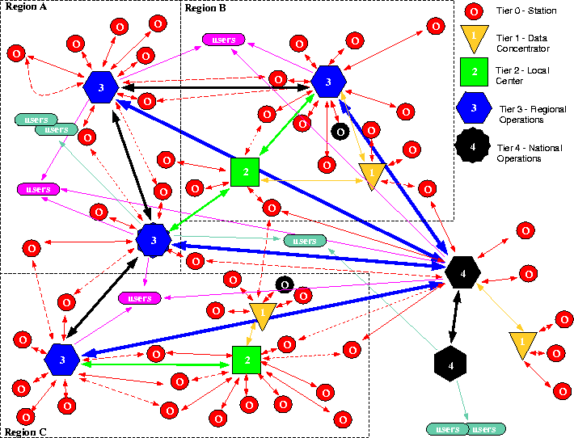
Figure 7: A map view of the hierarchy illustrated in Figure 4. This figure shows 3 adjoining regions with data concentrators, local centers, regional processing and in one case archiving centers, and national processing and archiving facilities.

Interfaces and system hierarchy

Functional Design
To address the issues of functional design, we have organized the section into several subsections:
Distribution among nodes
Distribution within nodes
Rapid Data Delivery
Interface with non-ANSS networks
To facilitate the discussion, we define some common terms:
- A processor refers to one or more integrated computers dedicated to accomplish a particular task.
- A system implies an information system composed of hardware, software, and human resources designed to accomplish a particular functional task.
- Waveform data are digital seismic data stored in a standard format.
- Control implies messages passed between human and software components of the system to change some aspect of the overall real-time data acquisition system. This includes things like instructing a data logger to change it's gain, restarting a remote data concentrator, etc.
- Metadata is ancillary information that has a relation to the pool of active seismic waveform data. This can be parametric information that is readily stored in a database or more complex data object derived from the parent seismic data (e. g. spectral estimates, shake maps, damage assessment maps, etc. )
- Database system interactions is used to imply a consolidation of all types of data transfer required to maintain and operate a distributed database. This includes simple queries and updates as well as more complex database synchronization procedures.
- A data concentrator is a component of the system that primarily relays data to and from the ANSS. These can be remote, automated sites or they may be sites monitored by humans. They may also have local processing capabilities but the results of their processing efforts are not integrated with the ANSS.
- Offline processing are those functions of the ANSS that are not fully automated and require a human analyst for verification and completion.
- A node is one or more computers at a single location that fulfill a particular function. Thus this term encompasses data concentrators and single components of the regional or national data centers.
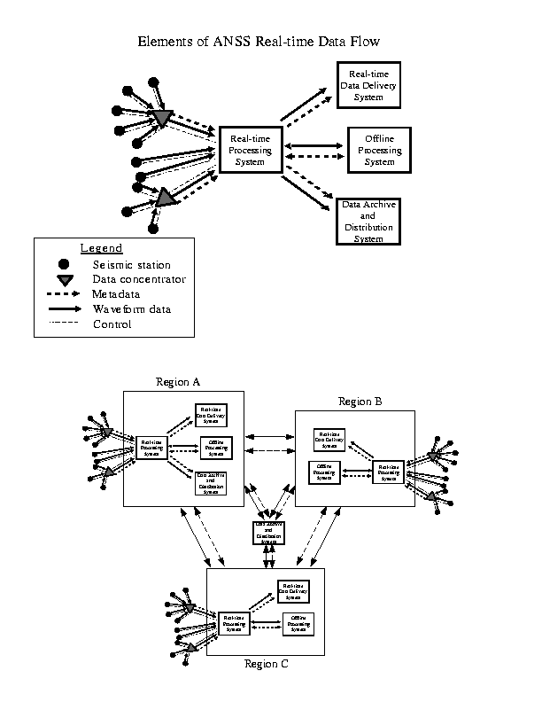
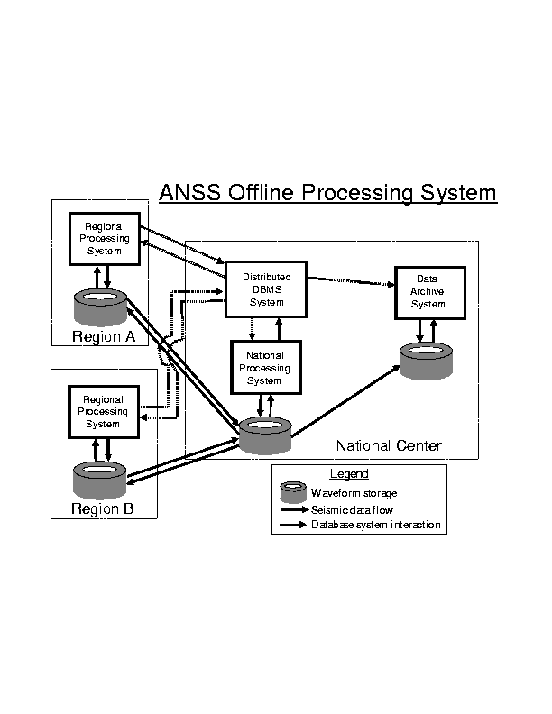
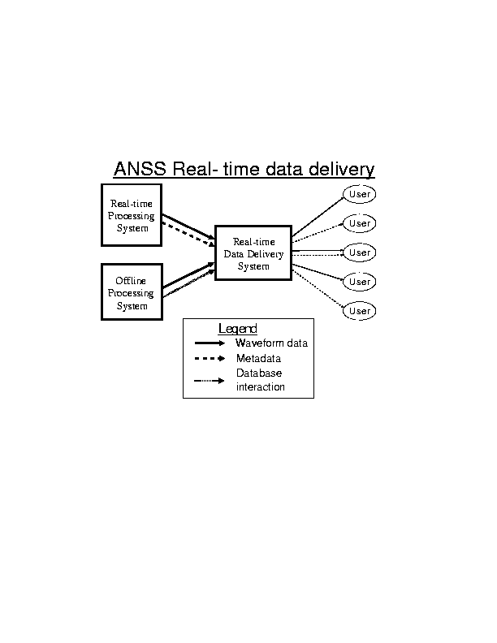
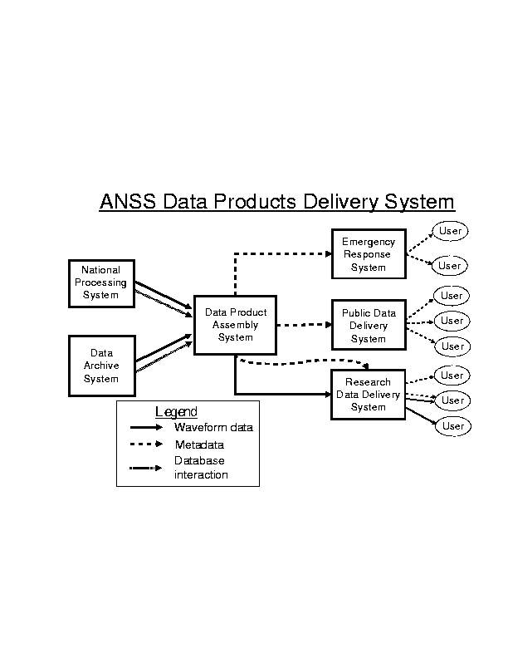

Distribution among nodes of the ANSS
Seismic data transfer. The system must be capable of error free transmission of seismic data between all nodes of the system. This mean sufficient buffering must exist at all nodes to guarantee at least one week can pass after a link goes down before any data is dropped. When a link is broken mechanisms must exist to pick up the transmission where it left off without overlap and without dropping loss of any data. The best existing model of what is required is the orb2orb program in Antelope which has a demonstrated ability to recover without loss of data from a network outage of many days.
Metadata transfers. The real time system must be capable of error-free transmission of all required metadata from the data logger to the offline processing system. Metadata that are parameters in the processing database managing system must be seamlessly integrated into the working database. Other types of metadata must be automatically indexed and saved by the overall information system that handles the real-time data flow and hands data off to the offlline processing system.
Database interaction. The regional processing systems will be linked by a distributed database management system. Several existing commercial systems exist to solve this problem, but the final system must have the following capabilities:
- Database synchronization between the national and regional centers. This is necessary to allow updates from all regional processing centers to be integrated into the national database and provide seamless interchange of data between regional centers.
- Journaling and redundant backups. To assure data are not lost in the event of a significant earthquake or other natural disaster the master ANSS database must be mirrored and backed up in at least two geographically distint locations. The DBMS must be capable of journaling to back out erroneous transaction.
- The offline processing system and the archive system must be capable of seamless mapping of data from the offline processing database into the archive database. These two systems may not have the same schema, but they must be capable of moving data from the processing system into the archive without loss of content. Furthermore, the archiving system must be capable of automatically informing automated agents at regional centers which seismic data has been archived and can thus be safely deleted from it's data holdings.

Distribution within nodes of the ANSS
The requirements for data flow within an ANSS processing center are very similar to those for communication among centers and from centers to users. Data requests are of two types: requests for continuous real-time data streams or discrete requests for data satisfying some criteria. Either of these request types may be for waveforms or parameters.
Data flow within a center may be within a single computer or among many different computers running different operating systems. This creates a requirement of platform independence for the system. These systems may be in the same room or geographically separated. Therefore, all data flow, whether within or between centers, should use the same interfaces, protocols, and formats where feasible. All data access functionality must be provided to data clients via a standard, well documented Application Programming Interface (API). This approach will reduce costs, and increase flexibility, scalability, and maintainability.
However, there are requirements specific to a data delivery system within a center These requirements are controlled by the processing function or functions with the most extreme demands for data volume, data delivery speed, and buffering (data persistence).
Data volume - The total data volume within any center attempting to process the entire ANSS data set would be greater than the volume of data transferred between any two nodes. The total data volume of a system is determined by waveform data, which is orders-of-magnitude greater than the volume of parametric data types. Therefor, the data transport system must be capable of handling all 24,600 channels of the ANSS system (Table x). The design should also allow for future expansion. That capacity may be achieved by dividing processing tasks among many instances of the same processing module; each handling a subset of the total data set. This modular "divide and conquer" approach, if correctly designed, can provide open-ended scalability.
Table 1: Total channels* and estimated data volume of ANSS
(* Station counts are based on Circular 1188)

Data delivery speed - The requirements of early warning and calculation of real-time location and magnitude dictate that data delivery delay (latency) be minimized. The data delivery system should add no latency to that already caused by delivery from the data source. Realistically, some additional latency will be caused by any store-and-forward approach. A data packet cannot be resent until it is fully received. Additional latency can be minimized, however, by designing data buffers to operate at memory speeds and by minimizing the number of "hops" in the data path.
Buffering - The system must buffer the data long enough for client applications to have a reasonable chance of successfully getting the data they need to do their work. Data buffering also allows out-of-order data to be unscrambled before delivery.
If data buffering is not provided within the data transport system, each application will be forced to provide its own. This makes the programmer's task more difficult and causes duplication of the data into many, application-specific buffers.
A two-level buffer approach has been successful in some existing systems. The first level is a buffer containing from seconds to minutes of data in a fast memory resident buffer. This serves real-time applications where low latency is the primary constraint. The second level is a disk-based buffer that has a greater latency but greater persistence (hours to days) and serves applications that value persistence over speed. The API can be designed so that this two-buffer implementation is hidden behind a single interface.
Application-specific buffers may be unavoidable in some exceptional cases. If they are needed, they should be implemented with a standard API with the same look-and-feel as the one used to interact with the ANSS data transport system.
Some applications, particularly those that are not time-critical, may benefit by accessing data from a distributed database rather than from the real-time transport and buffering system. The feasibility of this approach would depend on the requirements of the application and the timeliness and completeness of such a distributed database.
Other requirements
Standard API's - All interfaces, protocols and formats should be the same as those used between centers. If specialized interfaces are needed to meet special requirements of processing applications, these interfaces should be implemented as a single, simple, well-documented API.
Security and client management - The data transport system should manage clients to assure predictable behavior and guarantee service to mission critical clients. Authentication should be used to allow data service only to authorized clients.
System management - The data transfer components should be simple to configure, run and monitor. Tools should be provided to report and monitor the performance and load of the system.
System topology - The system topology should be flexible. It should be possible to distribute modular functions over multiple hosts and they should be free to move from host to host. There should be no single-point-of-failure. The system should be distributed across multiple host systems. All critical functions should be offered by redundant servers. Switching from one server to an alternate should be simple, fast and, where possible, automatic. The system should be able to handle additional data volume by adding modules or hosts. Dynamic load balancing would enhance the robustness of the system.
Stable load - Where possible, the behavior and resource consumption of the system should be steady and predictable. Seismic events, telemetry "glitches" or other events should not introduce spikes in the data flow.
Graceful degradation - Components should fail only under exceptional circumstances. When they do, they should fail gracefully, produce error analysis information and provide alarms to alert operators of problems. Priority schemes should be used to insure mission critical clients receive the most important data when bandwidth degrades.
Exception handling - Exception handling must be part of the API. The API must fix or report corrupted, out-of-order, or incomplete data. It must allow clients to specify and handle time-outs for data requests.
Late and Out-of-order Data - The data delivery system must accommodate both late and out-of-order data delivery. Data of this type includes triggered data, data retrieved via dial-up systems, and data delivered over slow or "lossy" telemetry paths.
Data Clients and the API
Data clients include components of the data distribution system, real-time processing modules, post-processing modules, quality control tasks, and transfer to the archive. Data requests to the system fall into two general categories:
- Requests for continuous real-time data streams of waveforms or parameters
- Discrete requests for data satisfying some criteria; for example, waveform segments, parameters for a given time period, channel response data, etc.
In both cases the system must allow the client to specify what type of data is to be sent. However, data servers should be stateless, that is, they should retain no memory of previous connections. Each new connection must negotiate the data stream.
The number of client modules in an operating center may be large. If data transport is achieved with point-to-point connections the data bandwidth required by the whole system will rise arithmetically. For example, given ten waveform clients (pickers, amplitude calculators, QC modules, etc) each waveform stream would cross the transport system ten times. This strain on resources tends to force designers to lump many functions into each module to minimize redundant traffic. This pressure to lump functions is contrary to the design goal of modularity and makes development and maintenance difficult and costly. It also limits the scalability of the whole system.
A possible solution to this one-to-many dilemma is to multicast the data. A multicast packet traversed the network only once but can be read by multiple hosts. They have no impact on non-listening hosts. This reduces the bandwidth requirement and can reduce latency. Only one process per host can listen to a multicast address. Therefore, to support multiple clients on a single host would require either multiple network interfaces or a common buffer on the host populated by a multicast listener. Some commercial messaging oriented middleware (MOM) products implement this second approach. Use of commercial, off-the-shelf products could accelerate the development process at the risk of binding the system to a single vendor's product.

Rapid Data Delivery
This section addresses rapid ANSS product delivery (Figure 1 connections between Processing Centers and Real-time Customers) which we distinguish from exhange of products within ANSS components. These connections are primarily "push" and recipient initiated "pull" mechanism's are made via the ANSS archive in order to avoid unpredictable loads on real-time processing systems. Delivery systems may vary depending upon requirements such as latency, completeness, bandwidth, and reliability, and these requirements may vary depending upon the customer. The ANSS must be able to calculate and distribute a wide variety of information. The system should be designed so that new varieties of information may be added, and distributed without impacting existing rapid notification capabilities. Users are asking for more and more types of information. To support this, the ANSS should be capable of producing a wide variety of parametric earthquake information such as phase picks, different types of ground motion amplitude information, and types of magnitudes. Flexibility in the processing system - both real-time and non-real time - will allow the ANSS to expand and support new types of information as they are developed. A corollary of this is that the ANSS must be able to process, exchange, and store different types of information. Although the potential product list is long (see Appendix C), they fall into several distinct classes: continuous waveforms (with triggered waveforms as a special case), discrete parameters (such as picks, hypocenters, and moment tensors), and binary, large objects (a. k. a. blobs, such as ShakeMaps). The ANSS must be able to handle these three fundamental product classes.

Accuracy and Completeness
The accuracy of the information provided by the ANSS will depend on many aspects of the system. The ANSS should be design using the assumption that the accuracy of the information it produces will improve during the system use. Accuracy and speed are often a tradeoff. Users will often accept lower accuracy for higher speed. The system should provide accuracy information along with each data product. Also, the system should give users options when more than one source of information is available, identifying the speed and accuracy tradeoffs when applicable.

Best Answer
It has been proposed that the ANSS produce one answer for any earthquake in the U. S. This goal is motivated by the desire to speak with one voice. It is disconcerting to the press and public and to the reporting organizations for a local network to report a magnitude 6. 6 in Joshua Tree, while another reports a magnitude 7. 1 in Hector. With multiple processing centers producing earthquake information, implementing the one-answer approach will be challenging (particularly since region boundaries may cross seismic zones). However, the trouble involved in explaining multiple answers is so great that the goal of producing one answer for any event is highly desirable. The NAI subcommittee recommends that the ANSS be designed to provide one answer.

Improvement with Time
A fundamental principle of the ANSS should be that information about an earthquake improves with time. Behind this principle is the idea that as time passes, the acquisition system acquires more data to work with and the processing system has more time to process the data. Given more processing time, more sophisticated algorithms can be used. Given more time, human interaction with the data is possible, allowing even more improvements in information content.
In some cases, improvement of earthquake information with time is easily achieved. For example, current real-time earthquake monitoring systems can produce locations and magnitudes within 30 seconds. However, these automatic systems will update that preliminary information, and the location and magnitude information available at 90 seconds is substantially more accurate than the information produced a minute earlier. This is an example of how the information may improve with time. While this example focuses on rapid notification, the general principle may be applied to the entire lifecycle of earthquake information.
The situation becomes significantly more complex as multiple system report on the same event and when multiple networks report on the same event. Now, updates are not necessarily generated by the same network or by the same processing system. There is no guarantee that a later report has more or better information than an earlier report. The later report may just be from a slower system. The ANSS should be designed to support the principle that earthquake information improves with time. While this is a significant design issue, certain principles will be part of the solution. One such principle is that information should be uniquely identified. The standard example of this is event id. By labeling parametric information with a unique identifier, we distinguish between new data items, and updates. In addition, data items should be versioned. We need to be able to identify updates, and the order in which data items were produced. Finally, data that has been human reviewed should be identified including the human's identity, and possibly the time and date of the review. The ANSS alarming system should support version information on all data that it distributes. When information is updated, the updates should take precedence.

Quality Flags
All data distributed by the ANSS must include an associated assessment of quality, as defined by a national standard. The assessment of quality will naturally vary by data type. Within ANSS, data quality tags are essential to the distributed model of the ANSS for decisions such as the "one answer". For product delivery, the quality tags are needed to provide recipients with a measure of how the information can and can not be used. When products improve with time, quality measures become particularly important. These measures may also be used as flags for some users who are interested in only the highest quality information.

Alarming system
The ANSS alarming system should support alarm reversals. If bad alarm information is distributed, the system should support cancellation of any rapid notifications that were sent out.
The ANSS alarming system should identify information that has been human reviewed. Human reviewed information is considered more accurate than automatic information so distinguishing human reviewed information from automatic information is important.

Early Warning
There will always be requests for faster production of rapid notifications. Interest in earthquake early warning keeps constant pressure on system designers to produce information quickly. Indeed, USGS Circular 1188 calls for "where feasible, for sites at a distance, broadcast an early warning seconds before strong shaking arrives. "
One approach to the issue of earthquake early warning is to adopt the strategy of generating information as quickly as possible without specifically identifying the most rapid notifications as early warnings. While this distinction -- continuous performance improvement versus early warning -- may seem semantic, it does provide a reasonable development path for the ANSS. The ANSS should be designed so that the system produces and distributes earthquake information as quickly as it is determined. The system must allow for improvements in processing capability that accelerate rapid notifications. When the notifications are fast enough, early warning will be available.

Lineage and Standardized Interfaces.
While lineage is an important consideration for other parts of the ANSS architecture, is need not be considered for rapid product distribution. Users connect generically to the ANSS system which is a standardized interface into the distributed ANSS system of databases and buffers and also presumably includes mechanism's to ensure "one answer. " Certain flags or configurations may need to be assigned by the user so that the system can "decide" what products to send from which components. Interfaces should occasionally provide "positive feedback" to assure users that the system is alive and functioning. These connections must be made in such a way as to prevent spoofing

Reliability and Robustness

Reliability
It is very important that the ANSS rapid notification system be highly reliable. By reliability we mean that the system continues to run without problems. The emergency response users of the ANSS, in particular, need fast and reliable information. The reliability of rapid notification systems during large events is not too good. One reason for this is that large events are rare and it is difficult to simulate the conditions that the system experiences during a large event. Reliability for large events requires not only the outstanding system design and implementation but also expert system operation. To achieve reliability, good design, good implementation, system testing, and competent operation are all important.

Robustness
The ANSS rapid notification system should be robust. Robustness implies an ability to continue to work when there are problems. For example, the ANSS rapid notification system may be implemented using a primary and a backup processing system. This would add robustness by providing information from the backup system if the primary system fails. Robustness in the ANSS can be a costly issue. Robustness can often be purchased by duplicating hardware, or communications systems. However, the costs for duplicate system are often prohibitive. The ANSS designers should present robustness options to the ANSS management, and they should identify the costs associated with each level of robustness. The ANSS management can then make the cost/benefit decisions necessary while building the ANSS.

Flexibility
The ANSS should support many distribution methods for its rapid notifications. As earthquake information is produced, it must be delivered to users. At this time, delivery may involve email, paging, posting to web sites, and printing data sheets.
Our experiences generating rapid notifications have shown us that delivery methods change rapidly. When CUBE and REDI started, pagers were the delivery method of choice. Now, pagers are much less important, but users can't live without web-based information. In the future, who knows what users will demand.
The ANSS should provide significant flexibility in the delivery methods it supports. The system should be designed with the understanding that delivery methods will change. The system should not be designed around a single delivery method, such as the web, because that delivery method may be obsolete by the time the system is fielded.
The National Weather Service has an Emergency Managers Weather Information Network program that uses multiple distribution mechanisms. This program could be used as a model to provide guidance in developing the ANSS distribution system. For some applications and products it may be appropriate to leverage the EMWIN and inject products directly into the extant NWS distribution system. By employing multiple broadcast mechanisms the potential audience is widened and perhaps more importantly, robustness and reliability are enhanced.

State of Health
The system should have the capability to be excersized to ensure periodic end to end operation.
During times of low activity, mechanisms need to be employed to assure both ANSS operators and users that the system is functioning despite lack of apparent activity.
When broadcasts are made, ANSS operators need positive confirmation that the message was delivered.

Trinet as a rapid delivery example
The designers of the ANSS should be given the room to improve on any system that currently exist. We therefore are hesitant to specify implementation specifics that the ANSS must use. However, based on the substantial experience of the committee we would like to discuss some implementation specifics in order that the ANSS does no worse than the implementations achieved so far. In this section we discuss system requirements and implementation details that are important to the ANSS rapid earthquake notification system.

Parts of Alarming System
Currently, real-time monitoring systems frequently separate the functions in rapid notifications out into several parts. This design approach helps to modularize the rapid notification system. The following discussion may bring out some of the features of such system. This discussion is based largely on the TriNet system. The ANSS should provide this type of functionality.
Declare an Alarm: In the TriNet system, names are given to sets of criteria. These names, such as CUBE_DAY or BOMBAY_BEACH, represent a set of pre-selected values including geographical location, number of phases in solution, magnitude, number of stations in magnitude, and time of day. When the system declares an event (e. g. locates an earthquake), it is compares the event information against each alarm criteria defined by the system. When an event meets the alarm criteria, the alarm is raised.
Determine Alarm Actions: Whenever an alarm is raised, the system then checks what actions it should take for that particular type of alarm. The determine alarm action stage is sometimes considered a "fan out" stage because, for a specific type of alarm, multiple actions are frequently performed. For example, when a CUBE_DAY alarm is raised, the system should generated email messages, belt pages, and event review pages. By separating the Alarm criteria from the actions taken, new actions can be added without impacting the alarm criteria portion of the system.
Distribute Alarms: A third stage in alarm processing implements the individual actions that are called for in the alarm actions. The distribution processing for alarms must support a wide variety of actions as describe earlier.
An important element of alarm distribution is that for each action, there should be a cancellation action for that alarm. If an action has been taken, and the event is withdrawn, the system should be able to cancel the alarm previously distributed.

Information Hierarchies
The ANSS should support a system for prioritizing earthquake information. In simple terms, the ANSS rapid notification systems will receive many reports, and they will distribute the higher priority reports. This prioritization system will require both designer and management support to work but it is likely to be a key element in enabling the system to produce respectable results.
Two examples may serve to illustrate the basic ideas here. First, before TriNet, the SCSN used a magnitude rating system to determine which magnitude should be reported to the public. The system had various types of magnitudes available including Mcd, Ml, Me, and human entered magnitudes. The rapid notification system reported the first one it had, then if a higher priority magnitude became available, it updated its previous report. If a lower priority magnitude became available, it was not distributed.
A second example of information hierarchies is the system implemented by the Simpson maps. Any network can report any event it has. However, reports from the network in which the event occurred has precedence. This type of prioritization will be essential in implementing ANSS rapid notifications.

Format and Delivery Flexibility
Earlier, we discussed that it will be very important for the ANSS to support many formats and delivery systems for its rapid notifications. We believe that a system design that makes use of a relational database system will make such flexibility possible.
TriNet is an example of a system that generates all of its rapid notifications from database reports. By storing event information in database tables, the information can be retrieved and reformatted easily. Individual distribution systems can retrieve the data they need, and format the way the want.
To implement this approach to rapid notifications, all the information required by the rapid notifications must be in the database. If a notification requires information not in the database, the system must be modified to include it.
A potential limitation of this approach is that interactions with the database may add delays to the rapid notification delivery time. The benefits of generating notifications from database reports significantly outweighed the small increase in processing time.
To support public and private distribution of information to appropriate people, the ANSS could support a publish/subscribe model of distribution for publicly significant types of information. In this model, a list of available information is made available to users. The users then select the types of information that they would like to receive and the delivery method by which they would like to receive it.
This method of publishing what is available, and allowing users to subscribe to what they are interested in, significantly reduces the attention the seismic network operations staff must devote to distributing rapid notifications. It is important for any distribution of information to give users an easy way to opt out when they wish.

Robustness of System
Along with speed, robustness will inevitably never be good enough. The rapid notification system's role in emergency response requires a highly reliable and robust system. Some techniques used by existing system to be considered for use by the ANSS are described here.
The Earthworm system was designed using the concept of heartbeats. This is a valuable technique which allows a monitoring program to determine which other computers and programs are currently alive. Loss of a heartbeat from a program may be addressed by restarting that program.
The TriNet system improves its robustness by operating two rapid notification systems, a primary system and a shadow system. Each system generates event information, alarms, and rapid notification information. The systems also monitor each others state of health.
As rapid notifications are generated, when the notifications are in the distribution stage in processing, the systems check their role before distribution information. The primary system always distributes its information. The shadow system determines its role and refrains from distribution information so duplicates are not generated. The exception to this is if the shadow sees that the primary state of health is down. Then it proceeds to distribute its information. This technique reduces duplicate information, and also allows the shadow to distribute information if the primary is non-operational. The ANSS should consider techniques such as this to improve insure robust distribution of earthquake notifications.
An additional robustness technique to be considered by the ANSS may be a combination of system and procedural techniques. A layered approach to reporting may be implemented. Local networks report local events. If the local network does not report, the system fails up to the next level of the ANSS, possibly a regional network. If the regional network does not report, the national level will report. While this "fail up", or layered approach to reporting needs to be refined, it is likely that the ANSS rapid notification system will need to support such as system.

Interface with Non-ANSS networks
As stated in the [February 2001 draft of the] ANSS management plan, "The basic building blocks for implementation of the ANSS are existing regional and national seismic networks and data centers. These elements are in place and functioning today, and it is logical to base the implementation of the ANSS on this foundation. " Also, as acknowledged in the management plan, while the USGS operates some of the existing regional networks, others are supported by but not exclusively operated by the USGS. Also, there are approximately another 20 seismic networks operated by individual States and other Federal agencies. These external resources provide a critical asset to integrated seismic monitoring that cannot be ignored by ANSS. Building ANSS up from the existing monitoring efforts is the responsibility of the ANSS. In terms of communications strategies and protocols, this means that ANSS will need to provide waveform and parametric data-exchange interfaces or interface solutions (e. g. API's) that are compatible with the technologies of monitoring efforts external to ANSS. This is within reason even with existing technology.

Operation of the System

Scalability
When completed, the ANSS will encompass more seismic stations and process more data than any other network to date. Following the standard maxim “any complex system that works is based on a simple system that works,” the question is whether a system that works for hundreds of stations can be generalized to handle thousands merely by adding more components. This is possible if the interconnection mechanisms between the components are well thought out and if the software is designed to address scaling problems. Many software developers approach the scalability issue by transferring it: to the greatest extent possible, solve the problem with hardware. Buy bigger machines - or more machines. A major aspect to consider here is the linearity of the scaling: whether doubling the processor power or other available resource actually doubles the performance or data-volume handling ability of the system.
In analyzing scalability issues, one should recognize that functionality (number of fancy features in the system) and performance tend to be inversely related. For scalability reasons, therefore, it may be advantageous to have the communication substrate for the system not do a lot of extra fancy processing. Wherever possible, it is good to heavily leverage the capabilities of existing communications protocols and operating systems features. For example, this could mean relying on the checksums and packet-dropout detection of TCP/IP where possible, or relying on operating system features such as threading as much as possible for multitasking.

Security
Issues related to security have several different levels. For the CTBT, the Air Force has requested both a 16-character random serial number and a 16-character password with encryption - just to get access to the datalogger. The ultimate security would be to require a digital signature in every packet. This implementation design would increase cost in terms of required bandwidth as well as reducing performance due to extra processing. The NAI subcommittee does not recommend this level of security.
However, there are numerous areas where security needs to be addressed. For example, the ANSS must ensure that critical computers for data acquisition, processing, and archiving are secure against intrusion, denial of serivce attack, and “hacking”. Rapid notifications should also be protected against "spoofing".

System Reliability
The simplest statement of the ultimate reliability specification of the ANSS is that a total system failure during any significant event is unacceptable. In practical terms this means that enough of the ANSS must be operational to provide acceptable quality information about any possible potentially damaging event in the U.S. throughout the life of the system. On the other hand, it should be expected that the full performance of the system in terms of response time and accuracy should be available a very high percentage of the time. This is inevitably a cost-performance issue. 100% availability is, in practice, impossible to guarantee (e.g., against "acts of God") and the cost of closely approaching this ideal grows exponentially. This is the best single argument for multiple, geographically isolated, data processing centers. Finally, it seems obvious that the goal should be for the ANSS to function at the highest possible level possible under any possible circumstances. That is, performance should degrade gracefully as components of the system fail.
The most obvious failure mode is the complete failure of a single data processing center. This can occur through catastrophic damage to the facility, but is more likely to be due to infrastructure issues, particularly power or communications. Experience indicates that complete processing center failure occurs on the order of a few hours per year (i.e., availability of 99.977%). Barring a common failure mode, designing the system around two separate processing centers increases system availability to 99.999+% (i.e., a system down-time of a few seconds per year).
However, it is much more likely for a partial failure at one or more data processing centers to compromising system performance. Common scenarios include the loss of significant subsets of field stations due to the failure of a communications interface, the failure of a module in a distributed, loosely coupled hardware and software system, or the failure of non-real-time data storage (e.g., DBMS) and review subsystems. The impact of such failures can vary from increased latency to the loss of major processing subsystems (e.g., earthquake location). Because partial failures often require considerable time to diagnose and repair, experience suggests that such failures might affect a processing center for as much as 1 day every two months (i.e., full capability availability of 98.333%). Note that in an 8 data processing center system, the probability of a partial failure somewhere in the system exceeds 12%.

Communications Reliability
The need for reliable communications among all elements of the ANSS is obvious. This can be interpreted as the transmission of complete, error free data streams. Assuming standard communications protocols (e.g., the TCP/IP protocol suite), this means the delivery of all data packets in order and without errors. The use of connection protocols (e.g., TCP), meets these requirements, eliminating all single bit and most multiple bit (per packet) errors. Of course, the resulting bit-error-rate (BER) depends on the quality of the circuit. The disadvantage of connection protocols is that they are prone to "hanging" (data flow stops and is not restarted automatically), increased latency (due to the retransmission of bad packets), and the loss of all data on very noisy circuits (rather then the delivery of some data with errors). Experience indicates that for high speed, intra-urban communications, this trade-off is acceptable. However, the use of connection protocols in rural areas (i.e., for seismic stations) is problematical. The use of connectionless protocols (e.g., UDP) eliminates problems with hanging and latency and provides a multicast capability. However, the delivery of complete, error free data requires perfect communications circuits or a higher level, user developed and supported protocol layer.
In practice, the dominant source of data errors is not the failure of protocols such as TCP, but the disconnecting and reconnecting of the protocol due to communications problems or resetting hardware or software at either end. This suggests that a higher level, user defined and supported protocol layer is needed for either connection or connectionless protocols. The primary purpose of this layer would be to ensure the continuity of packet delivery across protocol disconnects. For connection protocols, the addition of bi-directional "heartbeats" also provides a means of dealing with "hanging". Other desirable properties of the user protocol level are less clear. For example, should this level provide additional error detection and/or correction capabilities? Should the user protocol allow out-of-order data to achieve the best balance of latency and completeness or should it discard out-of-order data to minimize latency? To what extent should the user protocol facilitate or restrict user connections and reconnections? Should the protocol support a request mechanism? Should the user protocol support multicasting using connectionless protocols?

Maintenance and Support
We understand that an important aspect of the ANSS project is to move the state of seismic monitoring in the U.S. from the current a patchwork of independent networks to an integrated and cohesive system. Our discussion concerning this goal of an integrated system caused much debated and we would like to present some of the issues discussed for consideration.

Systems Engineering Approach
We encourage the ANSS management and development groups to consider the ANSS as a system. Our definition of a system is "hardware, software, and people working together to solve a particular problem, or to produce a desired effect." We feel that all components of the “system” need to be considered in order to produce a satisfactory system. The systems approach implies there is some balance between these areas.
One way of evaluating whether an area is receiving sufficient consideration is to ask if it is receiving any funding. If the funding for hardware is 2 or 3 times the funding for software, maybe the system will have outstanding hardware, but the processing system will be not reliable, or robust, or will not produce the desired information. If the funding for software is large, but there is no funding for system operators, there may be problems keeping the system up to date.
Another metric focuses on the deliverables as an additional component of the system. Several levels of these components may be considered, including but not necessarily limited to, a network level and a management level. Each level typically includes all components. For example, the network needs seismometers, processing, and analysts, to produce seismic bulletins; management needs copiers, word processors, and administrative staff to formulate plans. The system must include an appropriate measure to ensure a balance among the various aspects and an appropriate tool or feedback mechanism to adjust resource allocation.

Assemble versus Build
Our discussions lead us to the following dilemma for the ANSS management. Building a new system leads towards a more integrated and cohesive system. However the cost of developing a system is significantly higher than assembling one from existing working parts. Assembling an ANSS from existing networks leads to a less cohesive system but increases the speed of development and reduces costs. It is difficult to assemble existing parts, and to cause them to behave as a cohesive and integrated whole.
It is very common in seismological networks to assemble their networks from a variety of pieces. As network increase in size, they become more and more heterogeneous in seismic equipment, computing hardware, and processing software. Based on the size of the ANSS, this type of heterogeneity is going to be a big issue for ANSS.

Standardization
The NAI subcommittee has not achieved consensus on the issue of standardization, particularly as it relates to ANSS software. As noted in the Introduction, one end-member model is that all components of the ANSS are built with identical software. The other end member is that all components are built with compatible software and that integrated operation comes through well-defined interfaces and protocols. A point between these end members provides for largely identical software with locally customized modules.
This is an issue where reasonable people disagree. There are benefits - and detriments - to both end members. Since "people costs" are one of the expensive components of any complex system, the ANSS should attempt to minimize the amount of duplicated effort and resources. Identical software is one means to achieve this, as support can be centralized. On the other hand, "one size" does not generally fit all - and some local customization will be essential. The requirement of identical software may also reduce the innovation and limit the evolution of the system.
The NAI subcommittee does not feel that the ANSS should require identical software at all processing nodes. The need for local customization is too evident. However, the degree of acceptable hetereogeneity is still being actively discussed. One solution may be for the ANSS to establish software performance standards and then to "qualify" packages or modules if they achieve those standards.

Operational Roles
The existing ANSS documentation presents a thorough analysis of the users of the system. These users include global seismologists, regional seismologists and others. We encourage the management to develop a similar analysis of the roles needed to develop and maintain the system. These roles would include software designers and developers, maintenance programmers, network administrators, database administrator, technical writers, technical trainers, duty seismologists, seismic analysts, technical support staff, and technical management staff. Then, given the roles involved, the system should budget support for properly trained operations staff to perform these roles.
The experience among network operators in our group indicates that the operations roles are almost always under estimated, and understaffed. Often, only one person is knowledgeable about some part of the system, introducing a human single-point-of-failure. The technical sophistication level proposed for the ANSS is fairly high involving technologies such as distributed real-time computing, LAN and WAN networking, and relational databases. There is a very common practice in networks to assign geologists, post-docs, and seismologist to perform seismic network operations tasks. They fairly quickly are no longer seismologists, but system operations staff. ANSS may get better system operations, and happier seismologists if it hires operations people for network operations work, and seismologists for seismological positions.

System Lifecycle
One more perspective offered by the “systems” view is to consider the lifecycle of ANSS. There are several issues related to the lifecycle of the system worth considering.
To begin, how long is the system expected to last? What is the expected lifespan of the ANSS? Computer and software system typically have a fairly short lifespan. A realistic lifespan would probably be about 10 years. Within 10 years, the hardware and software technology will have progressed to the point that anything developed now will look obsolete. By establishing a nominal lifespan for the system, now during the planning stages, you relive the developers of the burden of trying to consider what will be needed 10 years from now. They can just assume that another system will be build by them.
An alternate approach is to assume system development will be on-going. In this model the parts of the system will evolve over time to incorporate new technology and requirements. This will require yearly resources for software development and hardware replacement.
Another issue worth considering is how the ANSS staff roles change during the systems lifespan. During early development you need visionaries, and politicians, and system and software designers. Then, once designed, you need software developers, and installation groups, and project managers. Then, once operational, you need seismic analysts and duty seismologists, and maintenance programmers, and technical writers. It has been a common mistake within existing networks not to recognize the changing personnel roles as a project progresses. Just as there is a difference between a global research seismologist and an operations oriented duty seismologist, there are differences between software designers and maintenance programmers. It is important to make these types of distinctions in all the roles in the system during its life cycle.
Groups familiar with software system development report that 50% of the cost of software development occurs during the maintenance phase of a project. Rather than reducing the software development budget by half to reserve funds for maintenance, maybe the software development budget should be doubled with the increase earmarked for the maintenance phase of the project.

Appendices

Appendix A - Meetings of the NAI subcommittee
In order to develop this report, the NAI subcommittee held several meetings and conference calls.

November 13-14, 2000 - Meeting in Pasadena, CA
Members: Lind Gee, Kent Lindquist, Phil Maechling, Tony Shakal, Mitch Withers
Liaisons: Ray Buland
Visitors: Kuo-wan Lee (for Tony Shakal)

January 11, 2001 - Conference call
Members: Lind Gee, Kent Lindquist, Tony Shakal, Mitch Withers
Liaisons: Ray Buland

January 24-25, 2001 - Meeting in Golden , CO
Members: Lind Gee, Kent Lindquist, Tony Shakal, Mitch Withers
Liaisons: Ray Buland, Steve Malone, Rick Benson (for Tim Ahern)
Guests: Alex Bittenbinder, USGS; Danny Harvey, BRTT

February 7, 2001 - Conference call
Members: Lind Gee, Kent Lindquist, Gary Pavlis, Tony Shakal, Mitch Withers
Liaisons: Ray Buland, Steve Malone

February 14, 2001 - Conference call
Members: Lind Gee, Doug Given, Steve Goldstein, Kent Lindquist, Tony Shakal, Mitch Withers
Liaisons: Ray Buland, Steve Malone

February 20, 2001 - Conference call
Members: Lind Gee, Steve Goldstein, Kent Lindquist, Gary Pavlis, Tony Shakal, Mitch Withers
Liaisons: Tim Ahern, Ray Buland, Steve Malone
Visitors: Kuo-wan Lee

February 28, 2001 - Conference call
Members: Lind Gee, Kent Lindquist, Tony Shakal, Mitch Withers
Liaisons: Tim Ahern, Ray Buland
Visitors: Kuo-wan Lee

March 28, 2001 - Conference call

April 17, 2001 - Meeting in Berkeley, CA
Members: Lind Gee, Doug Given, Kent Lindquist, Mitch Withers
Liaisons: Ray Buland
Visitors: Harley Benz

April 25, 2001 - Conference call

May 17, 2001 - Conference call

May 30, 2001 - Conference call

Appendix B - Acronyms used in this document
ANSS Advanced National Seismic System
API Application Programmer Interface
BER Bit-Error-Rate
BLOB Binary Large OBject
CNSS Council of the National Seismic System
COTS Commercial-Off-The-Shelf
CTBT Comprehensive Test Ban Treaty
DBMS DataBase Management System
DWDM Dense Wave Division Multiplexing
IP Internet Protocol
LAN Local Area Network
NAI Network Architecture and Interconnections subcommittee
NAS National Archive System
NEIC National Earthquake Information Center
NPC National Processing Center
QC Quality-Control
REIC Regional Earthquake Information Center
RFC Request For Comments
SEED Standard for Exchange of Earthquake Data
SOH State of Health
TCP Transmission Control Protocol
TIC Technical Integration Committee
UDP User Datagram Protocol
UDWDM Ultra-Dense Wave Division Multiplexing
USNSN United States National Seismographic Network
WAN Wide Area Network
WDM Wavelength Division Multiplexing

Appendix C - ANSS Data Rate/Volume Estimates
A spreadsheet (available on request) has been prepared as a tool for examining ANSS data handling loads. By adjusting parameters, most of the common data handling strategies currently in use can be modeled. The model starts with a description of network elements including the number of stations per element, the number of components, sample rate, and field triggering percentage for both seismometers and accelerometers at each station, and the average number of bits per sample. The bits per sample represent the mean output of a compression algorithm (including compression overhead) or the raw number of bits output from a digitizer. Note that only the highest sample rate is considered. This is a good approximation if there are no lower rate data streams or if the highest rate data stream is telemetered continuously. It is a poor approximation if the highest rate data stream is triggered and a lower rate data stream is continuous.
Given this information, telemetry data rates, intermediate data buffer volumes, and archival volumes are estimated. Data rates include 20% telemetry overhead (data record and protocol packet headers, etc. ). Intermediate data buffer storage is a common element of many data handling schemes, but may or may not be part of the ANSS design. A typical implementation is that data is acquired, triggered, and buffered. The triggers are associated into events. The buffered data is then available for later processing for some short period of time to augment the automatic triggers. This process is particularly important if not all of the continuous data is to be archived. Archive volume calculations provide for the possibility of a different compression amount and for discarding additional data after telemetry from the field.
The examples provided start with about the right number of stations and some educated guesses about the configuration and rates of various ANSS elements. In all examples, all urban stations contribute 200 Hz triggered data for about 1 hour/year. (On the average, this is probably an extravagant estimate as only a few minutes are typically recorded for each event of interest---typically magnitude 5 or larger within a few 10s of kilometers. ) In all examples, the national backbone stations are limited to a sample rate of 50 Hz due to the large distance between them, but are archived continuously to support teleseismic work.
Four examples are provided: a worst case (maximum data load), a minimum (data load) model, and two compromise models. Things that affect the model are the initial sample rates, whether data is compressed from the field and/or into the archive, and whether all data is telemetered and/or archived. The figures in the worst case model are truly frightening: nearly 50 Mbps telemetry rates and over 150 TBytes/year archival storage. Note that these estimates don't include any data exchange for redundant monitoring or archiving purposes. The final ANSS aggregate would probably be at least two or three times this value. Using compression (100 sps model) reduces the telemetry rates to about 16 Mbps and archiving only events from regional and urban stations reduced the archive to about 3. 7 TBytes/year (near Tim Ahern's original estimate).

Appendix D - ANSS Goals
In order for the NAI subcommittee to proceed, it was necessary to identify the performance goals of the ANSS. From these goals, system specifications may be determined and appropriate design decisions discussed. Unfortunately, this has been a difficult process, in part since the USGS Circular 1188 did not fully specify the performance goals.

Products
Advanced infrastructure for seismic monitoring
Gather critical technical data
Provide earthquake information products
Do strong-motion monitoring (nothing mentioned about doing it in real-time. )
Automatic broadcast of information for immediate assessment of earthquake's impact.
In large urban areas regional centers will produce ground shaking maps.
Provide warning for tsunamis and volcanic eruptions.
Where feasible do early warning seconds before strong shaking arrives.
Information products must be timely and also appropriate for long-term needs.
Innovative and customized services provided to users needing info and assistance.

Network organization and structure
Do continuous monitoring nationwide but focus on regions of moderate to high risk
Modernize and expand infrastructure.
Use modern communication networks and processing centers
Components must function in a well-organized way.
Common infrastructure integrated with robust application software.
Should be designed, created and operated using a systems engineering approach.
Install robust hardware and software for real-time data acq. , processing and automatic exchange of network data among national and regional network recording centers.
Modernize regional centers to uniform standards to communicate with each other, to the national net and to the public.
NEIC is focal point for all seismic monitoring.
NEIC should serve as backup for all regional networks and data centers and be able to replicate their services should a regional center fail.
Integrate signals from all ground-deformation sensors including GPS

Standards
High performance standards
National and regional monitoring centers should have robust capabilities for RT acq, processing and exchange.
Set standards and performance goals.
Standardize collection, exchange and archiving
Integrate existing capabilities and expertise and use a system engineering approach to create a master plan which includes performance goals, standards and procedures.
Standardize data acq and processing software.
NEIC should lead in setting standards for data formats, processing and exchange.
Standards for data collection do NOT require stopping using existing hardware and software but rather prescribe guidelines to integrate with ANSS.
Performance goals should come from a review of regions throughout U. S. to develop specific plans to ensure:
1. continuous surveillance
2. reliable delivery of time-critical info in emergency situations
3. real-time responsiveness of national system 24x7

Archive
Establish effective data management scheme for integration, archiving and distribution of seismic data.
Investment is needed in data management facilities to organize and distribute raw seismic data for research purposes.
NEIC is the national distribution point for parametric earthquake data, catalogs and general information.
Facilities larger (than NEIC) with more specialized functions are need to archive and distribute raw seismic data.
ANSS should expand IRIS DMS and/or various regional centers such as NCEDC to accommodate increased data or build new facilities based on IRIS and NCEDC models.

Specific Numbers
Install new stations: 100-NSN, 1000-modern regional, 3,000-free-field SM 3,000-structural SM
Funding for up to 20 regional centers

Appendix E - ANSS Design Goals
In order for the NAI subcommittee to proceed, it was necessary to identify the performance goals of the ANSS. From these goals, functional specifications may be determined and appropriate design decisions discussed. Unfortunately, this has been a difficult process, in part since the USGS Circular 1188 did not fully specify the performance goals.

- Data collected by ANSS need to be accessible in a seamless manner designed for seismological and engineering applications, for the weak-motion and strong-motion communities, and for the researcher and practitioner.
- Avoiding single points of failure, data communication and connection strategies must assure reliable delivery in spite of damage to the system. Waveform data must be delivered in a timely fashion. This requires choosing a strategy that accounts for the possibility of larger bandwidth needed for signals from large earthquakes.
- The system should not depend on any single hardware, software, or service provider. A modular design will insure no single source of dependency.
- The data exchange mechanisms must be designed such that either direct interfacing with standard seismological applications or appropriate interfaces to these applications is supplied. Mechanisms for data distribution need to present a standardized interface for the end user that is not confusing, allowing straightforward customization for their interests.
- The ANSS infrastructure must integrate component and contributing networks. This involves accepting input from the broad cross-section of agencies that contribute to seismic monitoring in the United States. The ANSS provides a unique opportunity to blend these efforts together in a synergistic way, through construction of a networking infrastructure that allows algorithmic diversity, local and regional systems heterogeneity, and nevertheless integrates the input from all components in a seamless way, with final output products available to the community in a standardized form.
- The need for consistent earthquake reporting in ANSS, combined with the need to integrate data and processing results from contributing networks, suggests specifying quality-control mechanisms for contributed data. These could take the form of threshold levels of data timeliness, reliability, and timestamp accuracy for waveform data; or perhaps a graded approach for incorporation of several different quality-levels of data.
- The current case, and also a possibility at the outset of ANSS implementation, is that not all datalogger manufacturers will adhere to a common format. Therefore, it may be advantageous to consider a high degree of interoperability in the system, namely an ability to mesh with existing data formats and protocols.
- Scalability decisions need to be based on an understanding of how much of the scalability can be done directly with hardware combined with appropriately designed software.
- The system should be designed, developed, implemented and operated using a systems engineering approach to ensure that both the whole and its parts meet the desired performance goals in a cost-effective way.
- The system should have a master plan for nationwide seismic monitoring and information flow, including performance goals, standards, and procedures.
To improve understanding and public safety , the ANSS earthquake data products must be available to a broad user community.

Appendix F – Data Products
Although this topic is properly the subject of the Subcommittee on Data Analysis and Products, we wish to address a few words on this subject.
One or more of the current seismic networks supports the following data types. Most, or all, of these should be provided by the ANSS. As discussed above, other derived data items will most certainly be developed and must be supported by the system. This list should be used as an indication of the type of data currently generated by earthquake monitoring systems. This list focuses primarily on real-time products.
- Real-time seismograms - Media, installation crews, researchers, and public like access to real-time waveforms.
- Phase picks - Currently single component phase picks are common. Recently three component picks have been developed.
- Origin time - Time should be available in GMT format and local time formats.
- Hypocenter – Locations should be available in both degrees minutes and decimal degrees format. Depth should be available. Quality information such as number of phases used should be available.
- Distance from – Reports often include distance from small city, big city, quarry, faults, and historical large events. Distance from stations is often requested.
- Magnitudes - A wide variety of magnitudes should be available including Mcd, Ml, Me, Mw. Quality information should be available such as number of stations, and components used in solution.
- Earthquake reports - Event summaries are distributed in many ways including emails and pages.
- Acceleration reports - Peak accelerations recorded in the network should be available. Current systems send pages as well as email messages listing acceleration recordings.
- Ground Motion Amplitudes – A wide variety of ground motion types are calculated including acceleration, velocity, displacement, spectral acceleration and velocity, and energy.
- Intensities listed by city or landmark – Intensity reports on a city-by-city basis may provide more useful information to the public than magnitude reports.
- Simpson maps – Web based maps showing recent events in a geographical area are popular and important.
- Catalog of quakes – Some users continue to favor text based earthquake catalog formats.
- Event review pages – Rapid evaluation of automatic solutions is supported by specially designed review pages that show waveforms, automatic phase picks and other information.
- Focal mechanisms – A variety of techniques are supported.
- ShakeMaps – Emergency response information is rapidly becoming essential information expected from all networks.
- Community intensity map – The public contributes to produce an intensity map based on public reports.
- Event and continuous waveform data - The seismological research community will look to the ANSS to provide continuous waveform data for studies in earthquake and volcano processes and Earth structure. This will require both archives of continuous waveforms and event-based waveforms. In the past, limits on storage capacity have restricted the continuous archives to lower sampling rates and the event-based archives to higher sampling rates.
- Derived time series – The engineering community is vitally interested in both raw time series as well as in derived time series (acceleration, velocity and displacement). Details about the processing steps used to obtain the product are essential to its use.
- Spectral data series – The engineering community also want response spectra, distributed in standard formats with documentation of damping values, periods, and the computational algorithm used.
- Station infrastructure information - Station coordinates, datalogger and sensor type, instrument response. For strong-motion data, additional information about the near-surface geology and shear wave velocity are needed
Also, the system should allow specialized reports on subsets of all data - at all stages. For example, it is increasingly common to request a subset of all the data available, and then to perform additional processing using just this data subset. For example, network partners may be interested in information from ANSS stations co-located at their facilities. The ANSS should support this type of data report.

Appendix G - ANSS Design, Development, and Implementation
In preparing this report, the NAI subcommittee discussed the process of ANSS development in some detail. USGS Circular 1188 calls for the use of "a systems engineering approach to create a master plan for nationwide seismic monitoring and information flow, including performance goals, standards, and procedures”. When complete, the report of the NAI subcommittee will specify the functional design of the system architecture However, there are many steps between the functional design and the implementation of the ANSS. The NAI subcommittee feels that this process could be facilitated by the explicit identification of necessary tasks - and possible means for their completion.
For the ANSS, the process of moving from the goals to the final system can be divided into several steps:
- Derivation of detailed functional specifications from the broad goals of the ANSS mandate
- Inversion of the functional specifications to obtain a self-consistent set of detailed design specifications that meet the functional needs
- Implementation and testing of a prototype system based on the draft design goals, and/or a review of existing systems for component parts and workable strategies that already exist and can meet part of ANSS needs
- Modification of the initial design to incorporate the lessons of the prototype test
- Implementation and acquisition of the necessary components for the ANSS operational system
- Evaluation of system performance
The completion of these tasks requires a wide variety of skills: seismological and engineering expertise, facility in system and software design, and competence in software development and installation to name a few. Some of these tasks, especially guidance tasks, may be available from the seismological community without requiring full-time commitment. However, other aspects, especially the system/software construction work, will require full-time effort from multiple persons. With a software and hardware project the size of ANSS, even the specification of a detailed design will probably require full-time effort by multiple parties. Possible sources of labor for these tasks include pro-bono work from the seismological and engineering communities, consulting work from technical management firms and networking specialists, contracting work from commercial companies, and USGS staff.
For clarity, these major tasks can be placed in a matrix against the possible sources of labor (Table 2). This matrix is intentionally mostly blank, and has been made available to promote discussion. The work of the NAI and other TIC subcommittees naturally fall under the first task and represent the use of pro-bono effort from the seismological and engineering communities.
While it may be beyond this particular subcommittee to define roles in ANSS implementation, we recommend that the source of labor for each of the major implementation steps be explicitly clarified. And we urge the TIC to give careful thought to the most appropriate source of labor for each task. Although much of the ANSS effort thus far has come from the pro-bono efforts of the community, the NAI believes that that some of these tasks are beyond what should be expected from pro-bono efforts alone. Pro-bono committees providing direction and guidance to either USGS staff or a combination of USGS staff and external consultants or contractors may provide the best form of community inclusion and oversight while satisfying the need for professional systems engineering.

Table 2: ANSS Development and Implementation Matrix
Necessary Tasks | Means to accomplish tasks
 | Pro-bono, non-full-time work by seismological community members | Paid work by seismological community members: Request for Proposals | Paid consulting advice from technical management firms, networking specialists etc. : Request for Quote | Paid contracting work from commercial companies: Request for Quote | Consulting guidance from USGS staff | Construction work by USGS staff
Derivation of detailed functional specifications from ANSS circular | Technical Integration Committee and Subcommittees
Inversion of functional specifications for design specifications
Implementation and testing of prototype system based on draft design goals; and/or review of existing systems
Modification of initial design after prototype test
Implementation of components for final ANSS operational system: main construction work
Seismological guidance to make sure ANSS goals will be met

