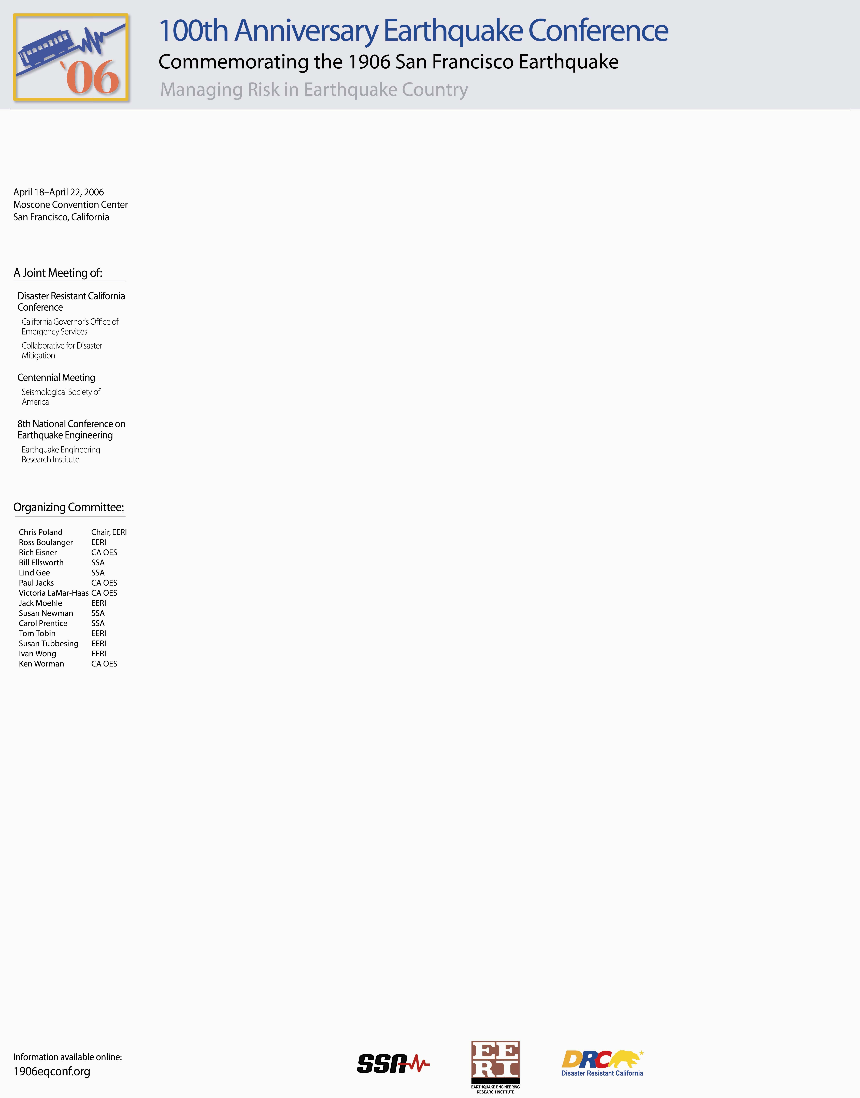
Date: March 17, 2005
Recipient Name
Street Address
City, State, Zip Code
Dear Name of Society contact:
Next year will mark the centennial of the great San Francisco earthquake of 1906. To commemorate this historic event, the 100th Anniversary Earthquake Conference will be held in San Francisco on April 18-21, 2006. The conference is co-convened by the Earthquake Engineering Research Institute (EERI), the Seismological Society of America (SSA), and the California Governor's Office of Emergency Services (OES). Over 2000 professionals engaged in earthquake research and mitigation are expected to attend.
Under the theme “Managing Risk in Earthquake Country”, the 100th Anniversary Earthquake Conference will bring together the Centennial Meeting of the Seismological Society of America, EERI’s Eighth U.S. National Conference on Earthquake Engineering (8NCEE), and the annual Disaster Resistant California (DRC) conference of California OES to celebrate a century of accomplishment in earth science, earthquake engineering and emergency management. Conference attendees will include professionals from the full range of disciplines committed to reducing the risk of earthquakes, including earth scientists, geotechnical and structural engineers, architects, economists, land use and regional planners, emergency managers, educators, insurance professionals, and local government policymakers and office holders.
Each day of the conference will begin with a joint multi-disciplinary plenary session devoted to the lessons learned from the great 1906 earthquake and the vision for reducing earthquake risk in the 21st century. Technical sessions, poster sessions and exhibits will continue throughout the meeting day and will include the full range of topics normally presented at DRC, EERI and SSA conferences. Tutorials will also be held every day on a wide range of topics that should be of particular interest to practicing professionals and educators. No earthquake conference would be complete without field trips, and the 100th Anniversary Earthquake Conference is planning a full schedule to highlight historical, geological, and engineering sites of interest.
On behalf of the Organizing Committee of the 100th Anniversary Earthquake Conference commemorating the 1906 San Francisco Earthquake we would like to invite the Name of Society to become a sponsoring organization of the 100th Anniversary Earthquake Conference. By becoming a sponsoring organization, your members will be able to register for the meeting at the reduced member’s rate and participate fully in all conference activities. Your members can look forward to a gala anniversary reception, a joint anniversary luncheon co-hosted by EERI, OES and SSA, a commemorative dinner, exhibits, and optional field trips, in addition to the technical sessions. All sponsoring organizations will be listed in Conference publications, on our website and prominently displayed at the Moscone Convention Center.

As a sponsoring organization, we ask only that Name of Society promote participation in the 100th Anniversary Earthquake Conference to your membership through your regular channels of communication. We would be happy to provide you with announcements suitable for use in newsletters, mailings and e-mail at your request. We would be willing to send invitations directly to your members by e-mail, if you would permit us to use your e-mail list for this sole purpose. We would also welcome your suggestions for topical sessions that would be of particular interest to your membership or to the meeting as a whole, covering any subject that would be appropriate for the 8NCEE, SSA annual meeting or Disaster Resistant California conference.
Additional information about the 100th Anniversary Earthquake Conference, including a PowerPoint presentation and other promotional material that may be downloaded for your use is available from the Conference website at http://www.1906eqconf.org/.
We would very much appreciate it if you would notify us by May 1, 2005, if possible, of your interest in becoming a sponsoring organization, as we would be most delighted to list Name of Society on our next mailing. If you are interested but need more time to reach a decision or would like more information, we would be happy to answer any questions that you might have about the meeting or sponsoring organizations. In any case, please contact name of contact for more information or with your decision.
We sincerely hope that the Name of Society will join EERI, DRC and SSA to be part of what promises to be among the most important earthquake conferences ever held.
Sincerely,

