Calibration of the Ground Motions in the San Francisco Bay Area: Excitation, Regional Propagation and Absolute Site Responses

Luca Malagnini¹, Kevin Mayeda², Robert Uhrhammer³,
Aybige Akinci¹, and Robert B. Herrmann⁴

¹Istituto Nazionale di Geofisica e Vulcanologia, Rome, Italy
²Lawrence-Livermore National Laboratory, Livermore, CA
³University of California, Berkeley, CA
⁴Saint Louis University, St. Louis, MO

To be submitted to: Bulletin of the Seismological Society of America

December 21, 2005, Version 1.8_u
Abstract
A complete ground motion study has been implemented and validated in the San Francisco Bay Area for selected stations of the Berkeley Digital Seismic Network (BDSN). By using moderate-sized earthquakes located within ~200 km from downtown San Francisco we characterized the scaling of ground motion for frequencies ranging between 0.25 and 20 Hz and find good agreement with previous studies that used much larger calibration events. Throughout the Bay Area, the average 1-D regional attenuation of the ground motion in log-log space can be modeled with a bi-linear geometrical spreading function with a 30 km crossover distance, coupled to an anelastic function $\text{exp}\left(−\frac{p\text{fr}}{βQ(f)}\right)$, where: Q(f)=180 f^{0.42}. A body-wave geometrical spreading, g(r)= r ^{1.0}, is used for r less than the crossover distance whereas g(r)= r ^{-0.6} fits the attenuation of the spectral amplitudes at distances beyond the crossover. Although the functional form used to model the crustal attenuation in Northern California is practically equivalent to the one used by Raoof et al. (1999) for Southern California, notable differences are observed in the duration function used to model the peak values of the ground motions in the time domain (PGA, PGV, and PSA’s at 0.33, 1.0, and 5.0 Hz). (Is this last sentence important?) Next, in order to account for the station site response, we used stable, coda-derived moment-rate spectra provided by Mayeda et al. (2005), and the extension of their technique given by Malagnini et al. (2004), to isolate the absolute site response at the BDSN stations. Our results were validated by the following: 1) the absolute site responses correlate with local magnitude (M_{L}) residuals for each of the stations ranging between 0.3 and 2.0 Hz; 2) moment-magnitude (M_{W}) derived from our path and site-corrected spectra are in excellent agreement with those derived using full-waveform modeling; 3) our ground-motion predictions using weak-motion data are in good agreement with previous studies using much larger events and validated with strong motion data.
We also address a long-standing issue related to estimating site responses from the spectral ratio of the horizontal and vertical components of ground motion. The so-called H/V spectral ratios (HVSR) are widely considered as estimates of the true horizontal site amplification, although some recent papers question the robustness of this assumption. For a majority of the stations of the BDSN, we conclude that the estimates of the site transfer functions obtained through the H/V spectral analysis cannot be considered as estimates of the horizontal site transfer functions. As others have pointed out, we also observe that rock sites may be characterized by their own responses and cannot be considered as a homogeneous half-space.
Introduction
The aim of this study is to provide a complete characterization of the ground motion for selected sites in the San Francisco Bay region. Through the application of a simple regression technique, thoroughly described by Herrmann and Malagnini (2005), and using the moment-rate spectra given by Mayeda et al. (2005), and the extension to their technique provided by Malagnini et al. (2004), we computed a functional form to quantify the attenuation due to the regional propagation, and the “absolute” site responses at broadband stations of the Berkeley Digital Seismic Network (BDSN) in the San Francisco Bay Area database. An important motivation for this study is to obtain results in a region where a number of studies have already been carried out on strong-motion data (e.g., Atkinson and Silva, 1997, 2000), and where predictive relationships for the ground motion are already available. Such pre-existing relationships can be used for comparing and validating our results in terms of peak ground shaking (PHA, PHV, PSA's), to strong-motion-based predictions. Comparisons will also be carried out between our predictions and some of the available ground motion data, providing some validation to the results presented in this paper (and, indirectly, validating the results of previous works). The extrapolation of results to large magnitudes, outside the sampled range, is always a major concern. This is especially true when weak-motion-based predictive relationships are used, like in this study, but the availability of seismometric and accelerometric data from large magnitudes in northern California will allow direct comparisons against synthetic predictions produced by our weak-motion-based model. A large number of papers are available on predictive relationships for the strong ground motions (for an overview, see Abrahamson and Shedlock, 1997). The idea of regionalizing the mentioned relationships has been used extensively, and a number of studies are available in different environments: where earthquakes are frequent and data are abundant, like in California (Atkinson and Silva, 2000; Boatwright et al., 2003, whereas Atkinson and Boore, 1997, provided a comparison between recent ground motion relationships in Eastern North America and California), but also where low seismicity rates prevent seismologists from organizing large data sets of strong ground motions, like in some seismic areas located within stable continental regions (Atkinson and Boore, 1995, 1997; Toro et al., 1997). However, most of the effort in the field is obviously focused on studying shallow earthquakes in active tectonic environments.

Where moderate-to-large crustal earthquakes are abundant (or on global data sets), different studies can be dedicated to define the characteristics of the ground motions induced by certain predominant faulting mechanisms, or by the relative source-receiver position. Spudich et al. (1996), for example, showed that predictive relationships used in the Western United States, which are strongly biased toward strike-slip mechanisms, tend to overpredict the ground motions from normal faulting mechanisms. Spudich et al. (1997) defined predictive relationships for peak ground acceleration (PGA) and for spectral acceleration (SA) using a global data set of recordings collected in normal faulting regimes. Abrahamson and Silva (1997), in their study on spectral attenuation relationships, distinguished between ground motions recorded on the hanging wall and on the footwall of dipping faults, the hanging wall systematically experiencing higher ground shaking. Campbell and Bozorgnia (2003), analyzing a worldwide dataset of shallow crustal events, developed near-source attenuation relationships for the horizontal and the vertical component of the peak ground acceleration, including the effects of site characteristics, and hanging wall effects.

The characteristics of the radiated seismic spectrum play a major role in predictive relationships. Some authors (Atkinson and Boore, 1997; Schneider et al., 1993; Silva and Darragh, 1995; Atkinson and Silva, 1997) pointed out the tendency of the Brune spectral model to overpredict low-frequency spectral amplitudes of large earthquakes. When used in conjunction with the stochastic model (Hanks and McGuire, 1981; Boore, 1983; Boore et al., 1992; Silva and Darragh, 1995), the Brune source spectrum with a stress parameter Δσ=5-10 MPa provides reasonable results in predicting the high-frequency ground motions, the stress parameter always trading off with the high-frequency attenuation. Boatwright and Choy (1992), and Atkinson and Boore (1997) observed that a two-corner frequency spectral model seems to better predict the spectra of large intraplate events, which generally depart from the Brune model.

In doing so, we assume that the area under investigation is homogeneous, in terms of the main characteristics of the wave propagation (see also Malagnini et al. 2000a,b,c, 2002, 2004; Akinci et al., 2001, 2005; Scognamiglio et al., 2004; Morasca et al., 2005). In other words, we assume that there are no important variations in the gross crustal structure around the Bay Area, at the wavelengths in the range: 0.25 – 20 Hz. In any case, the limited lateral extent of the studied region (within 150-200 km from downtown S.Francisco) makes our assumption more acceptable. The homogeneity of the region applies mostly to the depth of the Moho, and so we should consider an area where the Moho can be considered flat, and at a constant depth (note that the same assumption is implicitly made in most, if not all, attenuation studies). In the process of defining predictive relationships for the ground motion, we average our results over all available azimuths and takeoff angles.

Generally speaking, large magnitudes may induce directivity effects on the observed ground motions, which are included in the relationships by Somerville et al. (1997). Directivity biases are not taken into account in our approach, nor can they be resolved by it. For a complete description of the techniques adopted in this empirical study, we refer to previous literature. About the aspects relative to the ground motion scaling with distance, we especially refer to the recent work by Herrmann and Malagnini (2005), who provided a critical review of the procedure used for modeling high-frequency S-wave ground motion.

We feel that the results of this study are important for two reasons: i) for providing predictive relationships for the ground motion for the Bay Area, where other relationships are already available, for specific NEHRP site classes; ii) for exploring the possible extrapolation of the results to magnitudes outside the range available in the data set. Specifically, we will provide predictions for the ground motions (PGA, PGV, PSA) at C- and D-class NEHRP sites for some important earthquakes that occurred in the past (e.g., Loma Prieta, 1989, Morgan Hill, 1984, and the most recent Parkfield event, 2004), whose moment magnitudes are above the maximum magnitude present in the data set (M_{w} ≈ 5.3).
Standard and H/V Spectral Ratios: Previous Studies and Possible Issues

Malagnini et al. (2005) carried out an absolute-site response study, mostly on alluvium-covered seismic sites that were instrumented to record the aftershock activity right after the Bhuj Mw 7.6 mainshock (Western India). They showed that on soil sites characterized by strong shallow impedance contrasts, the features of the H/V ratios were similar to those of the corresponding absolute horizontal site terms. Their conclusion was that the H/V ratio technique is not robust enough to provide reliable estimates of absolute site responses. Similar remarks will be formulated in the present study.

With regard to the determination of the absolute moment-rate spectra, we refer to the studies by Mayeda and Walter (1996), and Mayeda et al. (2003). For the determination of the spectra that will be used in this specific study, we refer to the coda-wave study carried out by Mayeda et al. (2005). The latter paper describes a new technique that takes into account the lateral variations of the attenuative properties of the Earth's crust, and allows the computation of precise moment-rate spectra that are unbiased by the effects of the shallow structural heterogeneities beneath the recording sites.

In 1999, a geophysics survey was conducted by Havenith et al. (2002) in the region of the 1911 M8.2 Kemin in Eastern Tien Shan (Kyrgyzstan) earthquake, and ground motion from small earthquakes were analyzed using standard spectral ratios (SSRs), as well as H/V ones. Both techniques yielded consistent results, and Bard et al. (2002) concluded the dominant frequencies at the investigated sites were isolated, and amplification effects were modeled using a finite-element model. Havenith et al. (2002) wrote that SSRs are to be considered lower bounds on the amplification, implicitly stating that they are direct measures of absolute site amplification.

H/V ratios are often used as microzonation tools, like in the work by Lebrun et al. (2001), who conducted a H/V microzonation study in the Grenoble valley. The Grenoble basin was chosen also by Cornou et al. (2003b) for the application of the MUSIC algorithm on 18 events recorded in the basin by a dense array (Cornou et al., 2003a). Differences were noticed between SSRs, 1-D theoretical transfer function, and H/V spectral ratios, and were thought to be due to lateral propagation of seismic waves. At low frequency (f<0.2 Hz), arrivals identified backazimuths that were very similar to the backazimuths of the epicenter, indicating no scattering in the incoming wavefield. At higher frequency (f>0.2 Hz), arrivals were extremely scattered and came from every direction. As a consequence of these observations, we can assume that our azimuthally averaged results reflect most individual cases.

Cornou et al. (2003b) also computed receiver functions, and compare them, at a number of sites, with the SSRs to a reference station, and with theoretical 1D transfer functions. Receiver functions (H/V ratios) were very different from SSRs, but well in agreement with the 1D transfer function. The latter observation made Cornou et al (2003b) conclude that SSRs were more affected by horizontal propagation than were the H/V ratios, so that SSRs would be more suitable for relative site-to-bedrock analysis. Our observations, however, indicate that SSRs may be reflecting the (generally unknown) behavior of the reference site, more than an absolute site effect at the non-reference location.

For the determination of the absolute site terms for the stations used for the regressions on the ground motions, we follow the procedure by Malagnini et al. (2004), and Malagnini et al. (2005). The first of these two studies dealt with the absolute horizontal site responses of rock sites in NE Italy, demonstrating that even hard rock sites suffer substantial site effects. This conclusion was consistent with the ones by Steidl et al. (1996), who stated that surface-rock sites can have a site amplification on their own. Malagnini et al. (2004) also pointed out that, in the case of the rock stations of the Friuli-Venezia Giulia Seismic Network, the horizontal-to-vertical ratios (H/V) cannot be compared to their absolute horizontal site responses, and that standard spectral ratios (SSRs) may also be substantially biased by the behavior of the reference site.

It is clear that our site term estimates will be obtained in a linear regime. In other studies, however, the recording sites are explicitly allowed to be non-linear (e.g., Abrahamson and Silva, 1997), with a dependence on the peak amplitude of the ground shaking.
Predictive Relationships for the Ground Motion in California
Given the vast amount of seismological information available in Northern California, a number of studies have already tackled the problem of providing predictive relationships for the ground motions at regional distances. For testing our conclusions against existing equations, we will use the ones obtained by Atkinson and Silva (2000, hereinafter cited as AS2000). In the effort of providing a simple spectral model to be used for predicting the ground motions induced by moderate-to-large earthquakes, AS2000 postulated that a point source with two corner frequencies is equivalent to the use of a finite-fault model comprised of a number of elementary sub-faults, each of them radiating a Brune source spectrum. With such an approach, they developed predictive relationships for the ground motion in Californa through a stochastic simulation that exploited the difference between finite-fault models and the two-corner point source model.

For the sake of simplicity and clarity, we chose to compare the results of our study only to the well-known AS2000 relationships. Figures 10, 11, and 12 of this paper will deal with such comparisons. Comparisons with other predictive relationships can easily be obtained by checking them against the values provided in the Appendix of AS2000.

AS2000 obtained a good agreement with California strong-motion data using the stochastic point-source simulation from the two-corner source spectrum and the Generic Rock Site amplification function (V(f)) published by Boore and Joyner (1997). The site term was coupled with the high-frequency attenuation term: exp(-πκ₀f). For soil sites, the amplitudes predicted in AS2000 were modified from the rock ground motions using the empirical factors obtained by Abrahamson and Silva (1997): a nonlinear, frequency-dependent soil amplification, which was also a function of the input rock peak-ground motion. We will compare our results for soil sites (NEHRP class D) with the AS2000's soil ground motions, although our approach will be linear.

As pointed out by Atkinson and Silva (1997), their two-corner spectral model was chosen because the ω² spectral model (point source-single corner frequency) consistently over-predicted the ground motions at low-to-intermediate frequencies (~ 0.1 − 2.0 Hz), for moderate-to-large events. Atkinson and Silva (1997) pointed out that the finiteness of the fault, even for moderate events, induces effects that may persist at large distances from the source. They showed that the finite-source effects could be the reason for the observed discrepancy between single-corner point source simulations and the empirical data. For the definition of the spectral model by AS2000 (the low-frequency corner is related to the source size), lengths and widths of the extended faults as a function of magnitude were taken from Wells and Coppersmith (1994), using the definition of seismic moment. The high-frequency corner in the AS2000's spectral model is related to the size of the sub-faults.

Differences between the single-corner frequency point source, and the two-corner model are not very large for M<6, and for M~5 the two spectral models yield results that are practically identical. In this paper, however, we provide predictions for the ground motions up to M_{w}7 (Loma Prieta earthquake) by using the classic Brune model at a single corner frequency, with a static stress drop Δσ= 20 Mpa. This value is larger than the estimates given by other authors: for example, Chen and Atkinson (2002) state that in a number of regions around the world (Japan, Mexico, Turkey, California, British Columbia, and Eastern North America), apparent source spectra for small to moderate earthquakes (M < 6) show good agreement with single-corner Brune spectra (point sources with Δσ ≈ 10 MPa). At M≥6, they observed that a two-corner model better matches spectra for intermediate frequencies, and that spectra of small to moderate earthquakes (M 3.5 − 6.5) appear to be very similar in the different regions.

The functional form describing the regional attenuation used by AS2000 was the one published by Raoof et al. (1999): a bi-linear geometrical spreading with a cross-over distance at 40 km hypocentral distance, coupled to the regional attenuation parameter Q(f)=180f^{0.45}. The geometric term was characterized by a body-wave-like attenuation (∝ 1/r) at short distances, and a surface-wave-like attenuation at larger distances (∝ $1/{\sqrt{r}}$). The duration function used in AS2000 was also taken from Raoof et al. (1999): T=T₀ + 0.05R (R is the hypocentral distance in km; T₀ is the duration of the specific rupture). The magnitude of validity for the AS2000 relationships is within the range: M_{w} 4−8.
Our Data Set
We collected a data set of 5769 waveforms from 281 events recorded at either 80 sps or 100 sps by the Berkeley Digital Seismic Network (BDSN). Figure 1 shows a map of the region, with the location of the events used for this study, and of the BDSN stations in our data set. Note the relatively large cluster of events from the area of the Loma Prieta earthquake. Figure 2 shows the distribution of the data with respect to the hypocentral distance at each station. Except for station PACP, that is characterized by two distinct clusters of sampling distances, at 20-60 km and around 100 km, the distributions at the other stations of the BDSN are relatively even and will provide reliable results. Data used in this study are those from the HH data streams (80 sps or 100 sps). Our investigation goes up in frequency to 20 Hz (Nyquist/4 at the lower sampling rate).

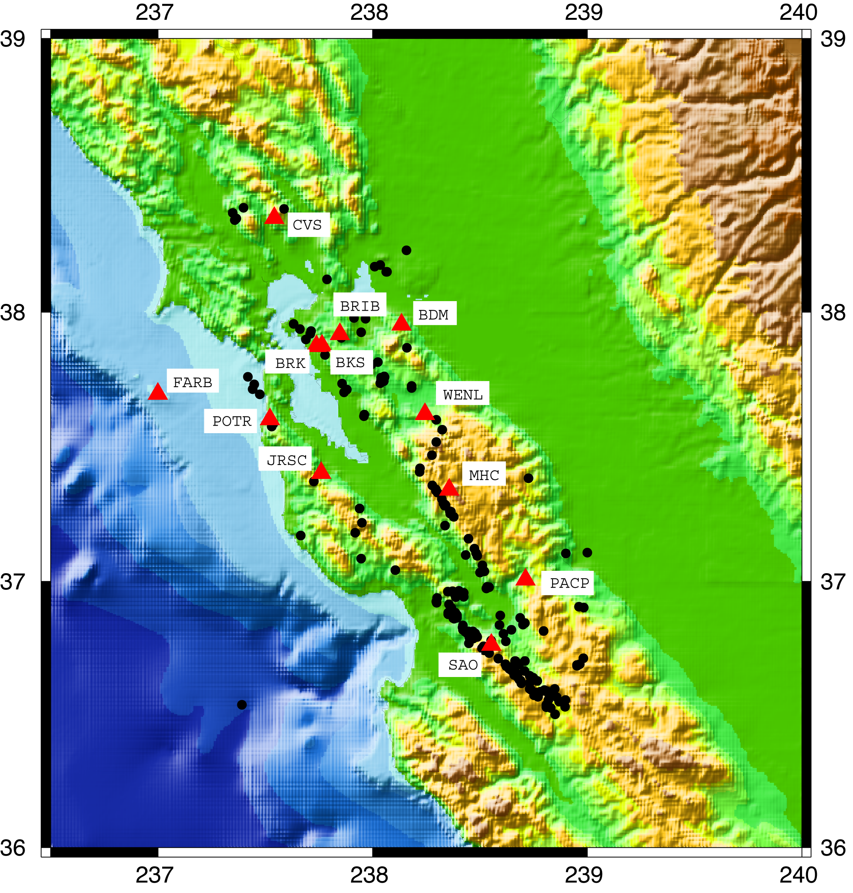
Figure 1. Map of the region investigated in this study, where are shown the events used for the regressions, and the stations of the BSL network that recorded them.
NOTE: The location of POTR is incorrect. The correct coordinates are 38.203,-121.935.
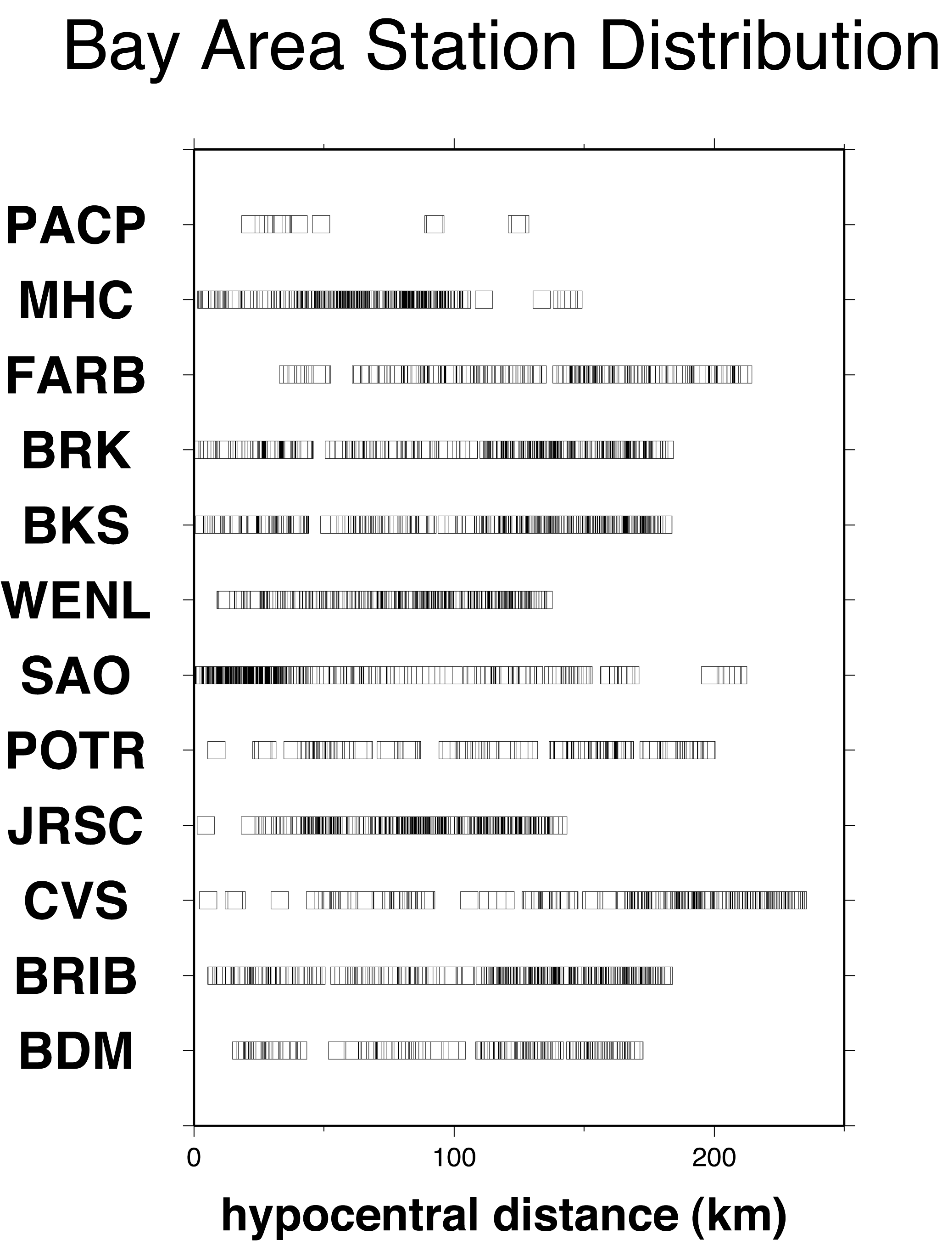

Figure 2. For each station of the BDSN network used in this study, we plotted the distribution of sampled hypocentral distances. Except for the station PACP, for which the data distribution is characterized by two separate clusters of observations, the distributions of sampled distances at the other stations are very even, and will guarantee that the results are reliable in the entire distance range (5-170 km).

Regression Results

Duration of the ground motion
Random Vibration Theory (RVT) is used in order to quantity the different time-domain parameters that characterize the ground motion in a specific region. For doing so, we need to provide a table to describe the effective duration of the ground motions as a function of frequency and hypocentral distance. The duration of the event must be added, in form of a constant term equal to the reciprocal of the corner frequency.

Universally accepted definitions of the effective duration are not available: Boatwright and Choy (1992) defined the duration of the ground motions as the sum of two terms: the inverse of twice the lowest spectral corner frequency, and the length of the dispersion window due to the crustal propagation. Atkinson (1993) quantified the duration of the ground motion in Eastern North America between 10 and 1000 km from the hypocenter, observing a distance range (60-250 km) for which duration was almost constant. Similar conclusions were reached by Toro and McGuire (1987), and by EPRI (1993 ---1988?), who used a constant duration function for moderate and large earthquakes: T=1/f₀, for hypocentral distances less than 100 km.

Our definition of effective duration for the ground motion is that given by Raoof et al. (1999): the time window comprised by the time marks indicating 5% and 75% of the integrated energy. Such a quantity is computed at each sampling frequency, for each recorded seismogram, and a piece-wise-linear functional form is found for each sampling frequency by regressing all the available data points.

In general, the duration of the ground motions is strongly affected by the crustal structure at the regional scale. For example, depth clusters determine multi-modal distributions (as in the NE Alps, see Malagnini et al., 2002). Duration at low-frequency (f<1.0 Hz), generally, increases with distance. Past the Moho supercritical reflections, where surface waves start to develop, duration of the ground motions increases more rapidly with distance (Herrmann and Malagnini, 2005). High-frequency duration, generally, tend to increase less rapidly with distance, and sometimes is constant over the entire distance range.

For each sampling frequency, for each filtered seismogram, the 5%-75% duration is automatically computed. Results are plotted in the various frames of Figure 3. A series of L₁-norm optimizations are run in order to obtain piecewise-linear functions to quantify the median values of the duration distributions at different hypocentral distances. Although a clear functional form was not obtained for the lowest frequencies (0.25 and 0.6 Hz), reliable durations were computed for all the other frequencies. Even for the central frequencies between 0.25 Hz and 0.6 Hz, the quantities shown in Figure 3 are close enough to an acceptable median behavior to be used in the RVT applications. Figure 3 shows a clear frequency dependence of the empirical duration functions, which will be taken into account in all the ground motion predictions provided in this study. At higher frequencies, noise in the duration data set strongly diminishes, and the duration trends become much clearer. The median values of duration computed at each sampling frequency are provided in Table 1. At high-frequency, duration is nearly constant for increasing distances.

For the applications that will be described in this paper, the use of the duration functions will be of two different types: i) when peak ground motions are predicted (PGA, PGV), the 1.75 Hz duration function is used (the chosen frequency represents the behavior of intermediate-high frequencies); ii) when other quantities are computed (e.g., PSA’s), the specific duration at each frequency is used.
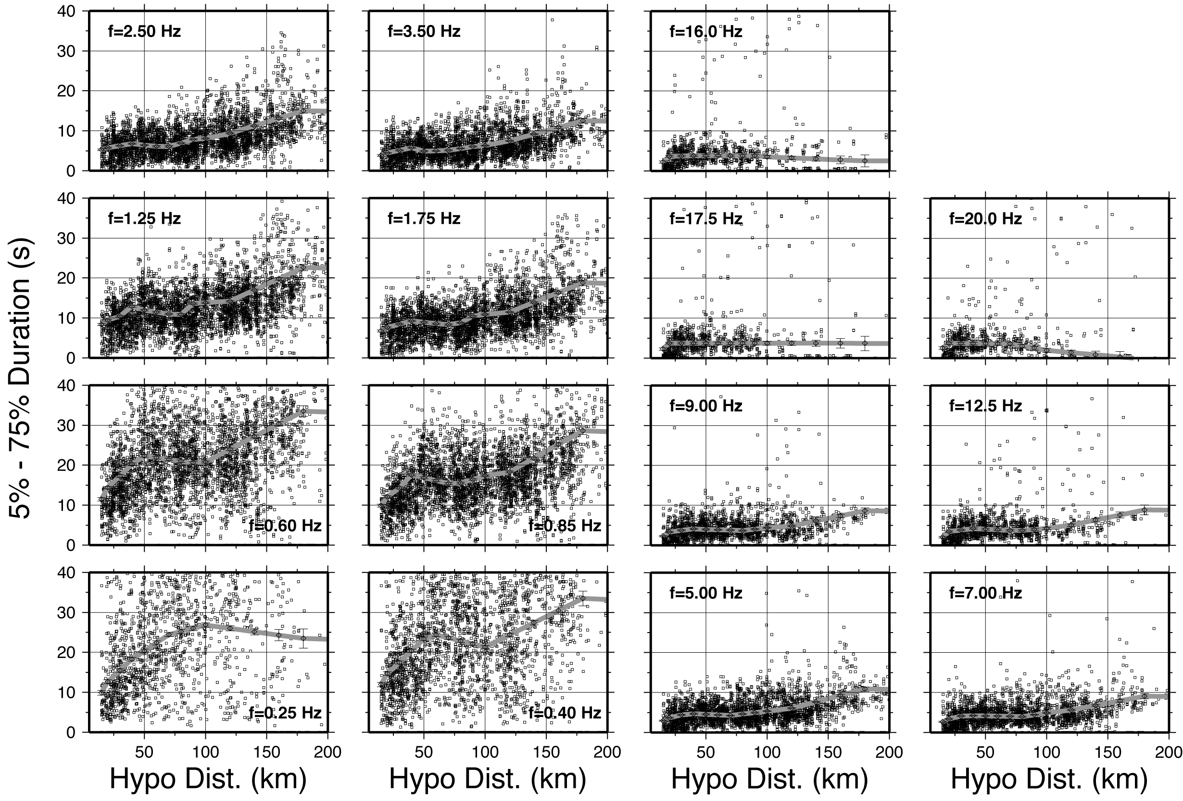

Figure 3 – 5%-75% duration of the ground motion, computed for each filtered seismogram, plotted as a function of the hypocentral distance. The thick gray lines linking the symbols with the y-axis error bars represent L₁-norm estimates of the duration. Note the strong frequency-dependence of the duration functions, with the low frequencies describing strong dispersive waveforms, and the high frequencies showing non-dispersed wavetrains. Strongly dispersive surface waves would develop at longer wavelengths, whereas more impulsive signal, characterized by a constant duration as a function of distance (T~ 5 s), dominate the waveforms at frequencies f_{c} >= 5 Hz. For the automatic moment magnitude calculation (see later), we used the duration T(f=1.75 Hz). The values of duration plotted in the Figure are also listed in Tables 1a,b.

Table 1a
f₀ (Hz)  R (km) | 0.25  Τ(R) ± ΔΤ(R) |  | 0.40  Τ(R) ± ΔΤ(R) |  | 0.60  Τ(R) ± ΔΤ(R) |  | 0.85  Τ(R) ± ΔΤ(R) |  | 1.25  Τ(R) ± ΔΤ(R) |  | 1.75  Τ(R) ± ΔΤ(R) |  | 2.50  Τ(R) ± ΔΤ(R)
15.000 | 9.868 | 0.593 | 11.931 | 0.539 | 11.469 | 0.434 | 9.877 | 0.345 | 8.369 | 0.280 | 6.764 | 0.243 | 5.271 | 0.218
20.000 | 12.674 | 0.461 | 14.696 | 0.400 | 14.384 | 0.320 | 12.078 | 0.255 | 9.421 | 0.208 | 7.602 | 0.180 | 5.774 | 0.162
30.000 | 15.480 | 0.480 | 17.461 | 0.416 | 17.300 | 0.333 | 14.279 | 0.262 | 10.473 | 0.213 | 8.441 | 0.184 | 6.277 | 0.164
40.000 | 18.286 | 0.475 | 20.415 | 0.429 | 20.215 | 0.333 | 17.576 | 0.258 | 12.917 | 0.208 | 9.279 | 0.179 | 6.779 | 0.160
50.000 | 20.333 | 0.507 | 23.369 | 0.458 | 22.293 | 0.341 | 16.847 | 0.263 | 11.973 | 0.213 | 8.913 | 0.182 | 6.427 | 0.163
60.000 | 22.380 | 0.534 | 24.372 | 0.472 | 21.861 | 0.346 | 16.118 | 0.266 | 11.476 | 0.216 | 8.547 | 0.185 | 6.091 | 0.166
70.000 | 24.427 | 0.525 | 23.617 | 0.435 | 21.429 | 0.318 | 15.389 | 0.243 | 10.979 | 0.196 | 8.328 | 0.169 | 6.088 | 0.151
80.000 | 25.230 | 0.563 | 22.862 | 0.445 | 20.998 | 0.322 | 15.511 | 0.245 | 10.873 | 0.195 | 8.790 | 0.168 | 6.922 | 0.150
90.000 | 26.032 | 0.560 | 22.106 | 0.426 | 20.566 | 0.312 | 16.417 | 0.237 | 13.596 | 0.191 | 10.417 | 0.164 | 7.827 | 0.147
100.00 | 26.834 | 0.551 | 21.351 | 0.373 | 20.782 | 0.267 | 17.323 | 0.202 | 13.812 | 0.163 | 10.897 | 0.141 | 8.052 | 0.128
120.00 | 25.991 | 0.641 | 24.383 | 0.440 | 23.969 | 0.305 | 18.313 | 0.227 | 14.172 | 0.182 | 11.435 | 0.158 | 9.387 | 0.146
140.00 | 25.147 | 0.827 | 27.415 | 0.528 | 27.156 | 0.353 | 21.751 | 0.255 | 16.989 | 0.202 | 13.881 | 0.175 | 11.257 | 0.164
160.00 | 24.304 | 1.401 | 30.447 | 0.914 | 30.343 | 0.584 | 25.190 | 0.406 | 19.807 | 0.317 | 16.327 | 0.272 | 13.127 | 0.255
180.00 | 23.461 | 2.420 | 33.479 | 1.829 | 33.530 | 1.318 | 28.628 | 0.987 | 22.625 | 0.787 | 18.774 | 0.678 | 14.996 | 0.619

Table 1b
f₀ (Hz)  R (km) | 3.50  Τ(R) ± ΔΤ(R) |  | 5.00  Τ(R) ± ΔΤ(R) |  | 7.00  Τ(R) ± ΔΤ(R) |  | 9.00  Τ(R) ± ΔΤ(R) |  | 12.5  Τ(R) ± ΔΤ(R) |  | 17.5  Τ(R) ± ΔΤ(R) |  | 20.0  Τ(R) ± ΔΤ(R)
15.000 | 3.820 | 0.190 | 2.947 | 0.166 | 2.667 | 0.174 | 2.287 | 0.180 | 2.029 | 0.221 | 2.282 | 0.313 | 2.523 | 0.374
20.000 | 4.479 | 0.143 | 3.679 | 0.125 | 3.389 | 0.129 | 3.321 | 0.136 | 3.437 | 0.171 | 3.760 | 0.239 | 3.724 | 0.279
30.000 | 5.137 | 0.144 | 4.411 | 0.127 | 4.111 | 0.131 | 3.730 | 0.140 | 3.824 | 0.178 | 3.756 | 0.255 | 3.695 | 0.302
40.000 | 5.796 | 0.140 | 4.685 | 0.123 | 4.207 | 0.128 | 4.089 | 0.136 | 4.210 | 0.181 | 3.751 | 0.276 | 3.667 | 0.332
50.000 | 4.905 | 0.144 | 4.535 | 0.126 | 4.151 | 0.134 | 3.990 | 0.145 | 4.055 | 0.202 | 3.746 | 0.316 | 3.638 | 0.376
60.000 | 5.002 | 0.147 | 4.385 | 0.130 | 4.096 | 0.138 | 3.891 | 0.150 | 3.899 | 0.207 | 3.742 | 0.326 | 3.609 | 0.401
70.000 | 5.099 | 0.134 | 4.235 | 0.119 | 4.040 | 0.128 | 3.792 | 0.141 | 3.743 | 0.195 | 3.738 | 0.328 | 3.581 | 0.419
80.000 | 5.579 | 0.133 | 4.605 | 0.120 | 3.985 | 0.132 | 3.692 | 0.149 | 3.732 | 0.213 | 3.734 | 0.366 | 3.035 | 0.457
90.000 | 6.060 | 0.131 | 4.976 | 0.119 | 4.430 | 0.135 | 4.040 | 0.157 | 3.979 | 0.243 | 3.730 | 0.415 | 2.488 | 0.497
100.000 | 6.319 | 0.116 | 5.346 | 0.110 | 4.875 | 0.133 | 4.388 | 0.160 | 4.227 | 0.263 | 3.726 | 0.460 | 1.942 | 0.530
120.000 | 7.504 | 0.136 | 6.049 | 0.132 | 5.644 | 0.160 | 4.850 | 0.196 | 5.034 | 0.324 | 3.722 | 0.551 | 1.396 | 0.614
140.000 | 9.174 | 0.155 | 7.655 | 0.159 | 6.795 | 0.205 | 6.107 | 0.269 | 6.308 | 0.480 | 3.718 | 0.782 | 0.850 | 0.858
160.000 | 10.844 | 0.248 | 9.261 | 0.254 | 7.946 | 0.347 | 7.365 | 0.447 | 7.582 | 0.772 | 3.714 | 1.201 | 0.304 | 1.325
180.000 | 12.514 | 0.570 | 10.867 | 0.539 | 9.097 | 0.655 | 8.622 | 0.779 | 8.856 | 1.216 | 3.710 | 1.801 | -0.242 | 1.990

Table 1a,b – Duration of the ground motion (the time window that contains the 5% - 75% of the S-wave energy), as a function of hypocentral distance and frequency, for all the sampling frequencies used in this study. For each central frequency-distance pair, the median duration is shown, associated with the L₂ estimate of the corresponding standard error.

Amplitudes of the Ground Motions
Peak values from the narrow bandpass filters, and the rms-averages of the Fourier amplitude spectra, are separately regressed in a simple scheme to obtain excitation, regional propagation, and site terms at every sample frequency (see Raoof et al., 1999; Malagnini et al., 2002). We model both the Fourier and, through RVT, the peak filtered velocity amplitudes. RVT uses the Parseval's theorem, and needs duration and Fourier amplitudes.
The double analysis (Fourier amplitudes in the frequency domain, and peak amplitudes of the bandpass filtered waveforms in the time domain) is not strictly necessary. When we are able to model both the peak values and the Fourier amplitudes with the same parameters, though, we are producing an internally self-consistent model for the excitation and propagation of the ground motion at regional distances. Moreover, in such a situation, the empirical duration function indirectly validates the choice of the 5%-75% effective duration.

The regional attenuation
Figure 4 shows the regional attenuation terms, normalized to zero at the reference hypocentral distance of 40 km. These empirical functions are also normalized to a reference body-wave-like decay, so that a horizontal line in Figure 4 would decay proportionally to 1/r.

Colored lines represent the results of the regressions (note the error bars at the nodal points), and black lines in the background represent our theoretical prediction based on a bi-linear geometrical spreading function (in log-log space), with a 30 km crossover distance. A body-wave-like geometrical attenuation (∝1/r) is used to model the decay of the Fourier amplitudes at short distances (all frequencies), and an almost surface-wave-like decay, (∝r^{-0.6}), seems to fit the results at larger hypocentral distances. An exponential function exp(-πf/βQ(f)) is coupled to the geometrical spreading, using a regional attenuation parameter Q(f)=180f^{0.42}. Compared to the parameters published by Raoof et al. (1999) for Southern California, we obtain equivalent numbers for Northern California. We must point out, however, that the frequency-dependent duration function used in this study for predicting peak values at regional distances may be very different, for some frequency-distance pairs, from the duration function T(R)=T₀+0.05R (R in km) that was used by Raoof et al. (1999).

Changes in the geometrical spreading may correspond to the arrival of supercritical bounces off the Moho, or off other primary crustal interfaces. Atkinson and Boore (1997) mentioned the recordings of the Saguenay earthquake as good examples of the effects of supercritical bounces at about 100 km from the source. Similarly, the 30-km crossover distance described in this study must be related to some strong, vertical heterogeneity within the crust. The fact that well-developed surface waves seem to dominate the seismograms, starting at relatively short distances, is consistent with the relatively shallow depth of the Moho in the region around the Bay Area. From Figure 3, it seems that a change in slope affects a number of duration functions near 80-100 km (e.g., the ones at 0.85Hz, and1.75 Hz), and a strong hint for a change in wave propagation is present in the duration functional forms also at a hypocentral distance around 50 km.

The tool of Random Vibration Theory (RVT), based on the duration information shown in Figure 3, and on the described geometrical/anelastic attenuation function, is used to produce the synthetic attenuation lines (plotted in black) in the lower frame of Figure 4 (the one marked: “Band Pass D(r)”). The same attenuation model (geometrical and anelastic) is used to describe the empirical results plotted in the upper frame of Figure 4, the one marked: “Fourier Amplitude D(r)”. No duration is involved in the modeling of the Fourier spectral amplitudes.

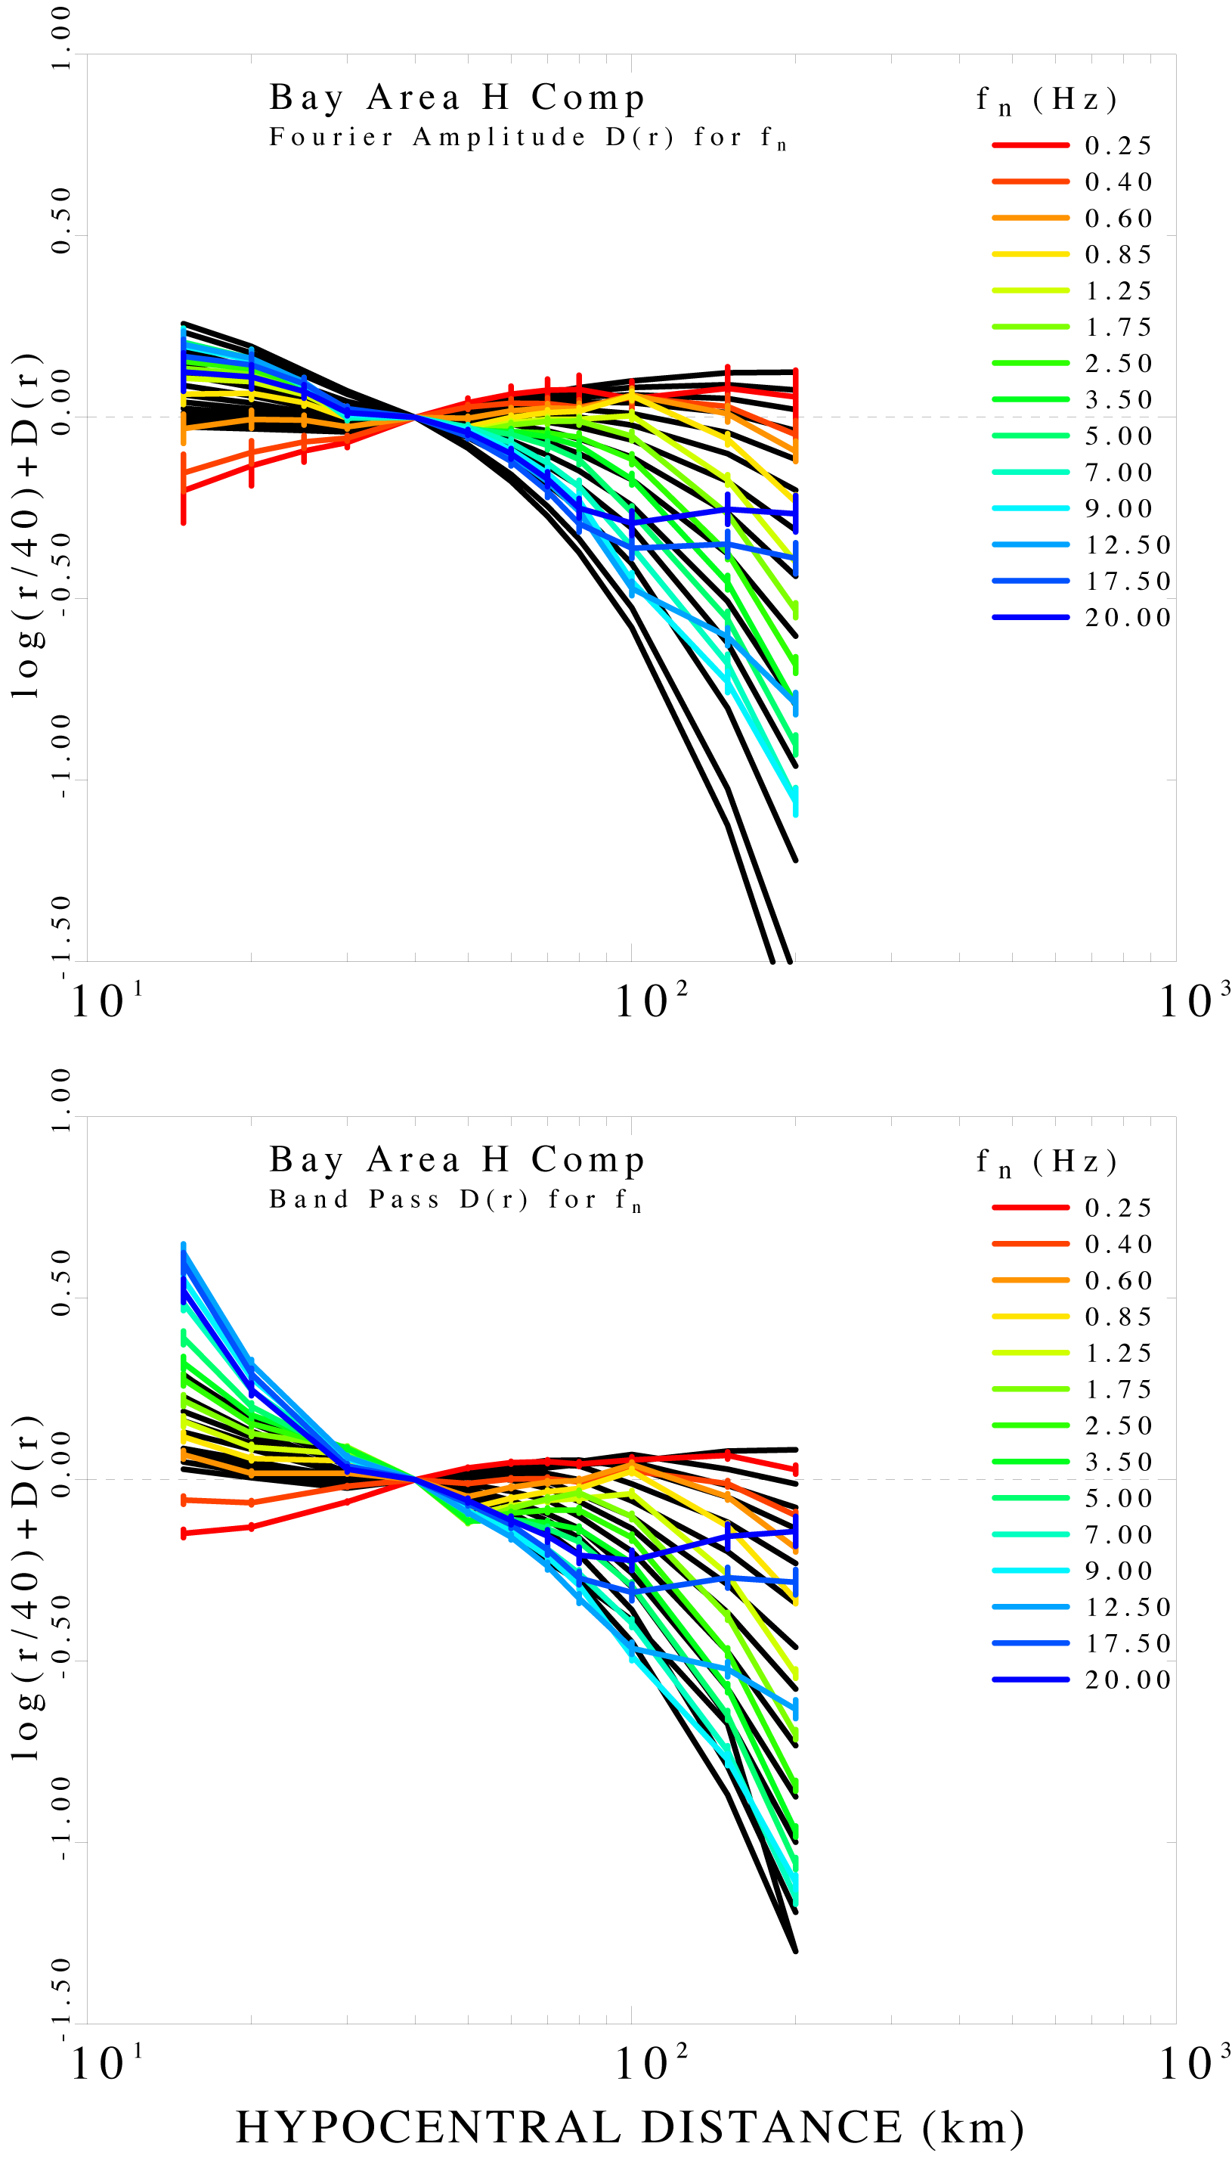
Figure 4 – Top frame: Fourier amplitude regional attenuation empirical terms (color lines), superimposed to theoretical predictions based on a single crossover distance at 30 km, body-wave-like attenuation (1/r) is used to model the empirical terms to the crossover distance, and a more surface-wave-like geometrical attenuation is used (~r^{-0.6}) for larger distances. Bottom frame: empirical regional attenuation terms for the peak filtered amplitudes (color lines). The black lines in the background represent the synthetic RVT predictions, at every frequency, of the empirical D(r,f). The same attenuation model described for the Fourier amplitude results is used here. In order to obtain the RVT predictions, all the frequency-specific estimates of duration presented in Figure 3 are used. High-frequency empirical curves depart from their trends around 80 km hypocentral distance, because the peak amplitudes are not carried by direct waves anymore.
NOTE: The axes should be darker.

The normalized excitation terms at 40 km
As described by Herrmann and Malagnini (2005), the excitation terms obtained from the regressions have some interesting features: i) at low frequencies, they contain surface-wave contributions (in this case, since we deal with both the radial an the transverse ground motions, both Love and Rayleigh waves); ii) because of i), if clusters exist at specific depths, the empirical excitation terms tend to split into “families” at low frequencies (see also the results of Bodin et al., 2004). In general, excitation terms always need to be calibrated against independent estimates of M_{w}.

In their study, Chen and Atkinson (2002) observed that no compelling differences existed between seismic sources in different regions. In other words, in the same magnitude ranges, seismic spectra show little regional differences, and the vertical spectra have the least scatter. Moreover, they pointed out that seismic spectra appear to be approximately independent on source environment, although there may be differences attributable to tectonic styles within a specific region.

In Figure 5 we show the empirical excitation term obtained through the regressions of both the filtered peak amplitudes, and of the Fourier spectral amplitudes. Superimposed to the empirical terms are the synthetic excitation terms at various magnitudes, which are obtained through the use of the Brune spectral model, the regional geometrical/anelastic attenuation just defined for the regional propagation terms, and the absolute empirical absolute site term at station BRIB (see the later, dedicated section), which was arbitrarily chosen as the reference for the regressions (see Figure 6).

Figure 7 shows the absolute source terms, obtained by taking the absolute moment-rate spectra computed by Mayeda et al. (2005) from coda envelope spectral measurements, after using a 2-D attenuation tomography of Northern California. The moment-rate spectra are transformed to velocity spectra, then the regional attenuation function g(r)*exp(-πfr / βQ(f) ) is used to simulate the regional propagation to a hypocentral distance of 40 km. Based on the results of Figure 8, the theoretical spectra are also multiplied by V(f), the absolute site term of the reference station BRIB (see in later section). The static stress drop assumes the value of about 3 MPa at M_{w} 3.0, 4 MPa at M_{w} 4.0, and 10 MPa at M_{w} 5.5. V(f) (see later) contains the combined effects of impedance contrast (amplification), and κ₀ (shallow attenuation at BRIB, estimated to be κ₀=0.055 sec if the Generic Rock Site of Boore and Joyner, 1987, is used). The theoretical spectra of Figure 5 contain the following constants: the rms-average radiation pattern, the partition of energy, and the free surface parameters (here we used <R_{θφ}>=0.55, P=0.707, and F=2.0, respectively).
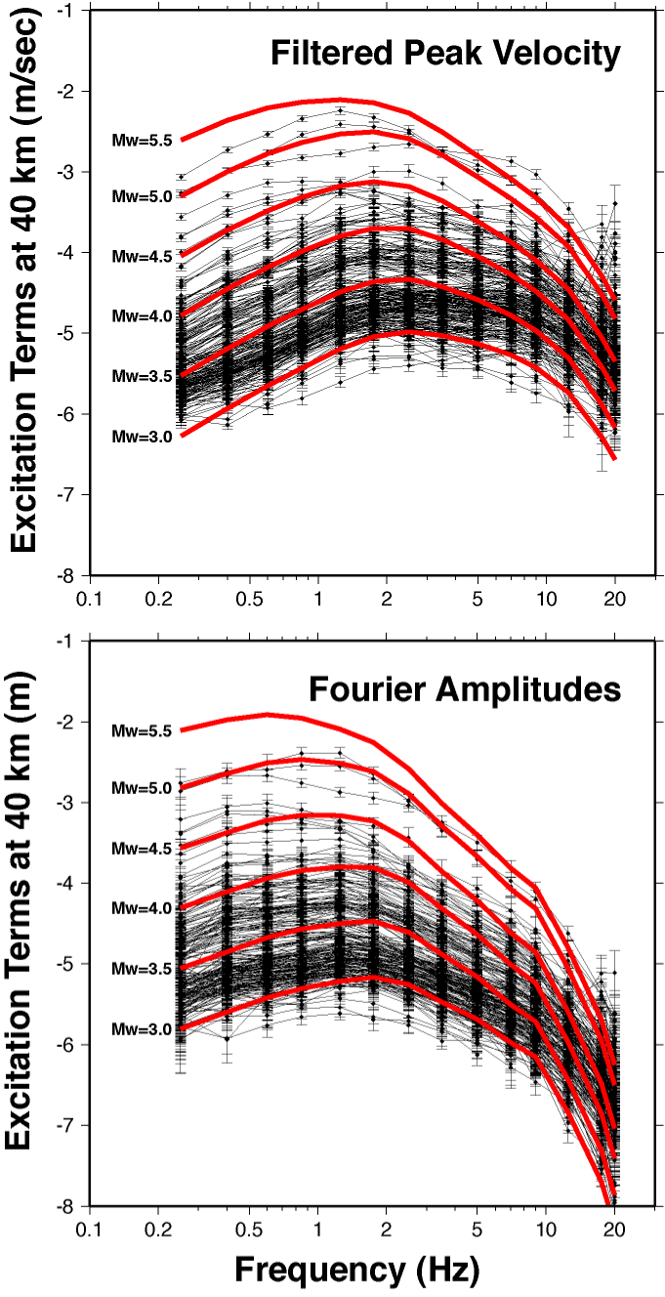
Figure 5 – Excitation terms relative to the regressions over the peak ground velocities (top frame), and over the rms-average of the Fourier amplitudes around the set of the sampling central frequencies (bottom frame). Black lines connecting symbols with y-axis error bars represent the empirical terms. Thick red lines represent the theoretical terms computed via a Brune spectral model, and the described geometrical-anelastic attenuation model. The frequency-specific estimates of duration at the different frequencies, at the 40 km reference hypocentral distance are used for the RVT simulations of the peak ground velocities (upper frame). The geometrical/anelastic attenuation function: g(r)*exp(-πf r / βQ(f) ) is used to simulate the regional propagation to the reference hypocentral distance. The theoretical spectra are multiplied by V(f), the absolute site term of the reference station BRIB (see in a later section). The static stress drop used in the Brune spectral model assumes the value of about 3 MPa at Mw 3.0, 4 MPa at Mw 4.0, and 10 MPa at Mw 5.5. V(f) (see later) contains the combined effects of impedance contrast (amplification), and κ₀ (shallow attenuation at BRIB). If the Generic Rock Site by Boore and Joyner (1997) is used to compute the impedance contrast effect at BRIB, κ₀=0.055 sec. The theoretical spectra of Figure 5 contain the following constants: the rms-average radiation pattern, the partition of energy, and the free surface parameters (here we used <R_{θϕ}>=0.55, P=0.707, and F=2.0, respectively).

The Empirical Site Terms
Figure 6 shows the empirical site terms obtained from the regression on the peak filtered amplitudes, and on the rms-averages of the Fourier spectra around the sampling frequencies. Thick lines refer to the horizontal components of station BRIB, to which the regressions are normalized to zero. With respect to the reference station BRIB, most of the BDSN stations are characterized by lower amplitudes, consistent with the observations by Boatwright (2002).

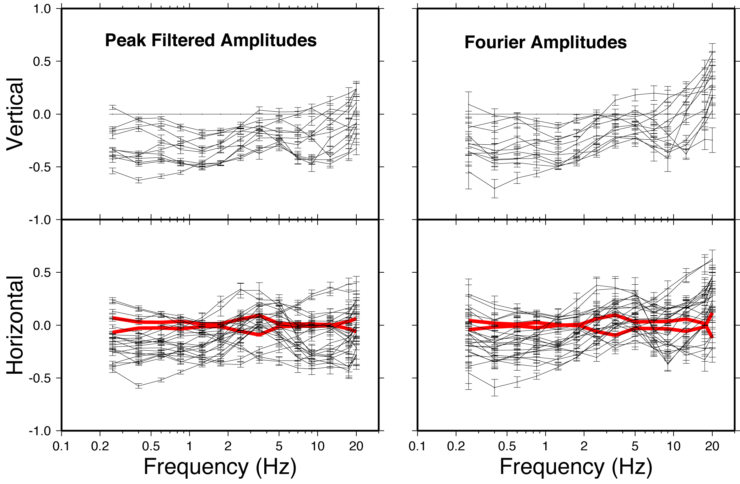

Figure 6 – Relative site terms (reference is the average of the horizontal components at BRIB) obtained from the regressions on both the peak filtered amplitudes (left frames), and on the Fourier spectral amplitudes (two frames on the right).
The upper two frames are relative to the vertical site terms, whereas the two bottom frames show the horizontal (radial and transverse) site terms. The two thick curves represent the two horizontal terms at station BRIB, used as the reference for the regressions. The two horizontal site terms at BRIB are forced to have null average during the regressions. In a later section of this paper, we will show that station BRIB, from 0.25 Hz to 2.0 Hz, actually behaves as a generic rock site in the Boore and Joyner (1997) sense, but with a parameter κ₀=0.055 sec.

The Absolute Excitation Spectra
The regional attenuation terms yielded by the regressions on the Fourier amplitudes were used to “propagate” the moment-rate spectra computed by Mayeda et al (2005) to the arbitrary reference hypocentral distance of 40 km (Figure 7). The moment-rate spectra are transformed to velocity spectra, then the regional attenuation function g(r)*exp(-πfr / βQ(f) ) is used to simulate the regional propagation to a hypocentral distance of 40 km.

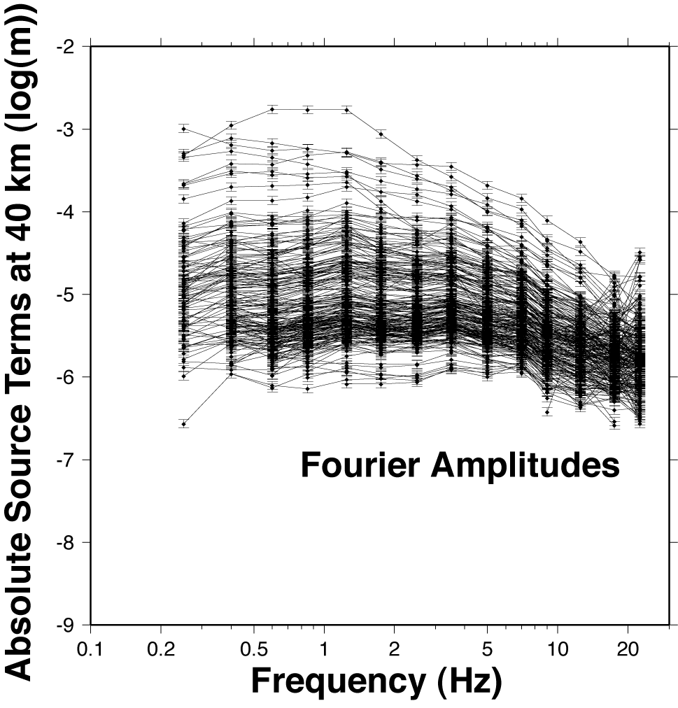
Figure 7 – Absolute source terms from the moment-rate spectra given by Mayeda et al. (2005). Spectral amplitudes were obtained from a 2-D attenuation tomography of Northern California. For the present plot, the moment-rate spectra were transformed to velocity spectra, then the regional attenuation function g(r)*exp(-πfr / βQ(f) ) was used to simulate the regional propagation to a hypocentral distance of 40 km.

Absolute Site Terms and H/V Spectral Ratios
It is believed that the strong ground motion is largely controlled by the characteristics of the geology in the upper 30 m (Anderson et al., 1996). ). Based on the characteristics of the velocity structure in the first 30 m, each site can be classified (e.g., NEHRP). Atkinson and Boore (1997) noticed that the NEHRP class C is the predominant site condition for the state of California.
Although the 30-m depth represents, typically, 0.1% – 0.2% of the distance from the seismic source, Anderson et al. (1996) concluded that the shallow geology has an influence on the ground motions that is comparable to that of the underlying several km of crustal rocks (5 km, in their numerical studyAs described by Malagnini et al. (2004), let a_{k}(r_{ij},f)=k-th observation (i.e., the Fourier spectral amplitude around frequency f, recorded at the hypocentral distance r_{ij}):
A_{k}(r_{ij},f)=EXC_{j}(r=r_{ref},f)+SITE_{i}(f)+D(r_{ij},r_{ref},f)
where: A_{k}(r_{ij},f)=log(a_{k}(r_{ij},f))
The term D(r_{ij},r_{ref},f) was obtained in a previous section, the terms EXC_{j}(r=r_{ref},f) are those taken from Mayeda et al. (2005), “propagated” to the 40 km reference distance, and plotted in Figure 7. Thus, we can cast all our observations in a matrix form, fix the known terms, and invert only for the site terms, SITE_{i}(f). Since the empirical excitation terms by Mayeda et al. (2005) are not biased by any site term, the site terms obtained with these regressions will be absolute, and represent the response of whatever is not included in the average path terms. In other words, they represent the absolute response from the surface to the depth of the bedrock, where all sites can be considered equivalent.

It is worth noticing (Figure 8) that our reference station (BRIB) behaves, up to 2 Hz, like the “Generic Rock Site” defined by Boore and Joyner (1997). The high-frequency decay at station BRIB can be described by a parameter κ₀=0.055 sec, superimposed to the same Generic Rock Site by Boore and Joyner (1997). A very similar roll-off characterizes stations CVS, JRSC, POTR, PACP. A steeper decay characterizes the site terms at high-frequency at stations BDM, BKS, MHC, and WENL.

Figure 8 shows also the H/V ratios at each station: in most cases, both the vertical and the horizontal ground motions are affected by significant distortions induced by the shallow geology. Thus, H/V ratios are usually not related in a simple way to the horizontal site responses.
The assumption we make here is that the H/V ratios do not depend on the distance from the source. Boore and Atkinson (1987) used a constant average ratio between each individual horizontal component of the ground motion and the vertical one: <H/V>=1.4; Atkinson (1993), using data from Eastern North America, observed almost constant, distance-independent H/V ratios. Atkinson (2004) analyzed a dataset from the Southeastern Canada and the Northeastern United States, and observed that the H/V ratios that she computed were not affected by any discernible trends with the distance from the source. At 90% confidence limit, she found: log(H/V)=0.0519+0.112log(f), with a standard error: σ(H/V)=0.24 log units. However, Herrmann and Malagnini (2005) showed that the H/V ratios could also depend on the source-receiver distance, since the vertical and the horizontal motions may decay with distance in different fashions, the attenuation of the horizontal motions is least sensitive to faulting mechanism, and differences in crustal structure may affect the vertical motions more strongly than the horizontal ones.

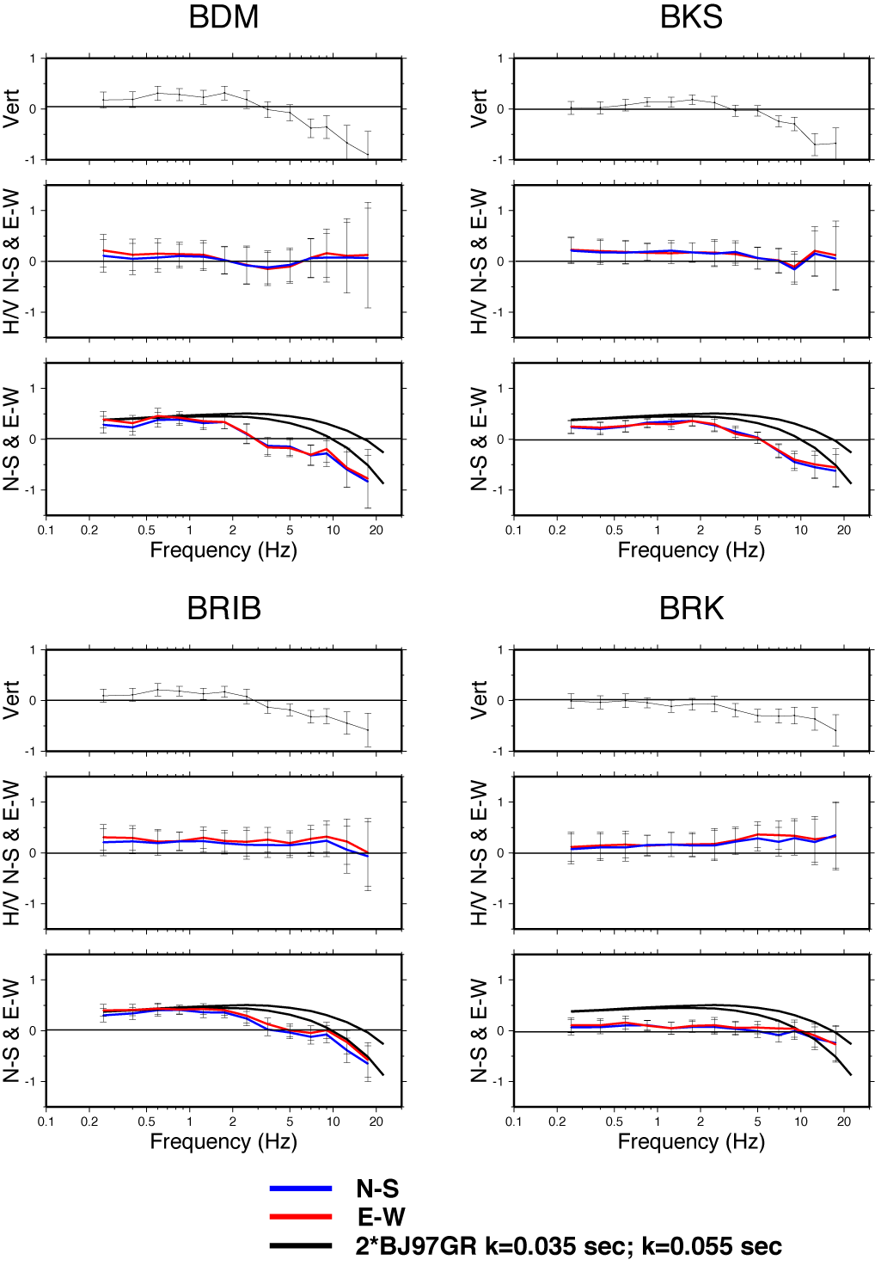

Figure 8 – Absolute site terms of stations BDM, BKS, BRIB, BRK. For each station, three frames are provided: the uppermost one shows the absolute vertical site term; the middle one shows the H/V ratios for the two horizontal components of the ground motion (N-S and E-W); the lower frame shows the absolute site terms for the two horizontal components of the ground motion (N-S, red, and E-W, blue), together with the generic rock site term by Boore and Joyner (1997) (black lines). The Generic Rock Site term proposed by Boore and Joyner (1997) was associated with an anelastic attenuation parameter κ₀=0.035 sec (Atkinson and Silva, 2000, upper black line). At the reference station BRIB, we propose  κ₀=0.055 sec, based on the high-frequency roll-off of its site term.
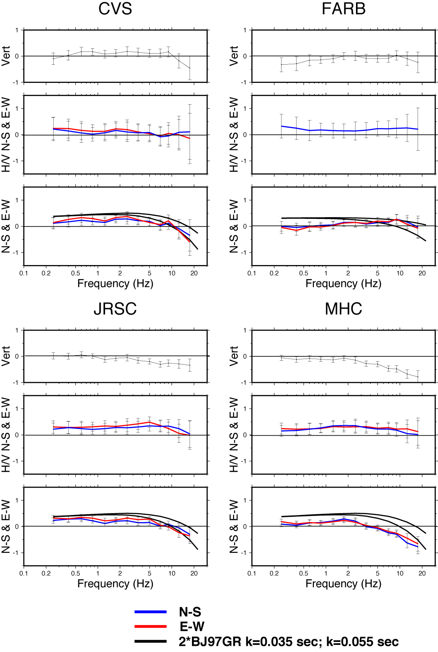

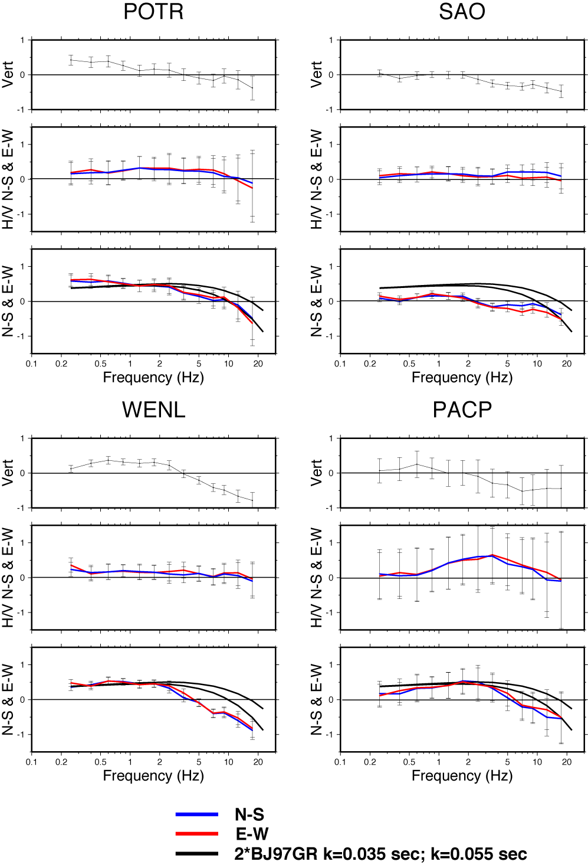

Moment Magnitude Calibration
The study by Mayeda et al. (2005) provided an absolute moment-rate spectrum for each earthquake used in this work. In order to compute a moment magnitude for each event, we applied the technique proposed by Bodin et al. (2004), based on the correction of the direct S-wave spectra for the attenuation they undergo along their paths. Two different codes were used: the first one would be analogous to the one used by Bodin et al. (2004), and would take into consideration only the average attenuation properties of the crust of the region, and of the network reference station: g(r)=r^{-1.0} for r≤30 km; g(r)=r^{-0.6} beyond that hypocentral distance; κ₀=0.055 sec; <R_{θϕ}>=0.55; β=3.5 km/sec; ρ=2.8e+03 kg/m³; F=2 (free surface effect); FF=0.707 (coefficient of partition of energy); T(r)=T(r,f=1,75 Hz); T=const=7 sec for r≤70 (r in km); T=0.01*r for r > 70 km (r in km). Duration is also augmented of the quantity T₀=1/f₀, the duration of the rupture. The estimates of M_{w} are calibrated against reference M_{w}’s from Mayeda et al. (2005), and results are plotted in Figure 9a. The second code would correct also for the absolute site term of each component of the ground motion. Results are shown in Figure 9b. The coda-wave moment magnitudes represent the “ground truth” of all the events.

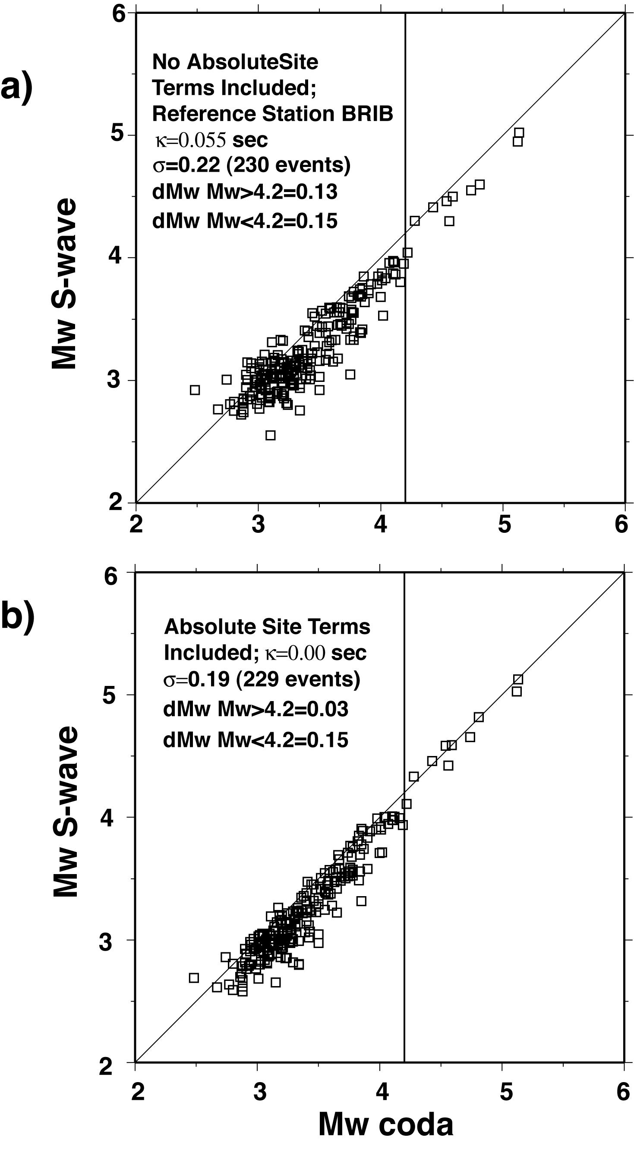
Figure 9: The picture is obtained using the code developed by Bodin et al. (2004) for the automatic computation of the moment magnitude, given g(r), Q(f), κ₀, and T(r) obtained from the regional study on excitation and attenuation of the ground motion. The parameters in the code are the following: g(r)∝ r⁻¹ to r=30 km; g(r)∝r^{-0.6} beyond that hypocentral distance; κ₀=0.055 sec; <R_{θφ}>=0.55; β=3.5 km/sec; ρ=2.8e+03 kg/m³; F=2 (free surface effect); FF=$\sqrt{2}$(coefficient of partition of energy);
T(r)=T(r,f=1.75 Hz); T=const.=7 sec for r<70 km; T=0.01*r for r>70 km (r in km). The coda-wave moment magnitudes represented our reference estimates. Frame a): Y-axis: automatically obtained S-wave M_{w}’s, computed by correcting the observed spectra for the regional attenuation (path term), and for the high-frequency attenuation relative to the reference station BRIB (κ₀=0.055 sec). X-axis: “ground truth”, coda-based M_{w}’s, computed by Mayeda et al (2005). Although the result may already be acceptable for validating our regional attenuation function, scatter of the data points make the automatic code useless for any real-time application. A magnitude residual of 0.13 is found for the median at M_{w}>4.2, whereas for magnitudes smaller than this threshold, a slightly larger residual is found (0.15 magnitude units). Since the choice of the reference station determines the absolute level of the corrected S-wave spectra, such adjustments are caused by an absolute deamplification of the ground motion observed at the reference station BRIB, at frequencies f≥ 1 Hz (see the comparison with the generic rock site of Boore and Joyner, 1987, shown in Figure 8). Frame b): after the inclusion of the absolute site terms in the automatic computation of S-wave M_{w}’s (see later section), not only the variance is reduced (the presence of large outliers prevents a large reduction), but the absolute levels of the largest M_{w}’s are very well matched with the ground truth ones. A residual adjustment of 0.03 magnitude units would be needed to perfectly match (in an L-1 sense), the ground truth values. For smaller magnitudes (M_{w}<4.2), scatter is larger and a residual adjustment of 0.15 magnitude units is found.

Local Magnitude Station Adjustments (δM_{L})
Station adjustments (δM_{L}) for the 12 stations in this study were calculated using a selected group of 16 local and regional earthquakes (Table 1) which were recorded by all three broadband components at all 12 stations between 2003/09/05 and 2004/12/15 and with an adequate signal-to-noise level (0.217mm < A < 890mm). The waveforms were deconvolved to ground motion and convolved with the response of a standard Wood-Anderson (WA) torsion seismograph (Uhrhammer et al., 1996). The maximum trace amplitude (A: measured zero to peak in mm) foreach synthesized WA (SWA) seismogram was then determined.

Table 1. Earthquakes selected for δM_{L} analysis.
Date | Time | Latitude | Longitude | Depth | M_{L} | sem
2003/09/05 | 01:39 | 37.84 | -122.22 | 10.9 | 4.20 | 0.044
2003/09/25 | 14:33 | 36.82 | -121.35 | 6.3 | 3.40 | 0.042
2003/10/24 | 22:00 | 36.70 | -121.34 | 4.9 | 3.42 | 0.041
2003/11/06 | 22:04 | 37.21 | -121.66 | 7.0 | 3.85 | 0.034
2004/01/31 | 02:11 | 37.10 | -121.56 | 6.9 | 3.74 | 0.037
2004/03/16 | 06:38 | 36.81 | -121.52 | 5.2 | 4.49 | 0.044
2004/04/29 | 19:49 | 37.73 | -121.82 | 18.8 | 3.65 | 0.044
2004/05/04 | 17:25 | 36.70 | -121.29 | 5.7 | 3.6 | 0.042
2004/08/30 | 04:30 | 36.58 | -121.18 | 8.9 | 3.79 | 0.034
2004/08/31 | 09:12 | 36.59 | -121.18 | 6.8 | 3.32 | 0.034
2004/09/22 | 10:57 | 36.80 | -121.53 | 8.1 | 3.59 | 0.046
2004/10/25 | 19:55 | 36.97 | -121.60 | 7.5 | 3.89 | 0.029
2004/11/01 | 22:02 | 37.07 | -122.28 | 9.1 | 3.47 | 0.055
2004/11/24 | 02:06 | 36.61 | -121.21 | 6.9 | 4.42 | 0.041
2004/11/24 | 05:23 | 36.60 | -121.20 | 7.0 | 3.24 | 0.043
2004/12/15 | 04:16 | 36.64 | -121.25 | 10.7 | 3.80 | 0.047

Once the WAS maximum trace amplitudes (A) were determined for each station/component (576 total observations), the local magnitude (M_{L}) was determined for each earthquake from the average of the individual horizontal component A’s using the classic formulation of Richter:
M_{L} = log A – log Ao(Δ)
Where –log(Δ) is given analytically by:
-log Ao(Δ) = 10 0.3173 exp( -0.00505 R / R ^1.14 )
The δM_{L} for each component at each station is then determined from their respective mean residuals and the results are given in Table 2.

Table 2

Station Name | Component | Abs-Site ±σ(Abs-Site) |  | δM_{L}±σ(δM_{L})
BDM | HHZ | 0.223 | 0.112 | -0.084 | 0.084
BDM | HHE | 0.376 | 0.112 | 0.025 | 0.124
BDM | HHN | 0.338 | 0.111 | 0.011 | 0.132
BKS | HHZ | 0.134 | 0.083 | -0.122 | 0.128
BKS | HHE | 0.294 | 0.084 | 0.041 | 0.112
BKS | HHN | 0.346 | 0.081 | 0.033 | 0.14
BRIB | HHZ | 0.129 | 0.092 | -0.105 | 0.124
BRIB | HHE | 0.427 | 0.086 | 0.155 | 0.148
BRIB | HHN | 0.363 | 0.087 | 0.068 | 0.12
BRK | HHZ | -0.113 | 0.096 | -0.348 | 0.1
BRK | HHE | 0.047 | 0.096 | -0.141 | 0.124
BRK | HHN | 0.051 | 0.096 | -0.153 | 0.12
CVS | HHZ | 0.081 | 0.121 | -0.29 | 0.104
CVS | HHE | 0.215 | 0.123 | -0.117 | 0.12
CVS | HHN | 0.148 | 0.129 | -0.219 | 0.116
FARB | HHZ | -0.097 | 0.122 | -0.37 | 0.112
FARB | HHE | 0.032 | 0.113 | -0.202 | 0.164
FARB | HHN | 0.056 | 0.111 | -0.187 | 0.152
JRSC | HHZ | -0.107 | 0.084 | -0.252 | 0.124
JRSC | HHE | 0.221 | 0.081 | 0.098 | 0.14
JRSC | HHN | 0.119 | 0.081 | 0.037 | 0.14
MHC | HHZ | -0.133 | 0.081 | -0.289 | 0.172
MHC | HHE | 0.191 | 0.081 | 0.015 | 0.196
MHC | HHN | 0.216 | 0.079 | 0.041 | 0.18
PACP | HHZ | -0.007 | 0.313 | -0.239 | 0.168
PACP | HHE | 0.406 | 0.321 | 0.233 | 0.176
PACP | HHN | 0.414 | 0.322 | 0.18 | 0.14
POTR | HHZ | 0.121 | 0.131 | -0.18 | 0.132
POTR | HHE | 0.450 | 0.129 | 0.067 | 0.112
POTR | HHN | 0.447 | 0.133 | 0.082 | 0.112
SAO | HHZ | -0.005 | 0.089 | -0.325 | 0.176
SAO | HHE | 0.156 | 0.080 | -0.19 | 0.18
SAO | HHN | 0.148 | 0.080 | -0.192 | 0.152
WENL | HHZ | 0.280 | 0.086 | 0.02 | 0.148
WENL | HHE | 0.427 | 0.087 | 0.128 | 0.14
WENL | HHN | 0.458 | 0.085 | 0.186 | 0.14

Table 2. For each station used in this study, the table indicates the ML residual, with the corresponding error bar, and the corresponding absolute site term at 1.25 Hz, with its error bar. All the values about the horizontal components of the ground motion, for which the error bar is <0.2, are plotted in Figure 10. Station PACP, characterized by an error > 0.2 on the absolute site terms at 1.25 Hz, is missing in Figure 10.

Discussion of the Local Magnitude Adjustments (δM_{L})
The average residual difference M_{L} between the vertical (V) and horizontal (H) components is –0.194 ± 0.076. Thus +0.194 should be added to the H δM_{L} estimate to obtain the corresponding V δM_{L} estimate for comparison (Table 3).

Table 3.
Station | δM_{L}(V) | Surface Geology
PAS | +0.394 | Granite
BRK | +0.348 | Franciscan Sandstone
FARB | +0.370 | Granite
SAO | +0.325 | Granite

Table 3. Average vertical component local magnitude at the stations sited on hard rock. PAS, located in a granite tunnel, which extends approximately 7 meters into a hillside in Southern California, is given for comparison because it was one of the original stations used in Richter’s classic 1935 Local Magnitude paper.

The δM_{L}(V) for PAS, which is sited on granite, is comparable to the δM_{L}(V) values for the BDSN stations that are also sited on granite or hard rock. This implies that there is not a significant bias in the δM_{L}(V) values for northern and southern California. Using FARB as the reference station (because it is sited on granite) and assuming that δM_{L}(V) = +0.37 corresponds to Vs30 = 3300 (the value for granite), the estimated Vs30 values for the 12 BDSN stations used in this study are given in Table 4.

Table 4.

Station | δM_{L}(V) | Amp | Vs30 (m/s) | Bedrock
BDM | +0.084 | 0.52 | 1900 | Sand
BKS | +0.122 | 0.56 | 2050 | Claremont Cherts Shales
BRIB | +0.105 | 0.54 | 1980 | Sandstone
BRK | +0.348 | 0.95 | 3170 | Franciscan Sandstone
CVS | +0.290 | 0.83 | 2840 | Tuff
FARB | +0.370 | 1.00 | 3300 | Granite (reference station)
JRSC | +0.252 | 0.76 | 2640 | Serpentine
MHC | +0.289 | 0.83 | 2840 | Franciscan Graywacke and Greenstone
PACP | +0.223 | 0.71 | 2500 | Miocene Volcanic Andesite
POTR | +0.180 | 0.65 | 2300 | Eocene Marine
SAO | +0.325 | 0.90 | 3040 | Gabilan Granite
WENL | +0.020 | 0.45 | 1670 | Miocene Marine

Where it was assumed that the Vs30 value is proportional to ρVs and ρ = 2.01 + 0.182Vs (a variant of Birch's empirical relation). For Vs30 = 760, the corresponding δM_{L}(V) = -0.268 which corresponds to a very soft alluvial site. For reference, the two softest sites, that were previously occupied by BDSN stations, are STAN and PKD1 which had δM_{L}(V) estimated adjustments of -0.039 and -0.004, respectively. The average residual M_{L} difference between the V and H components is -0.194± 0.076 (excluding PACP which was not on the 1.25 Hz plot).

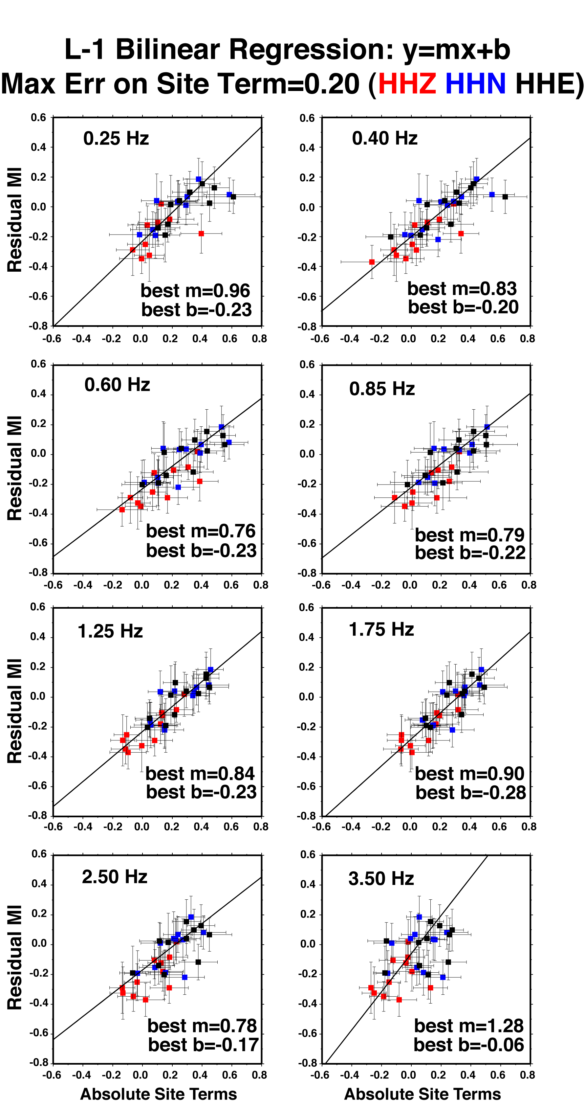

Figure 10. The plots show the correlation between the absolute site terms obtained at some of the central sampling frequencies, and the M_{L} residuals (not a function of frequency). M_{L} residuals were obtained by multiplying the M_{L} adjustments of Table 2 by –1.0. Each frame shows all the data points, with the error bars on both the x- and y- axes. A bilinear regression is performed at each central frequency, in the L1-sense. The best parameters of the linear functions are indicated for each frequency. The visual inspection of the eight frames indicate that, although all the frequencies up to 2.5 Hz show a good degree of correlation, the linear trend of the data set of 1.25 Hz is characterized by the best linear correlation. This is in good agreement with the value of the median dominant frequency on which the M_{L} are computed, found during the analysis of the M_{L} corrections (f_{d}=1.3± 0.3 Hz). The central frequency of 1.75 Hz also shows an excellent correlation. The results shown in the figure are similar to the ones described in the paper by Mayeda et al. (1991), where a similar analysis was performed on coda spectral measurements. The data points of the chosen best frequency (1.25 Hz) are quantified in Table 2. Correlation deteriorates beyond 2 Hz, and definitely breaks down at f=3.5 Hz. Higher sampling frequencies (not shown in this picture) show no correlation at all.

Figure xx a) Y-axis: automatically obtained S-wave M_{w}’s, computed by correcting the observed spectra for the regional attenuation (path term), and for the high-frequency attenuation relative to the reference station BRIB (κ₀=0.055 sec). X-axis: “ground truth”, coda-based M_{w}’s, computed by Mayeda et al (2005). Although the result may already be acceptable for validating our regional attenuation function, scatter of the data points make the automatic code useless for any real-time application. A magnitude residual of 0.13 is found for the median at M_{w}>4.2, whereas for magnitudes smaller than this threshold, a slightly larger residual is found (0.15 magnitude units). Since the choice of the reference station determines the absolute level of the corrected S-wave spectra, such adjustments are caused by an absolute deamplification of the ground motion observed at the reference station BRIB, at frequencies f≥ 1 Hz (see the comparison with the generic rock site of Boore and Joyner, 1987, shown in Figure 8). b) after the inclusion of the absolute site terms in the automatic computation of S-wave M_{w}’s, not only the variance is reduced (the presence of large outliers prevents a large reduction), but the absolute levels of the largest M_{w}’s are very well matched with the ground truth ones. A residual 0.03 magnitude units adjustment would be needed to perfectly match (in an L-1 sense), the ground truth values. For smaller magnitudes (M_{w}<4.2), scatter is larger and a residual adjustment of 0.15 magnitude units is found.

Predicting the Ground Motion
All the information on the characteristics of excitation, regional propagation, duration of the ground motion, and site response for a Generic Rock Site (amplification function of Boore and Joyner, 1997, coupled to a high-frequency attenuation parameter κ₀=0.035 sec, as recommended by Boore and Joyner, 1997), is used to produce predictions for peak ground motions in the Bay Area. The quantities that will be modeled are the peak horizontal acceleration, the peak horizontal velocity, and the horizontal spectral acceleration at 0.33, 1.0, and 5.0 Hz. The stress parameters, because of the obvious tradeoff with the site terms used, need to be calibrated over the existing observations. We will do this calibration on data between magnitudes M_{w} 6.0 and 7.0. The spectral model used for providing ground motion predictions is the single-corner Brune’s one. Stress parameters of 10 MPa are used between M_{w} 5 and 5.5, and then the stress drop increases to 15 MPa at Mw 6.0 and 7.0. In doing so, we provide an effective model for the excitation and propagation of the ground motion in the extended Bay Area region, calibrated over the wide range of magnitude available in the region.
When compared to the “true” values of the stress parameter, the ones decoupled from the site term at the reference station BRIB, we find values of 4 MPa at M_{w} 5, 5 MPa at M_{w} 5.5, roughly a factor of two smaller than the stress parameters needed when the Brune source is coupled to the BJ97 generic rock site. Because of the “absoluteness” of the site term used, the stress parameters coupled to the BRIB site term may be representative of the actual stress drop of the events. If the factor of two holds at all magnitudes, a stress drop of about 7.5 MPa may be representative of the actual stress drop for the Loma Prieta event.

By taking ratios between the amplification tables for specific NEHRP class sites provided by BJ97, we obtain tables to be used for RVT predictions of peak ground shaking for each NEHRP site class. We present RVT predictions for NEHRP site classes C and D. In Figure 10, our predictions for site C and D are plotted as thin and thick lines, respectively, whereas open and solid symbols are used for observations at sites C and D, respectively. Predictions taken from AS2000 are also plotted in Figure 10. They are available for rock and soil sites (no further classification was available from their study).

Figure 10 shows the comparison between RVT predictions and observed peak values (PGA, PGV, and PSA's at 0.33 Hz, 1.0 Hz, and 5.0 Hz, as a function of hypocentral distance), for the Loma Prieta earthquake of 1989 (M_{w} 7.0), a M_{w} 6.2 event, and two M_{w} 5.8 earthquakes. The observations are taken from the NGA Strong Motion database, which provides observed strong ground motion as a function of hypocentral distances (other metrics are also used). The values of static stress drop used in these RVT predictions was Δσ=10 MPa (NOTE: is this value correct?). Our predictions are also compared against those obtained using the ground motion tables provided, for rock and for soil sites, by Atkinson and Silva (2000).
We note that, at M_{w} 7, PGA’s and PGV’s are well-modeled as a function of distance, PSA's at 5.0 Hz are well predicted by our model, and also by Atkinson and Silva (2000) (soil site, Figure 10). The PSA at 1.0 Hz is well-predicted by our model, and also by the model by Atkinson and Silva (2000), whereas the PSA at 0.33 Hz is well-predicted by us, and underestimated by Atkinson and Silva (2000). See Figure 10 for comparisons.
For the M_{w}’s 5.8 and 6.2, except for the frequency of 0.33 Hz, for which we do a better job than Atkinson and Silva (2000), PGA and PGV are equally well-predicted by our model, and by Atkinson and Silva (2000).

Figure 11 shows RVT Predictions of the horizontal ground acceleration for NEHRP sites C and D (parameters from this study, thick lines marked M2005-[CD]), compared with values provided by Atkinson & Silva (2000) for generic rock and soil sites (thin lines marked AS2000-G[RS]). Peak acceleration data are from the Parkfield, September 28, 2004 earthquake (M_{w} 6.0). The stress drop used to produce the predictions of Figure 11 is 15 MPa.

In Figure 12 are plotted the horizontal spectral accelerations predictions (in unit of g), based on results of this study, are provided for the Boore and Joyner (1997) generic rock site (marked M[?]-GR), and for NEHRP site class D (marked M[?]-D), for M 5, 6, and 7 (respectively, blue, black, and red lines), at 20 and 50 km epicentral distance. For comparison, predictions from Atkinson and Silva (2000) are also plotted in the same colors, with thicker lines marked M[?]-AS00-[RS]. The source model used was the single corner Brune spectrum, with a magnitude-dependent stress parameter.

For all the predictions of Figures 10, 11, and 12, we used the Generic Rock Site amplification factor by BJ97, coupled with a high-frequency parameter κ₀=0.035 sec, and a stress drop Δσ=10 MPa at M=5.0 and M=5.5; Δσ=15 MPa at M=6.0 and M=7.0.

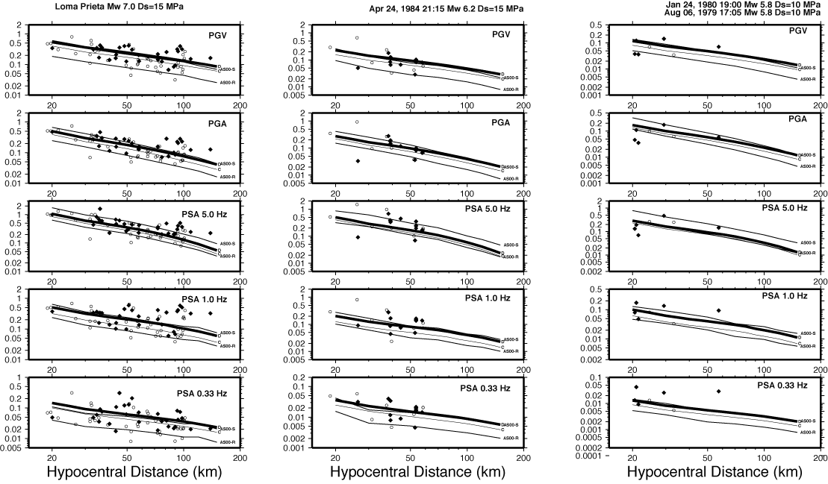
Figure 10 – Predictions of ground shaking for three different magnitudes: M_{w} 7.0 (Loma Prieta), 6.2 (Morgan Hill), and 5.8. Solid symbols are relative to NEHRP class D sites, whereas clear symbols refer to NEHRP class C sites. Our predictions are marked C (thin line) and D (thick line). They are relative to horizontal peak ground velocity (in m/s, top frame), horizontal peak ground acceleration (second top frame, in units of g), and in horizontal spectral accelerations at three reference frequencies (in units of g): 0.33 Hz, 1.0 Hz, and 5.0 Hz. All our results were computed relative to the generic rock site term by Boore and Joyner (1997), integrated with the high-frequency filter exp(-πκ₀f), κ₀=0.035 sec. Boore and Joyner (1997) also provided tables that allow us to obtain predictions for different NEHRP class sites, by simply taking the ratios between the tables specific to some NEHRP class, and the correspondent amplification amplitudes given for the Generic Rock Site.

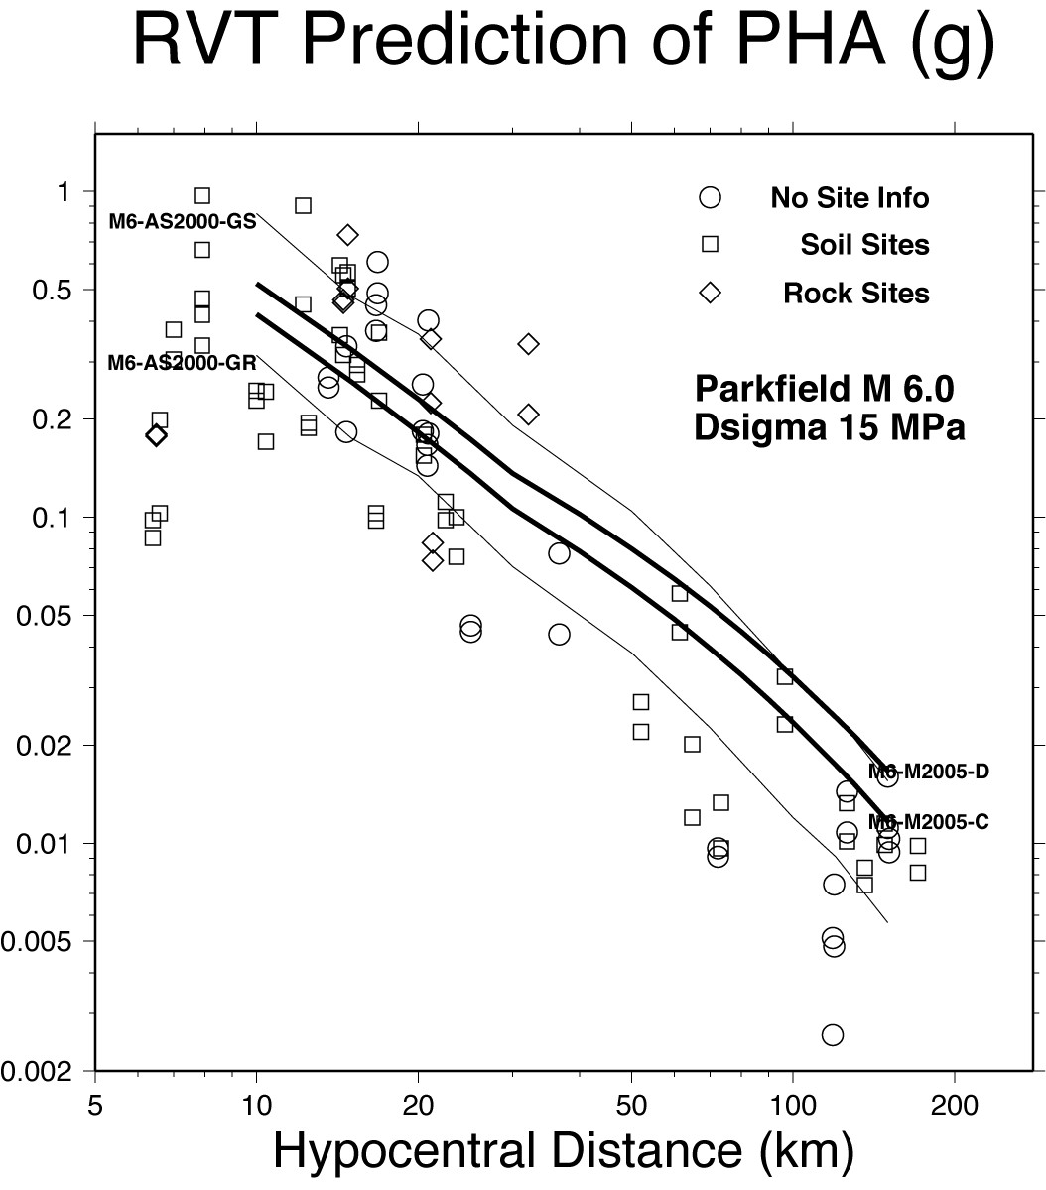
Figure 11 - RVT Predictions of the horizontal ground acceleration for NEHRP sites C and D (parameters from this study, thick lines marked M2005-[CD]), compared with values provided by Atkinson & Silva (2000) for generic rock and soil sites (thin lines marked AS2000-G[RS]). Peak acceleration data are from the Parkfield, September 28, 2004 earthquake (M_{w} 6.0).

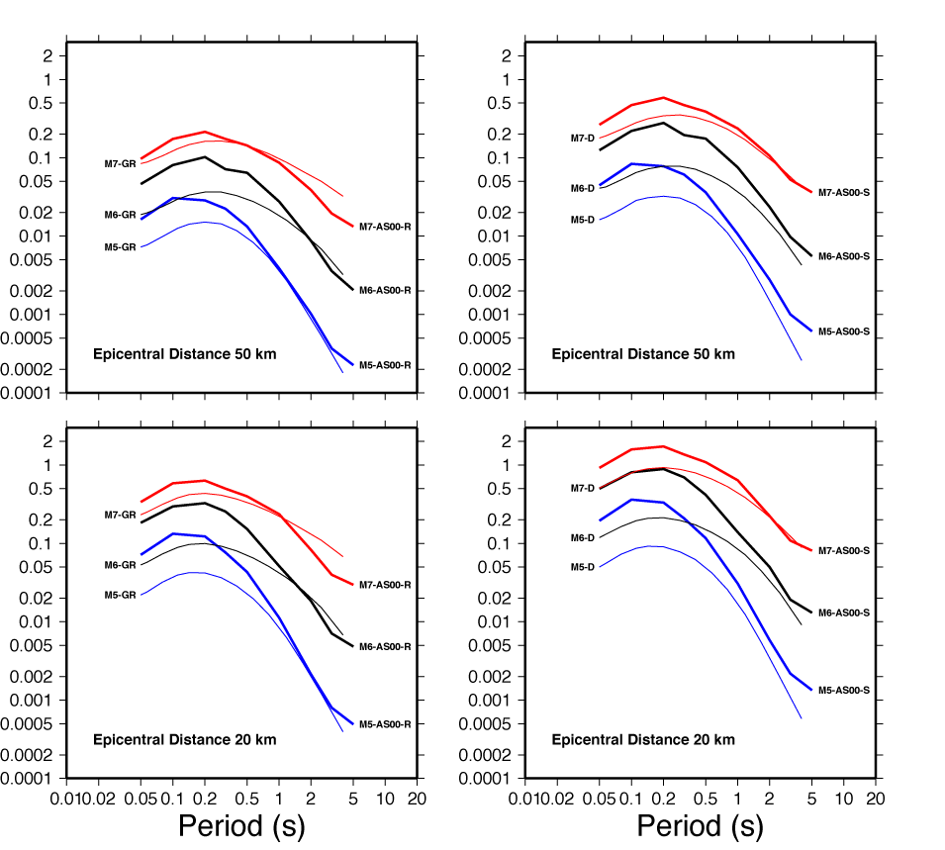

Figure 12 – Horizontal spectral accelerations predictions (in unit of g), based on results of this study, are provided for the Boore and Joyner (1997) generic rock site (marked M[?]-GR), and for NEHRP site class D (marked M[?]-D), for M 5, 6, and 7 (respectively, blue, black, and red lines), at 20 and 50 km epicentral distance. For comparison, predictions from Atkinson and Silva (2000) are also plotted in the same colors, with thicker lines marked M[?]-AS00-[RS]. The source model used was the single corner Brune spectrum, with a magnitude-dependent stress parameter.

In obtaining Figures 10, and 11, we used hypocentral distances, whereas in Figure 12 we used epicentral distance. This is not an issue for small, shallow earthquakes and/or for large distances, since hypocentral, epicentral, and fault distance tend to coincide when distances are large compared to the fault dimensions. Also, we can easily transform hypocentral distances to epicentral ones for point sources. For small events (our entire magnitude range) epicentral distances coincide to fault distances. AS2000 used the metrics: R=$\sqrt{d^{2}+b^{2}}$, where d is the closest distance to the fault plane, and b≈5 at M_{w}≈5, and b≈14 for M_{w}≈8. We point out that predictive relationships based on epicentral distances are very important in near-real-time applications like ShakeMap, to predict the ground motion in a region when the fault geometry responsible for a certain earthquake is still unknown.

Discussion and Conclusions
A number of motivations are behind this study: i) in California, strong- and weak-motion data are abundant, and so we could easily develop a weak-motion-based predictive relationship that could be compared, in the range of magnitudes sampled by our data set, against the existing, strong-motion-based relationships; ii) we wanted to experiment the extrapolation of our predictions to magnitudes outside the range sampled by the data set, in order to understand the utility of a weak-motion-based relationship for predicting strong-motion shaking; iii) we wanted to calibrate our predictive relationships over specific NEHRP site classes, via the calculation of the absolute site terms for each station of the BDSN used in this study. After calibrating our relationships on an arbitrary NEHRP class, we are automatically able to predict the ground motion at all NEHRP classes, using results that are especially suitable for earthquakes of moderate magnitudes (M_{w}≤6, or even 6.5).

That of the moderate magnitudes is a very important issue, in California and elsewhere. From the results of this study, Figure 12 for example, it is clear that the high-frequency spectral acceleration that can be predicted with our regional results for an M5 earthquake is very different from what can be computed using a tool calibrated mostly on strong-motion data (i.e., the spectral accelerations labeled AS00 in Figure 12). A consequence is that, for a moderate earthquake of M5, the ShakeMaps relative to spectral acceleration at high-frequency (Wald et al., ...) obtained using our predictive relationships would be very different from those obtained using AS2000. The effects of moderate earthquakes may be very important, within the US, but especially in the extended Mediterranean region, where historical building may suffer substantial damage even from relatively small events. Attention should therefore be paid to carefully calibrate ground motion predictive relationships around M_{w} 5.

We estimated the absolute site terms of a number of stations of the BDSN, and compared them with the corresponding H/V ratios. It is beyond doubt that the H/V ratios are intimately connected to the true site transfer functions of the horizontal motion. However, we found that the H/V spectral ratios do not reproduce the horizontal site responses at any of the BDSN stations. Our results differ from the ones presented by Malagnini et al. (2005) about the sites of a temporary deployment around the Bhuj mainshock area, but they agree with the conclusions by Malagnini et al. (2004) on the responses of four rock sites of the Friuli-Venezia Giulia seismic network. We conclude that the main assumption on which the H/V method is based (the vertical motion is undisturbed, whereas the site distortion affects only the horizontal motion) is not valid at the sites of the BDSN. This statement indicates that the mentioned assumption is not valid in general, and forces us to conclude that the estimates of the site transfer functions obtained through the H/V spectral analysis should not, under any circumstances, be considered estimates of the horizontal site transfer functions without further investigations.

A further concluding remark, already stated by Malagnini et al (2004), is that rock sites often, if not always, are characterized by their own responses. Possible exceptions are the very hard rock sites of previously glaciated regions, like the ones in Eastern North America that were used by Atkinson (2004) for a study on the regional attenuation of the strong ground motions. In order to obtain a complete picture of how different sites distort the seismic waves, we plan to determine the absolute site responses of very hard-rock sites of the Canadian seismic network, for which Atkinson (2004) already pointed out that no important distortions affected the vertical ground motions.

Acknowledgements
This work has been partially supported under project FIRB, Prot. RBAU013NRZ_001, funded by the Italian Ministero dell’Universita’ e della Ricerca Scientifica (MIUR), and under project S4 (INGV-DPC).

References

Abrahamson, N. A. and Shedlock, K. M. (1997). Overview, Seism. Res. Lett., 68, 9-23.

Akinci, A., et al (2005). Marmara...

Anderson, J.G., Y. Lee, Y. Zeng, and S.Day (1996). Control of strong motion by the upper 30 meters. Bull. Seism. Soc. Am. 86, 1749-1759

Atkinson, G. (2004). Empirical attenuation of ground motion spectral amplitudes in southeastern Canada and the northeastern United States. Bull. Seism. Soc. Am., in press

Atkinson, G. M., and W. Silva (2000). Stochastic modeling of California ground motions, Bull. Seism. Soc. Am. 90, 255-274.

Atkinson, G.M. and D.M. Boore (1997). Some Comparisons Between Recent Ground-Motion Relations, Seismological Research Letters, Vol. 68, No. 1, pp. 24-40.

Atkinson, G.M. and D.M. Boore (1997). Stochastic point-source modeling of ground motions in the Cascadia region, Seism. Res. Lett. 68, 74–85.

Atkinson, G. M., and D. M. Boore (1995). Ground-motion relations for eastern North America, Bull. Seism. Soc. Am. 85, 17-30.

Atkinson, G. (1993). Notes on ground motion parameters for eastern North America: Duration and H/V ratio. Bull. Seism. Soc. Am., 83, 587-596.

Bard, ……

Bodin,…..

Boore, D. M. and W. B. Joyner (1997). Site amplifications for generic rock sites, Bull. Seism. Soc. Am., v. 87, p. 327-341.

Boore, D. M., W. B. Joyner, and L. Wennerberg (1992). Fitting the stochastic ω⁻² source model to observed response spectra in western North America: Trade-offs between Δσ and κ, Bull. Seism. Soc. Am., 82, 1956-1963.

Boore, D. (1983). Stochastic simulation of high-frequency ground motions based on seismological models of the radiated spectra, Bull. Seism. Soc. Am., 73, 1865-1894.

Boatwright, J., G. L. Choy, and L. C. Seekins (2002). Regional estimates of radiated seismic energy in The Hector Mine, California, earthquake of 16 October 1999, Bull. Seism. Soc. Am., 92, 1241-1255

Boatwright, J., and G. L. Choy (1992). Acceleration source spectra anticipated for large earthquakes in northeastern North America, Bull. Seism. Soc. Am., 82, 660 - 682.

Campbell, K.W., and Y. Bozorgnia (2003). Updated near-source ground motion (attenuation) relations for the horizontal and vertical components of peak ground acceleration and acceleration response spectra, Bull. Seism. Soc. Am., 93, 314-331

Chen, S., and G. M. Atkinson (2002). Global Comparisons of Earthquake Source Spectra, Bull. Seism. Soc. Am., 92, 885-895; DOI: 10.1785/0120010152.

Cornou, C., P.-Y. Bard, and M. Dietrich (2003a). Contribution od dense array analysis to the identification and quantification of basin-edge-induced waves, part I: methodology, Bull. Seism. Soc. Am., 93, 2604-2623.

Cornou, C., P.-Y. Bard, and M. Dietrich (2003b). Contribution of dense array analysis to the identification and quantification of basin-edge-induced waves, part II: application to Grenoble basin, (French Alps), Bull. Seism. Soc. Am., 93, 2624-2648.

EPRI (1993). Guidelines for determining design basis ground motions. Early site permit demonstration program, Vol. 1, RP3302, Electric Power Research Institute, Palo Alto, Calif.

Gutenberg, B. and C. F. Richter (1942)…

Hanks, T. and R. McGuire (1981). The character of high-frequency strong ground motion, Bull. Seism. Soc. Am., 71, 2071-2095.

Havenith, H-B., D. Jongmans, E. Faccioli, K. Abdrakhmatov, and P.-Y. Bard (2002). Site effect analysis around the seismically induced Anaevo rockslide, Kyrgyzstan
Bull. Seism. Soc. Am. 92, 3190-3209.

Herrmann, R.B., and L. Malagnini (2005). Interpretation of High Frequency Ground Motion from Regional Seismic Network Observations, Bull. Seism. Soc. Am., submitted.

Lebrun, B., D. Hatzfeld and P.-Y. Bard, 2001. A site effect study in urban area: experimental results in Grenoble (France), Pageoph, 158, 2543-2557.

Malagnini, L., R.B. Herrmann, and M. Di Bona (2000a). Ground-Motion Scaling in the Apennines (Italy), Bul. Seism. Soc. Am., 90, 1062-1081.

Malagnini, L. and R.B. Herrmann (2000b). Ground-Motion Scaling in the Region of the 1997 Umbria-Marche Earthquake (Italy), Bull. Seism. Soc. Am., 90, 1041-1051.

Malagnini, L., R.B. Herrmann, and K. Koch (2000c). Regional Ground-Motion Scaling in Central Europe, Bull. Seism. Soc. Am., 90, 1052-1061.

Malagnini, L., P. Bodin, K. Mayeda, and A. Akinci (2005). Unbiased moment-rate spectra and absolute site effects in the Kachchh basin, India, from the analysis of the aftershocks of the 2001 Mw 7.6 Bhuj earthquake, Bull. Seism. Soc. Am., submitted.

Malagnini, L., K. Mayeda, A. Akinci, and P. L. Bragato (2004). Estimating absolute site effects, Bull. Seism. Soc. Am, 94, 1343-1352

Malagnini, L., A. Akinci, R. B. Herrmann, N.A. Pino, and L. Scognamiglio (2002). Characteristics of the Ground Motion in Northeastern Italy, Bull. Seism. Soc. Am., 92, 2186-2204.

Malagnini L., R.B. Herrmann and M. Di Bona (2000). Ground motion scaling in the Apennines (Italy). Bull. Seism. Soc. Am.,90, 1062-1081.

Mayeda, K., L. Malagnini, W. S. Phillips, W. R. Walter, and D. Dreger (2005), 2-D or not 2-D, that is the question: A northern California test, Geophys. Res. Lett., 32, L12301, doi:10.1029/2005GL022882.

Mayeda, K. and W. R. Walter (1996). Moment, energy, stress drop, and Source spectra of western United States earthquakes from regional coda envelopes, J. Geophys. Res., 101, 11195-11208.

Mayeda, K., A. Hofstetter, J. Boyle and W. R. Walter (2003). Stable and Transportable Regional Magnitudes Based on Coda-Derived Moment-Rate Spectra, Bull. Seism. Soc. Am., 93, 224-239.

Mayeda, K., S. Koyanagi, and K. Aki (1991). Site amplification from S-wave coda in the long Valley Caldera region, California, Bull. Seism. Soc. Am., 81, 2194-2213.

Morasca, P., Malagnini, L., Akinci, A. & Spallarossa, D., (2005). Ground-motion scaling in the western Alps, Bull. seism. Soc. Am., submitted.

Morasca, P., K. Mayeda, L. Malagnini, and W. R. Walter (2005b). Coda-derived source spectra, moment magnitudes and energy-moment scaling in the western Alps, Geophys. J. Int., 160, 263- doi:10.1111/j.1365-246X.2005.02491.x

Richter, C. F. (1935)…

Schneider, J.F., W.J. Silva, and C. Stark (1993). Ground motion model for the 1989 M 6.9 Loma Prieta earthquake including effects of source, path, and site, Earthquake Spectra 9, 251-287

Scognamiglio, L., L. Malagnini, and A. Akinci (2005). Ground-Motion Scaling in Eastern Sicily, Italy, Bulletin of the Seismological Society of America, 95, 568-578; DOI: 10.1785/0120030124.

Silva, W.J. and R. Darragh (1995). Engineering characterization of earthquake strong ground motion recorded at rock sites. Palo Alto, California, Electric Power Research Institute, TR-102261

Spudich, P., Fletcher, J.B., Hellweg, M., Boatwright, J., Sullivan, C., Joyner, W.B., Hanks, T.C., Boore, D.M., McGarr, A., Baker, L.M., and Lindh, A.G. (1997). SEA96 - A new predictive relation for earthquake ground motions in extensional tectonic regimes: Seism. Res. Lett., v. 68, pp 71-79.

Spudich, P., Fletcher, J.B., Hellweg, M., Boatwright, J., Sullivan, C., Joyner, W.B., Hanks, T.C., Boore, D.M., McGarr, A., Baker, L.M., and Lindh, A.G., 1996, Earthquake Ground Motions in Extensional Tectonic Regimes, U.S. Geological Survey Open File Report 96-292, 351 pp.

Steidl, J. H., A. G. Tumarkin, and R. J. Archuleta (1996). What is a reference site? Bull. Seism. Soc. Am. 86, 1733-1748.

Toro, G.R., N.A. Abrahamson, and J.F. Schneider (1997), Model of Strong Ground Motions from Earthquakes in Central and Eastern North America: Best Estimates and Uncertainties, Seism. Res. Lett., 68, 41-57.

Raoof, M., R.B. Herrmann, and L. Malagnini (1999). Attenuation and excitation of three-component ground motion in Southern California, Bull. Seism. Soc. Am., 89,888-902. (move to alphabetical order)

Somerville, P. G., N. F. Smith, R. W. Graves, and N. A. Abrahamson (1997). Modification of empirical strong ground motion attenuation relations to include the amplitude and duration effects of rupture directivity, Seism. Res. Lett., 68, 199-222. (move to alphabetical order)

Toro, G.R., and R.K. McGuire (1987). An Investigation into Earthquake Ground Motion Characteristics in Eastern North America, Bull. Seism. Soc. Am., 77, 468-489.

Uhrhammer, R. A., S. J. Loper and B. Romanowicz, Determination of Local Magnitude Using BDSN Broadband Records, Bull. Seism. Soc. Am., 86, 1314-1330, 1996.

Wald,…

Wells, D. L., and Coppersmith, K. J. (1994). New empirical relationships among magnitude, rupture length, rupture width, rupture area, and surface displacement, Bull. Seism. Soc. Am., 84, 974-1002.

Yazd, M. R. S. (1993). Ground motion studies in the southern great basin of Nevada and California. PhD-thesis, St.Louis University.

Table 2

Station Name | Component | Abs-Site ±σ(Abs-Site) |  | dM_{L}±σ(dM_{L})
BDM | HHZ | 0.223 | 0.112 | -0.084 | 0.084
BDM | HHE | 0.376 | 0.112 | 0.025 | 0.124
BDM | HHN | 0.338 | 0.111 | 0.011 | 0.132
BKS | HHZ | 0.134 | 0.083 | -0.122 | 0.128
BKS | HHE | 0.294 | 0.084 | 0.041 | 0.112
BKS | HHN | 0.346 | 0.081 | 0.033 | 0.14
BRIB | HHZ | 0.129 | 0.092 | -0.105 | 0.124
BRIB | HHE | 0.427 | 0.086 | 0.155 | 0.148
BRIB | HHN | 0.363 | 0.087 | 0.068 | 0.12
BRK | HHZ | -0.113 | 0.096 | -0.348 | 0.1
BRK | HHE | 0.047 | 0.096 | -0.141 | 0.124
BRK | HHN | 0.051 | 0.096 | -0.153 | 0.12
CVS | HHZ | 0.081 | 0.121 | -0.29 | 0.104
CVS | HHE | 0.215 | 0.123 | -0.117 | 0.12
CVS | HHN | 0.148 | 0.129 | -0.219 | 0.116
FARB | HHZ | -0.097 | 0.122 | -0.37 | 0.112
FARB | HHE | 0.032 | 0.113 | -0.202 | 0.164
FARB | HHN | 0.056 | 0.111 | -0.187 | 0.152
JRSC | HHZ | -0.107 | 0.084 | -0.252 | 0.124
JRSC | HHE | 0.221 | 0.081 | 0.098 | 0.14
JRSC | HHN | 0.119 | 0.081 | 0.037 | 0.14
MHC | HHZ | -0.133 | 0.081 | -0.289 | 0.172
MHC | HHE | 0.191 | 0.081 | 0.015 | 0.196
MHC | HHN | 0.216 | 0.079 | 0.041 | 0.18
PACP | HHZ | -0.007 | 0.313 | -0.239 | 0.168
PACP | HHE | 0.406 | 0.321 | 0.233 | 0.176
PACP | HHN | 0.414 | 0.322 | 0.18 | 0.14
POTR | HHZ | 0.121 | 0.131 | -0.18 | 0.132
POTR | HHE | 0.450 | 0.129 | 0.067 | 0.112
POTR | HHN | 0.447 | 0.133 | 0.082 | 0.112
SAO | HHZ | -0.005 | 0.089 | -0.325 | 0.176
SAO | HHE | 0.156 | 0.080 | -0.19 | 0.18
SAO | HHN | 0.148 | 0.080 | -0.192 | 0.152
WENL | HHZ | 0.280 | 0.086 | 0.02 | 0.148
WENL | HHE | 0.427 | 0.087 | 0.128 | 0.14
WENL | HHN | 0.458 | 0.085 | 0.186 | 0.14

Table 2. For each station used in this study, the table indicates the ML residual, with the corresponding error bar, and the corresponding absolute site term at 1.25 Hz, with its error bar. All the values about the horizontal components of the ground motion, for which the error bar is <0.2, are plotted in Figure ??. Station PACP, characterized by an error > 0.2 on the absolute site terms at 1.25 Hz, is missing in Figure?.

Figure ?? a) Y-axis: automatically obtained S-wave M_{w}’s, computed by correcting the observed spectra for the regional attenuation (path term), and for the high-frequency attenuation relative to the reference station BRIB (κ₀=0.055 sec). X-axis: “ground truth”, coda-based M_{w}’s, computed by Mayeda et al (2005). Although the result may already be acceptable for validating our regional attenuation function, scatter of the data points make the automatic code useless for any real-time application. A magnitude residual of 0.13 is found for the median at M_{w}>4.2, whereas for magnitudes smaller than this threshold, a slightly larger residual is found (0.15 magnitude units). Since the choice of the reference station determines the absolute level of the corrected S-wave spectra, such adjustments are caused by an absolute deamplification of the ground motion observed at the reference station BRIB, at frequencies f≥ 1 Hz (see the comparison with the generic rock site of Boore and Joyner, 1987, shown in Figure 8). b) after the inclusion of the absolute site terms in the automatic computation of S-wave M_{w}’s, not only the variance is reduced (the presence of large outliers prevents a large reduction), but the absolute levels of the largest M_{w}’s are very well matched with the ground truth ones. A residual 0.03 magnitude units adjustment would be needed to perfectly match (in an L-1 sense), the ground truth values. For smaller magnitudes (M_{w}<4.2), scatter is larger and a residual adjustment of 0.15 magnitude units is found.

Figure?? The plots show the correlation between the absolute site terms obtained at some of the central sampling frequencies, and the M_{L} residuals (not a function of frequency). M_{L} residuals were obtained by multiplying the M_{L} corrections of Table 2 by –1.0. Each frame shows all the data points, with the error bars on both the x- and y- axes. A bilinear regression is performed at each central frequency, in the L1-sense. The best parameters of the linear functions are indicated for each frequency. The visual inspection of the eight frames indicate that, although all the frequencies up to 2.5 Hz show a good degree of correlation, the linear trend of the data set of 1.25 Hz is characterized by the best linear correlation. This is in good agreement with the value of the median dominant frequency on which the ML are computed, found during the analysis of the ML corrections (f_{d}=1.3± 0.3 Hz). The central frequency of 1.75 Hz also shows an excellent correlation. The results shown in the figure are similar to the ones described in the paper by Mayeda et al. (1991), where a similar analysis was performed on coda spectral measurements. The data points of the chosen best frequency (1.25 Hz) are quantified in Table 2. Correlation deteriorates beyond 2 Hz, and definitely breaks down at f=3.5 Hz. Higher sampling frequencies (not shown in this picture) show no correlation at all.

Discussion on the M_{L} residuals

I checked with the folks at Caltech and Egill Hauksson replied that PAS is sited in a granite tunnel that extends approximately 20 feet into a hillside. Gutenberg and Richter's 1942 BSSA paper lists PAS, BRK and MHC with the station adjustments (dM_{L}) of:

Station | dM_{L} | Surface Geology
PAS | +0.2 | Granite
BRK | +0.2 | Franciscan Sandstone
MHC | +0.1 | Franciscan Graywacke and Greenstone

Comparing these dM_{L} values for BRK and MHC with the values obtained by Uhrhammer et al., 1996 and by this study:

Station | Uhrhammer 1996 |  | This Study
BRK | +0.198 | ± 0.033 | +0.147 | ± 0.096
MHC | +0.128 | ± 0.018 | -0.028 | ± 0.080

These results are based strictly on horizontal component data and not on vertical component data. The average residual M_{L} difference between the V and H components is -0.194±0.076. Thus +0.194 should be added to the horizontal dM_{L} estimate to obtain the corresponding vertical dM_{L} estimate for comparison. Thus:

Station | dM_{L}(V) | Surface Geology
PAS | +0.394 | Granite
BRK | +0.348 | Franciscan Sandstone
FARB | +0.370 | Granite
SAO | +0.325 | Granite

Including the two BDSN stations used in this study, FARB and SAO, which are also sited on granite.

The dM_{L}(V) for PAS, which is sited on granite, is comparable to the dM_{L}(V) values for the BDSN stations that are also sited on granite or hard rock. This implies that there is not a significant bias in the dM_{L}(V) values for northern and southern California. This contradicts the CISN finding that there is a significant bias in the ML estimates calculated using only BDSN stations and those using only Terrascope stations. You referred to the Vs30 site condition which, if I understand it correctly, is relative to a generic Vs = 760 m/s average velocity in the upper 30 m. Using FARB as the reference station (because it is sited on granite) and assuming that dM_{L}(V) = +0.37 corresponds to Vs30 = 3300 (the value for granite), the estimated Vs30 values for the 12 BDSN stations used in this study are:

Station | dM_{L}(V) | Amp | Vs30 (m/s) | Bedrock
BDM | +0.084 | 0.52 | 1900 | Sand
BKS | +0.122 | 0.56 | 2050 | Claremont Cherts Shales
BRIB | +0.105 | 0.54 | 1980 | Sandstone
BRK | +0.348 | 0.95 | 3170 | Franciscan Sandstone
CVS | +0.290 | 0.83 | 2840 | Tuff
FARB | +0.370 | 1.00 | 3300 | Granite (reference station)
JRSC | +0.252 | 0.76 | 2640 | Serpentine
MHC | +0.289 | 0.83 | 2840 | Franciscan Graywacke and Greenstone
PACP | +0.223 | 0.71 | 2500 | Miocene Volcanic Andesite
POTR | +0.180 | 0.65 | 2300 | Eocene Marine
SAO | +0.325 | 0.90 | 3040 | Gabilan Granite
WENL | +0.020 | 0.45 | 1670 | Miocene Marine

Where it was assumed that the Vs30 value is proportional to ρVs and ρ = 2.01 + 0.182Vs (a variant of Birch's empirical relation). For Vs30 = 760, the corresponding dM_{L}(V) = -0.268 which corresponds to a very soft alluvial site. For reference, the two softest sites, that were previously occupied by BDSN stations, are STAN and PKD1 which had dM_{L}(V) estimated adjustments of -0.039 and -0.004, respectively. The average residual M_{L} difference between the V and H components is -0.194± 0.076 (excluding PACP which was not on the 1.25 Hz plot). With a slope of 0.84, the bias between the V and the H components is -0.253 along the slope direction (ie, slide the V estimates +0.253 along the slope direction to compare with the H component estimates).

